Junior Cycle School Report
Summer 2021

Student name

School name, Address 1, Address 2, Address 3, Roll Number
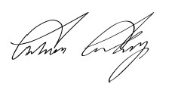
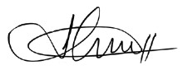
Colman Candy (Principal) Ann Howett (Year Head)

Priority Learning Units

Communicating, Language and Literacy |  | Teacher name
Descriptor
Teacher Comment

Being Part of a Community |  | Teacher name
Descriptor
Teacher Comment

Numeracy |  | Teacher name
Descriptor
Teacher Comment

Personal Care and Wellbeing |  | Teacher name
Descriptor
Teacher Comment

The Arts |  | Teacher name
Descriptor
Teacher Comment

Physical Education (PE) |  | Teacher name
Descriptor
Teacher Comment

Short courses

Personal Project: Around the World in Eighty Days |  | Teacher name
Assessment |  | Descriptor
Classroom-Based Assessment
Teacher Comment

Keeping Well, Looking Good, Being Great |  | Teacher name
Assessment |  | Descriptor
Classroom-Based Assessment
Teacher Comment

Food, Glorious Food |  | Teacher name
Assessment |  | Descriptor
Classroom-Based Assessment
Teacher Comment

Wellbeing and other areas of learning

Descriptors

L1LPs Priority Learning Units

Successfully Completed
The student presents evidence that indicates they accessed all and achieved the majority of learning outcomes related to the PLU.

Progress Achieved
The student presents evidence of learning that indicates the student has benefited from accessing some learning outcomes for that PLU.

L1LPs Classroom-Based Assessment Descriptor
Successfully Completed
The student presents evidence that indicates they have successfully completed the Classroom-Based Assessment related to the short course.

Progress Achieved
The student presents evidence of learning that demonstrates the student has benefited from accessing some learning outcomes in the short course.

