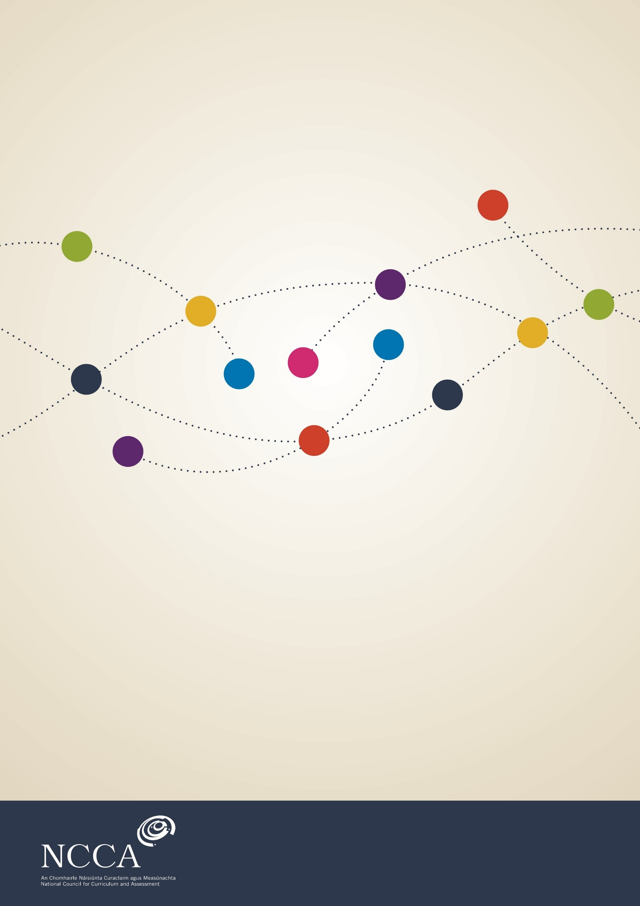

March 2017
Junior Cycle History
Draft Specification

Contents
Introduction to junior cycle 5
Rationale 6
Aim 7
Overview: Links 8
Overview of course 13
Expectations for students 20
Strand One: The Nature of History 21
Strand Two: The History of Ireland 23
Strand Three: The History of Europe and the Wider World 25
Assessment and reporting 27
Classroom-Based Assessment 1: My Life in Time 30
Classroom-Based Assessment 2: The Past in My Place 30
The final examination 32
Appendix A: Glossary of action verbs 33
Appendix B: Glossary of History terms 37

Introduction to junior cycle
Junior cycle education places students at the centre of the educational experience, enabling them to actively participate in their communities and in society, and to be resourceful and confident learners in all aspects and stages of their lives. Junior cycle is inclusive of all students and contributes to equality of opportunity, participation and outcome for all.
The junior cycle allows students to make a greater connection with learning by focusing on the quality of learning that takes place, and by offering experiences that are engaging and enjoyable for them, and are relevant to their lives. These experiences are of a high quality: they contribute directly to the physical, mental and social wellbeing of learners; and where possible, provide opportunities for them to develop their abilities and talents in the areas of creativity, innovation and enterprise. The junior cycle programme builds on students' learning to date and actively supports their progress; it enables them to develop the learning skills that will assist them in meeting the challenges of life beyond school.

Rationale
The study of History is about exploring human experience over time and how that experience has shaped the world we live in today. By asking questions of available evidence, students of History can make rational, informed judgements about human actions in the past and examine why people were motivated to act as they did and the effects of these actions. Studying History develops our historical consciousness, enabling us to orient ourselves in time and place our experiences in a broader framework of human experience. Being historically conscious transforms the way that we perceive the world and our place in it.
Having a ‘big picture’ of the past helps to develop our historical consciousness. A broad survey helps us to see major patterns of change and gives us a framework to understand and put into context the knowledge that we gain about the actions of people that came before us. Investigating evidence to identify moments or patterns of change in the human experience, and to make judgements on the significance of such change, is the key practice of the historian. This study of change relates to the fullness of human experience over time, from the initial emergence of humans to the more recent past. The study of the past allows us to examine the impact of human actions in a wide variety of dimensions, including politics, government, law, society, economics, culture, beliefs and ideas.
When we learn about the past, it is important also that we understand the nature of History as a discipline that allows us to make sense of what has happened in our world over time. This involves understanding such concepts as: how evidence allows us to make judgements about the past and how such judgements may need to be changed if new evidence emerges; awareness of the usefulness and limitations of different forms of evidence and the importance of being objective and fair when investigating the actions of people in the past, and taking care not to let opinions or prejudices affect our judgements; how human actions in the past have different levels of significance; that we see people in the past and their actions in the context of the time in which they lived.
Understanding the actions of people in the past and understanding how we come to know about these actions helps us to develop positive values about History. These include a respect for truth and evidence, a commitment to being open to seeing the past from different perspectives and a regard for the integrity of the past. This way of seeing the world deepens our understanding of the relationship between past and current events and the forces that drive change; helps us to appreciate how diverse values, beliefs and traditions have contributed to the culture in which we live; and enables us to value our local, national and international heritage. The ability to construct and communicate coherent, logical arguments on matters of historical significance, and in so doing utilise skills such as thinking critically, working collaboratively and utilising digital media effectively, is also enhanced by the study of History.
Studying History helps us also to develop a historical sensibility that leads to an appreciation of he cultural achievements and accomplishments of previous generations and derive pleasure and enjoyment from learning about the richness and diversity of human experience in the past, and how this has impacted on and shaped our own identity and experience of the world.

Aim
The study of History at Junior Cycle aims to enable students to develop the necessary conceptual understanding and disciplinary skills to investigate the actions of people in the past and coming to a deeper understanding of the human condition. Students also come to see the world, and their place in it, from an historical perspective; and understand how the people and events of the past have shaped the contemporary world.
By exploring the past from an historical perspective, students also develop an interest and enthusiasm for history and acquire values and attitudes that shape their view of people in the past, including a regard for heritage and their cultural inheritance, and a sense of historical empathy, where people are judged in the context and values of the time in which they lived.
The study of history instils in students a respect for integrity, objectivity and looking at issues from different perspectives. This capacity for critical thinking helps them to interrogate sources of information and detect bias and propaganda.
Hearing and telling the stories of people who lived in the past helps students to understand more about how people live today; and can help students to learn from the past in thinking about how to address the problems of today.

Overview: Links
The tables on the following pages show how History is linked to central features of learning and teaching outlined in the Framework for Junior Cycle 2015.
Table 1: Links between junior cycle History and the statements of learning
Statement of Learning | Examples of relevant learning
SOL 3: The student creates, appreciates and critically interprets a wide range of texts | Students will interrogate a range of primary and secondary historical sources and will use their historical knowledge and conceptual understanding to produce their own texts using a variety of formats.
SOL 6: The student appreciates and respects how diverse values, beliefs and traditions have contributed to the communities and culture in which he/ she lives | Students will learn about the roots of their historical inheritance through exploring aspects of the history of their own locality, such as interviewing older people about religious practices and traditions.
SOL 7: The student values what it means to be an active citizen, with rights and responsibilities to local and wider contexts | Students will explore how the role of the individual in society evolved over time, including an exploration of the concept of rights and citizenship, by exploring how ordinary people lived under different systems of government, such as Nazi Germany or the Soviet Union.
SOL 8: The student values local, national and international heritage, understands the importance of the relationship between past and current events and the forces that drive change | Students will explore why certain historical events are commemorated, such as the Holocaust; they will investigate the historical roots of a contemporary issue or theme, such as racism or conflict in the Middle East.
SOL 9: The student understands the origins and impact of social, economic and environmental aspects of the world around him/ her | The student will explore social change by looking at causes and consequences of migration patterns caused by the Black Death; or by exploring how migration and settlement affected identity on the island of Ireland.
SOL 18: The student observes and evaluates empirical events and processes and draws valid conclusions and deductions | Students will explore the discipline of history, including working with evidence and making historical judgements based on an interrogation of evidence; for example, exploring how the 1916 Rising influenced the events that led to the Anglo-Irish Treaty in 1921.
SOL 24: The student uses technology and digital media tools to learn, communicate, work and think collaboratively and creatively in a responsible and ethical manner | Students will engage with and critically evaluate ICT when locating historical sources and evidence and in the creation of responses to questions about the past.

Key skills

In addition to their specific content and knowledge, the subjects and short courses of junior cycle provide students with opportunities to develop a range of key skills. Figure 1 below illustrates the key skills of junior cycle. There are opportunities to support all key skills in this course but some are particularly significant.
Figure 1 : The elements of the eight key skills of junior cycle
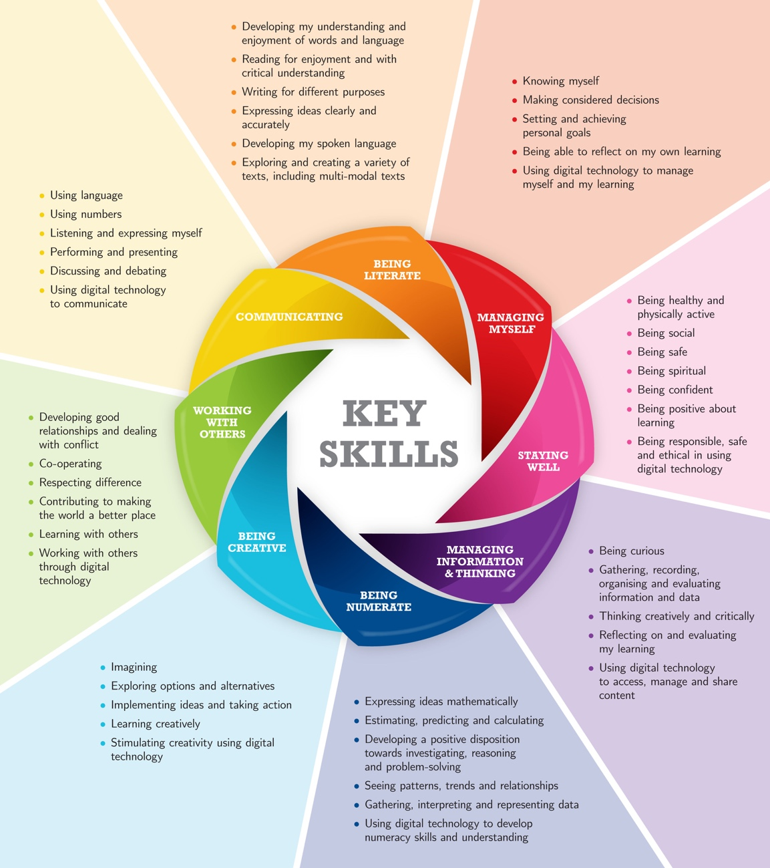

Table 2 identifies some of the elements that are related to learning activities in History. Teachers can also build many of the other elements of particular key skills into their classroom planning.
Table 2: Examples of links between junior cycle History and key skills
Key Skill | Example of Key Skill element | Examples of associated student learning activities
Being Numerate | Gathering, interpreting and representing data.  Seeing patterns, trends and relationships. | Students create timelines to show understanding of chronology and ‘the big picture. They analyse sources showing numerical data, such as census records.
Being Literate | Expressing ideas clearly and accurately.  Writing for different purposes. | Students learn to construct historical arguments, showing awareness of such concepts as source and evidence and cause and consequence in their writing.
Managing Myself | Being able to reflect on my own thinking. | Students keep a journal where they reflect on their learning and on how their study of history develops their understanding of the world.
Managing information and thinking | Using ICT and digital media to access, manage and share content | Students use websites or online resources to gather evidence about an aspect of the past flor a research project. They maintain electronic files of their work and create a digital presentation to show their findings.
Being Creative | Thinking creatively. | Students use the available evidence and their imagination to reflect upon the lives of people in the past and represent their thinking in a diary entry or letter.  Students make models or other representations of sites of historical interest, such as castles, round towers or memorial sites.
Communicating | Listening and expressing myself. | Students interview people in their family or community to gather memories or stories.  Students collaborate on group projects or presentations.
Working with Others | Contributing to making the world a better place | Students develop their appreciation of diversity and difference (gender, culture etc.) through their encounters with different people, issues and events in the past.
Staying Well | Being responsible, safe and ethical in using digital technology | Students evaluate the objectivity and fairness of online historical sources/ evidence.

Overview of course
The specification for Junior Cycle History provides a framework for students to acquire the skills, conceptual understanding and knowledge that lead to a sense of historical consciousness, whereby students can see the world and their place in it from an historical perspective. It has been designed for a minimum of 200 hours timetabled student engagement across the three years of junior cycle.
The specification has three interconnected strands, each with a set of related elements:
Strand One: The Nature of History; Strand Two: The History of Ireland; Strand Three: the History of Europe and the Wider World.
Strand one: The Nature of History - unifying strand
This unifying strand focuses on the nature of history as a discipline. It relates to the skills, conceptual understanding and procedural knowledge that are necessary to interpret the past. The strand emphasises the skills, concepts, values and attitudes that inform the learning of history.
There are three interrelated elements to Strand One:
- Developing historical consciousness
- Working with evidence
- Acquiring ‘the big picture’
Each element is associated with a range of learning outcomes that set out what the student should know or be able to do following their engagement with the strand.
As Strand One is the unifying strand, it is intended that its learning outcomes should inform students’ engagement with Strands Two and Three, which might be defined more as contextual strands. Strand One relates to the discipline of history and sets out the skills, concepts, values and attitudes that are central to the work of the historian and that should inform and underpin engagement with the historical personalities, issues and events that students will encounter in Strands Two and Three. Therefore, the learning outcomes in Strand One should permeate the learning in the other two strands.
This structure is consistent with a non-linear approach to engaging with learning outcomes. It is not intended that students engage with Strand One as a discrete entity prior to engaging with Strands Two and Three. Instead, Strands Two and Three provide will provide the context for students to deepen their understanding of the nature of history as a discipline.

Figure 2: The elements of Strand One: The Nature of History- Unifying strand
Overview of student learning
Strand One: The Nature of History (unifying strand)
Element: Developing historical consciousness
Being historically conscious means that students acquire a distinctive way of seeing the world and their place in it from an historical perspective. They are aware of the impact of change, both short-term and long-term, on the human condition and in different spatial and temporal contexts. They also have a sense of historical empathy or regard for the motivations and actions of people in the past in the context of their time. They can make judgements about the significance of events in the past, and appreciate the need to examine controversial or contested issues from more than one perspective. Historically conscious students are mindful of how their environment has been shaped by the people and events in the past and bring this historical sensibility to bear in their appreciation of human achievement.

Element: Working with evidence
This element relates to the fundamental role of evidence in enabling students to understand the past. Students explore the nature of source and evidence and make judgements about the usefulness and limitations of different types of evidence. Students appreciate the provisional nature of historical judgements and that such judgements may need to be revised in the light of new evidence. Related interpretive concepts such as bias and objectivity and cause and consequence are also considered in this strand element.

Element: Acquiring ‘the big picture’
The notion of the ‘big picture’ relates to the idea of a usable historical framework that allows students to see the past in a broad global context. A ‘big picture’ framework helps students to see significant patterns of change over time. As students learn, they can place their new knowledge and understanding in this framework, extending it and deepening it as they continue to ask questions of the past and acquire new knowledge and understanding. The ‘big picture’ also allows for students to deepen their chronological understanding and to appreciate how history is characterised by ‘eras’ or ‘ages’ of change.

Strands Two and Three: the contextual strands
Strands Two and Three relate to the historical context in terms of personalities, issues and events to which students apply Strand One conceptual understanding and learning. Strand Two relates to the history of Ireland while Strand Three relates to the history of Europe and the Wider World.
Figure 2: The elements of Strands Two and Three: The History of Ireland and the History of Europe and The Wider World
There are three interrelated elements to Strands Two and Three:
- Key moments of change;
- People, culture and ideas;
- Thinking historically.

Strands Two and Three: The History of Ireland and the History of Europe and the Wider World
Element | Overview of Student Learning
Key moments of change:  This element relates to key developments in Ireland and in Europe and the Wider World in the areas of identity, nation-building politics and international relations. | - Key changes / developments in the domains of politics and international relations  - Important related concepts, including, for example, nationalism, sovereignty, power, authority, ethnicity and identity  - Nature and impact of distinct civilisations in history  - Role of significant individuals as agents of change  - Impact of war, conflict and revolution in shaping history
People, culture and ideas  This element relates to the impact of ideas and beliefs about the nature of the human condition, including religious beliefs; of social, economic, cultural and technological change. | - How religious beliefs and practices influenced historical change  - Impact of new and changing ideas about how people should live and be governed  - Nature and impact of totalitarian ideologies  - Achievements of people in fields of human endeavour  - Impact of such factors as famine, population change, migration and technological innovation on lives of ordinary people
Thinking historically  This element allows students to critically apply their understanding and knowledge to different historical enquiries | - Connections between people, events and places in the past  - Application of research skills  - How the past has shaped the modern world  - Ideas around human rights, equality, peace and justice  - Sense of historical empathy in exploring people in the past  - Local or family history

Figure 3: Overview of junior cycle History: The interaction of Strands One, Two and Three

The Nature of History

You’re going to have to convert this in
Key moments of change

Historical consciousness
Thinking historically

The big picture

People, culture and ideas

Working with evidence

Progression from primary to senior cycle
Primary curriculum
Primary school history is one of three subjects (along with geography and science) framed within the Social, Environmental and Scientific Education (SESE) curriculum area. SESE has a strong focus on ‘environment’, which denotes the surroundings or external conditions with which an individual (human or other living organism) or community interacts. In this context, history focuses on how the activity of people has shaped human, built and cultural environments. The acquisition of knowledge, values and skills in a context of exploration and investigation is highlighted. The lives of people in the past, national and international history, local studies and the work of the historian are studied in a child-centred curriculum, thus suggesting opportunities for alignment with junior cycle.
Senior Cycle
The junior cycle history specification is intended to align with key features of the Leaving Certificate syllabus. The unifying strand seeks to develop an awareness of the discipline of history that informs students’ meaningful engagement with historical contexts and allow for progression to more detailed interrogation of the past in the Topics for Study at senior cycle. This strand also helps to students to acquire the skills and disposition to engage in research and working with documents-both key features of senior cycle history.
The twin focus on Ireland and on Europe and the Wider world at junior cycle aligns with the syllabus arrangement at Leaving Certificate level. The elements in the contextual strands at junior cycle are also similar in focus to the perspectives that shape content specification at Leaving Certificate level. The broad survey nature of the junior cycle experience is intended to provide an authentic foundation for progression to senior cycle history.

Expectations for students
Expectations for students is an umbrella term that links learning outcomes with annotated examples of student work in the subject or short course specification. When teachers, students or parents looking at the online specification scroll through the learning outcomes, a link will sometimes be available to examples of work associated with a specific learning outcome or with a group of learning outcomes. The examples of student work will have been selected to illustrate expectations and will have been annotated by teachers. The examples will include work that is
- exceptional
- above expectations
- in line with expectations.
The purpose of the examples of student work is to show the extent to which the learning outcomes are being realised in actual cases. Annotated examples of student work judged by teachers will be included alongside the specification.

Learning outcomes
Learning outcomes are statements that describe what knowledge, understanding, skills and values students should be able to demonstrate having studied history in junior cycle. The learning outcomes set out in the following tables apply to all students. As set out here they represent outcomes for students at the end of their three years of study. The specification stresses that the learning outcomes are for three years and therefore the learning outcomes focused on at a point in time will not have been ‘completed’ but will continue to support the students’ learning in history up to the end of junior cycle.
To support the exploration of the learning outcomes by teachers, parents and students, a glossary of the action verbs used in the specification is included in Appendix A. The outcomes are numbered within each strand. The numbering is intended to support teacher planning in the first instance and does not imply any hierarchy of importance across the outcomes themselves, nor does it suggest an order to which the learning outcomes should be developed in class. Junior cycle history is offered at a common level. The examples of student work linked to learning outcomes will offer commentary and insights that support differentiation and inclusive classroom practices
Strand One: The Nature of History
Brief overview of strand
Strand One is a formational strand, where students explore the skills, concepts, values and attitudes that inform the discipline of history and the work of the historian. It is also a unifying strand, where the learning outcomes will be achieved through engaging with the context provided in Strands Two and Three in relation to personalities, issues and events. Strand One will help students to acquire a ‘big picture’ of the past and an understanding of the importance of evidence that will enhance their historical consciousness.

Element | Students should be able to:
Developing historical consciousness | - View people, issues and events encountered in their study of the past in the context of that time in history.  - Appreciate the impact of history on the society in which they live and on other societies.  - Consider contentious or controversial issues in history from more than one perspective.  - Share stories about historical personalities, issues and events that they find interesting.  - Show awareness of their cultural inheritance through an appreciation of historically significant places and buildings.  - Discuss how and why certain historical personalities, events and issues are commemorated.
Working with evidence | - Show awareness of interpretive concepts including source and evidence; the nature of historical accounts; bias and objectivity; and cause and consequence.  - Research the job of the historian, including how s/he finds evidence and uses evidence to form historical judgements.  - Reflect upon the provisional nature of historical knowledge, which may be revised or reinterpreted in the light of new evidence.  - Debate the usefulness and limitations of different types of sources of historical evidence, such as written, visual, aural, oral and tactile evidence.  - Make historical judgements based on evidence about personalities, issues and events, showing awareness of historical significance.  - Report on a repository of historical evidence such as a museum, library, heritage centre, digital or other archive or exhibition.  - Review secondary sources relating to their study such as books/ articles/ documentaries/ websites.
Acquiring ‘the big picture’ | - Show awareness of the significance of the history of Ireland and of Europe and the wider world across various dimensions, including political, social, economic, religious, cultural and scientific dimensions.  - Identify and compare the characteristic features of different historical eras.  - Locate personalities, events and issues in the appropriate historical eras as they are encountered in Strand Two and Strand Three.  - Make connections between people, events and issues across different geographical places and historical eras.  - Create and maintain timelines of the events and issues encountered in their study of the past.

Strand Two: The History of Ireland
Brief overview of strand
Strand Two is a contextual strand, where students will apply their conceptual understanding to an exploration of key personalities, issues and events in Irish history, including local history.
Element | Students should be able to:
Key moments of change | - Recognise how demographic changes including settlement, migration, land ownership and plantation contributed to ideas about identity on the island of Ireland.  - Examine why political violence, conflict or rebellion occurred in pre-twentieth century Ireland, referring to causes and consequences.  - Discuss Irish relationships with other countries or the international community at large, before and after independence.  - Assess how individual people influenced key moments of change in Ireland across different periods of history, including references to biographical backgrounds.  - Explore the rise of nationalism and the emergence of independence and partition in Ireland, including key moments of change between 1911 and 1923.  - Trace the emergence and development of Ulster Unionist identity.

People, culture and ideas | - Describe how Irish people achieved distinction in various fields of human endeavour, including culture and the arts, exploring relevant aspects of their biographical backgrounds and justifying their historical significance.  - Consider the importance of religion to historical developments in Ireland.  - Describe the impact of famine and emigration on Irish society and how the Irish Diaspora contributed to historical developments in other parts of the world.  - Describe the impact of war and conflict on the lives of non-combatants on the island of Ireland  - Explain how the experience of women in Irish society has changed in the twentieth century.  - Identify and examine how a movement or organisation contributed to historically significant change in Ireland.
Thinking historically | - Explain the relevance of archaeology to their understanding of Irish history, citing local examples, if possible.  - Make connections between local history and wider national and/ or international historical personalities, events and issues.  - Present and discuss their approach to and findings from an individual research project conducted on a subject of personal historical interest relating to their locality.  - Contribute to a class archive (or historical repository) of family and/ or local history through the production of interview recordings or transcripts, models, images, family trees, time capsules or other relevant documents or artefacts.  - Debate the idea that the 1960s was an important decade on the island of Ireland, referring to relevant personalities, issues and events.

Strand Three: The History of Europe and the Wider World
Brief overview of strand
Strand Three is a contextual strand, where students will apply their conceptual understanding to an exploration of key personalities, issues and events in the history of Europe and the wider world.
Element | Students should be able to:
Key moments of change | - Investigate the lives of people in a civilisation of their choosing and explain how the actions and/or achievements of that civilisation contributed to the history of Europe and/or the wider world.  - Explore migration/population changes in Europe and/or the wider world, referring to the causes of changes and their impact on people and society.  - Assess the causes and consequences of conquest and/or colonisation, including an assessment of the impact on all of the people involved.  - Identify the cause, course and consequence of a revolution in pre-twentieth century Europe and/ or the wider world.  - Examine how political tensions led to war, how war impacted on people and nations and how the issues concerned were resolved.  - Assess the influence of individual people on historical change in Europe and/ or the wider world across different periods of history, including references to biographical backgrounds.
People, culture and ideas | - Show how the Renaissance is historically significant.  - Profile the experiences of people living in medieval/ feudal times.  - Appreciate the historical importance of religious beliefs and practices and the contribution of religion, including the Reformation, to historical developments.  - Analyse the rise and course of fascism and communism and how a country adopted each as a system of government.  - Describe how a range of people of their own choosing achieved distinction in various fields of human endeavour, including culture and the arts, exploring relevant aspects of their biographical backgrounds and justifying their historical significance.  - Explore the contribution of technological developments and innovation contributed to historical change.
Thinking historically | - Explore the causes, course and consequences of genocide in the history of Europe and/or the wider world, including the Holocaust.  - Explore how and why genocide occurred in the history of Europe and/or the wider world, including the Holocaust.  - Draw on their historical knowledge to create a biography/ profile of a young person living in the past.  - Reflect on the foundation and role of an international organisation, such as the European Union or United Nations, in relation to human rights, peace and cooperation.  - Debate the idea that the 1960s was an important decade in Europe and the wider world, referring to relevant personalities, issues and events.  - Illustrate changing patterns or trends observed in the study of a theme relating to life and society across different time periods (such as, e.g., Crime and Punishment, Food and Drink, Play, Sport and Leisure, Fashion and Appearance or Health and Medicine).

Assessment and reporting
Assessment in education involves gathering, interpreting and using information about the processes and outcomes of learning. It takes different forms and can be used in a variety of ways, such as to record and report achievement, to determine appropriate routes for learners to take through a differentiated curriculum, or to identify specific areas of difficulty or strength for a given learner. While different techniques may be employed for formative, diagnostic and summative purposes, the focus of the assessment and reporting is on the improvement of student learning. To do this it must fully reflect the aim of the curriculum.

The junior cycle places a strong emphasis on assessment as part of the learning process. This requires a more varied approach to assessment in ensuring that the assessment method(s) chosen is fit for purpose, timely and relevant to the students. Assessment in junior cycle History will optimise the opportunity for students to become reflective and active participants in their learning and for teachers to support this. This rests upon the provision for learners of opportunities to negotiate success criteria against which the quality of their work can be judged by peer, self, and teacher assessment; and upon the quality of the focused feedback they get in support of their learning.

Providing focused feedback to students on their learning is a critical component of high-quality assessment and a key factor in building students’ capacity to manage their own learning and their motivation to stick with a complex task or problem. Assessment is most effective when it moves beyond marks and grades, and reporting focuses not just on how the student has done in the past but on the next steps for further learning. This approach will ensure that assessment takes place as close as possible to the point of learning. Final assessment still has a role to play, but is only one element of a broader approach to assessment.

Essentially, the purpose of assessment and reporting at this stage of education is to support learning. Parents/guardians should be given a comprehensive picture of student learning. Linking classroom assessment and other assessment with a new system of reporting that culminates in the awarding of the Junior Cycle Profile of Achievement (JCPA) will offer parents/guardians a clear and broad picture of their child’s learning journey over the three years of junior cycle. To support this, teachers and schools will have access to an Assessment Toolkit. Along with the guide to the Subject Learning and Assessment Review (SLAR) process, the toolkit will include learning, teaching and assessment support material, including:
- formative assessment
- planning for and designing assessment
- ongoing assessments for classroom use
- judging student work – looking at expectations for students and features of quality
- reporting to parents and students
- thinking about assessment: ideas, research and reflections
- an assessment glossary.

The contents of the toolkit will include the range of assessment supports, advice and guidelines that will enable schools and teachers to engage with the new assessment system and reporting arrangements in an informed way, with confidence and clarity.

Assessment for the JCPA
The assessment of History for the purposes of the Junior Cycle Profile of Achievement (JCPA) will comprise two Classroom-Based Assessments: ‘A Young Life in Time', ‘The Past in My Place' and a final examination.
In addition, the second Classroom-Based Assessment will have a written Assessment Task that will be marked, along with the final assessment, by the State Examinations Commission.
All assessments will be at a common level.

Rationale for the Classroom-Based Assessments in History
Classroom-Based Assessments are the occasions when the teacher assesses the students in the specific assessments that are set out in the specification. Classroom-Based Assessments are similar to the formative assessment that occurs every day in every class. However, in the case of the Classroom-Based Assessments, the teacher’s judgement is recorded for the purpose of subject learning and assessment review, and for the school’s reporting to parents and students.
Over the three years of junior cycle, students will be provided with opportunities to stimulate their interest in discovering the experience of people in the past. It is envisaged that through the Classroom-Based Assessments students will actively engage in practical and authentic learning experiences that will enable them to meaningfully engage with learning outcomes.
The Classroom-Based Assessments will provide an opportunity for students to:
- Engage with areas of personal historical interest
- Work with evidence and research information using a range of methods
- Analyse data and evidence to make informed value judgements and decisions
- Organise information and plan logically
- Communicate clearly and effectively
- Develop their historical consciousness
- Collaborate with others on tasks
- Reflect on their own learning.
Through these Classroom-Based Assessments they will develop their knowledge, understanding, skills, and values, thereby achieving the learning outcomes across the strands.

Classroom-Based Assessment 1: A Young Life in Time
CBA  ‘A Young Life in Time’ | Format | Student Preparation | Completion of Assessment | SLAR meeting
Structured, evidence-based enquiry into the life of a young person in a chosen place and time in the past. | Report that may be presented in a wide range of formats. | Students will, over a specified time, research aspects of the life of a young person of a comparable age to themselves at a place and time in the past of personal historical interest. | Towards the end of second year. | One review meeting.

Classroom-Based Assessment 2: The Past in My Place
CBA  ‘The Past in My Place’ | Format | Student Preparation | Completion of Assessment | SLAR meeting
Structured, evidence-based enquiry into an historical aspect or theme relating to the locality of the student. | Report that may be presented in a wide range of formats. | Students will, over a specified time, prepare a report on a local history-related project. | Term two in third year. | One review meeting.

Assessing the Classroom-Based Assessments
More detailed material on assessment for reporting in junior cycle History, setting out details of the practical arrangements related to assessment of the Classroom-Based Assessments, will be available in separate Assessment Guidelines for History. This will include, for example, the suggested content and formats for student work and support in using 'on-balance' judgement in relation to the features of quality. The NCCA's Assessment Toolkit will also include substantial resource material for use in ongoing classroom assessment of junior cycle History as well as providing a detailed account of the Subject Learning and Assessment Review process.
Features of quality
The features of quality support student and teacher judgement of the Classroom-Based Assessments and are the criteria that will be used by teachers to assess the student work. The features of quality will be available in Assessment Guidelines for History. All students will complete both Classroom-Based Assessments.
Assessment Task
On completion of the Classroom-Based Assessments, students will undertake an Assessment Task. This will be completed after the second Classroom-Based Assessment component and will be marked by the State Examinations Commission.
The Assessment Task will assess students in respect of their learning including:
- Their ability to demonstrate their understanding of historical concepts by applying their historical thinking to a researching an aspect of local history
- Their ability to evaluate new knowledge or understanding that has emerged through their experience of the Classroom-Based Assessment
- Their capacity to reflect on the process of research and forming historical judgements based on evidence.
- Their reflections on how their experience of conducting research has influenced their attitudes and values.
The final examination
There will be one examination paper at a common level. This paper will be set and marked by the State Examinations Commission. The examination will be of two hours’ duration and will take place at the end of third year. In any one year, the learning outcomes to be assessed will constitute a sample of the relevant outcomes from the tables of learning outcomes.
Inclusive assessment practices
This specification allows for inclusive assessment practices whether as part of ongoing assessment or Classroom-Based Assessments. Where a school judges that a student has a specific physical or learning difficulty, reasonable accommodations may be put in place to remove, as far as possible, the impact of the disability on the student’s performance in Classroom-Based Assessments. The accommodations, e.g. the support provided by a Special Needs assistant or the support of assistive technologies, should be in line with the arrangements the school has put in place to support the student’s learning throughout the year.

Appendix A: Glossary of action verbs
This glossary is designed to clarify the learning outcomes. Each action verb is described in terms of what the learner should be able to do once they have achieved the learning outcome. This glossary will be aligned with the command words used in the assessment.

Action verbs | Students should be able to
Adapt | make something suitable for new condition, use or purpose
Analyse | study or examine something in detail, break down in order to bring out the essential elements or structure; identify parts and relationships, and to interpret information to reach conclusions
Apply | select and use information and/or knowledge and understanding to explain a given situation or real circumstances
Appraise | evaluate, judge or consider a piece of work
Associate | to connect or bring into relation; to fit together and cause to correspond
Argue | challenge or debate an issue or idea with the purpose of persuading or committing someone else to a particular stance or action
Classify | group things based on common characteristics
Comment | give an opinion based on a given statement or the result of a calculation
Compare | give an account of the similarities or differences between two (or more) items or situations, referring to both (all) of them throughout
Create | to bring something into existence; to cause something to happen as a result of one’s actions
Critique | state, giving reasons, the positive and negative aspects of, for example, an idea, artefact or artistic process
Define | give the precise meaning of a word, phrase, concept
Demonstrate | prove or make clear by reasoning or evidence, illustrating with examples or practical application
Describe | tell or depict in written or spoken words; to represent or delineate by a picture or other figure
Design | do or plan something with a specific purpose in mind
Develop | bring to a later or more advanced stage; to elaborate or work out in detail
Devise | plan, elaborate or invent something from existing principles or ideas
Discuss | offer a considered, balanced review that includes a range of arguments, factors or hypotheses; opinions or conclusions should be presented clearly and supported by appropriate evidence
Distinguish | make the differences between two or more concepts or items clear
Evaluate (information) | collect and examine information to make judgments and appraisals; describe how evidence supports or does not support a conclusion in an inquiry or investigation; identify the limitations of information in conclusions; make judgments about the ideas, solutions or methods
Evaluate  (ethical judgement) | collect and examine evidence to make judgments and appraisals; describe how evidence supports or does not support a judgement; identify the limitations of evidence in conclusions; make judgments about the ideas, solutions or methods
Examine | consider an argument, concept or object in a way that uncovers its assumptions, interrelationships or construction
Experiment | to try and test, in order to discover something new or to prove something
Explain | give a detailed account including reasons or causes
Explore | systematically look into something closely; to scrutinise or probe
Find | ‘find’: a general term that may variously be interpreted as calculate, measure, determine, etc.
Group | identify objects according to characteristics
Identify | recognise patterns, facts, or details; provide an answer from a number of possibilities; recognise and state briefly a distinguishing fact or feature
Illustrate | use drawings or examples to describe something
Indicate | to point out or point to; to direct attention to
Infer | use the results of an investigation based on a premise; read beyond what has been literally expressed
sInvestigate | analyse, observe, study, or make a detailed and systematic examination, in order to establish facts or information and reach new conclusions
Interpret | use knowledge and understanding to recognise trends and draw conclusions from given information
Justify | give valid reasons or evidence to support an answer or conclusion
List | provide a number of points, with no elaboration
Outline | give the main points; restrict to essentials
Present | to bring, offer or give in a formal way; to bring before or introduce to a public forum
Propose | offer or suggest for consideration, acceptance or action
Provide evidence | provide data, work and documentation that support inferences or conclusions
Recognise | identify facts, characteristics or concepts that are critical (relevant/appropriate) to the understanding of a situation, event, process or phenomenon
Suggest | propose a solution, hypothesis or other possible answer
Synthesise | combine different ideas in order to create new understanding
Use | apply knowledge, skills or rules to put them into practice
Verify | give evidence to support the truth of a statement

Appendix B: Glossary of history terms
This glossary has been added to explain the meaning of history terms as they appear in this specification to help with understanding when reading.

Term | Interpretation
Artefact | A human-made article of historical interest, including as a source of evidence
Authority | Relates to power or rule, e.g. government
Civilisation | A people or nation in the past that was socially and politically organised
Colonisation | Process where a country takes over another country, establishes its authority and settles its people there
Commemoration | Public act of remembrance of historically significant event or person
Contentious | An issue that is disputed or not agreed on by different parties
Conquest | Where a people or country takes control of another people or country by military force
Diaspora | Where people of an ethnic group are dispersed around the world through emigration
Empathy | Understanding the motivations, actions, values and beliefs of human beings in the context of the time in which they lived
Historical consciousness | Seeing the world from an historical perspective, informed by an awareness of historical concepts
Identity | How a group of people are bound together by nationality, ethnicity, religion or other social or cultural connections
Including | As used in learning outcomes, indicates material that must be focus of learning
Migration | Movement of people from one place to another, especially in a different country
Non-combatant | Person in a situation of conflict who is not directly involved, such as civilians
Orient | Determining how a person sees himself or herself from an historical perspective, showing awareness of the nature of change in time and space
Partition | Division of island of Ireland into two polities following Government of Ireland Act 1920
Plantation | 16th century English government policy of granting land in Ireland to English and Scottish settlers as part of plan to establish English authority
Significant | Person, issue or event in history that is considered important in effecting historical change
Such as | As used in learning outcomes, indicates material that might be focus of learning
Transcript | A written or recorded copy

