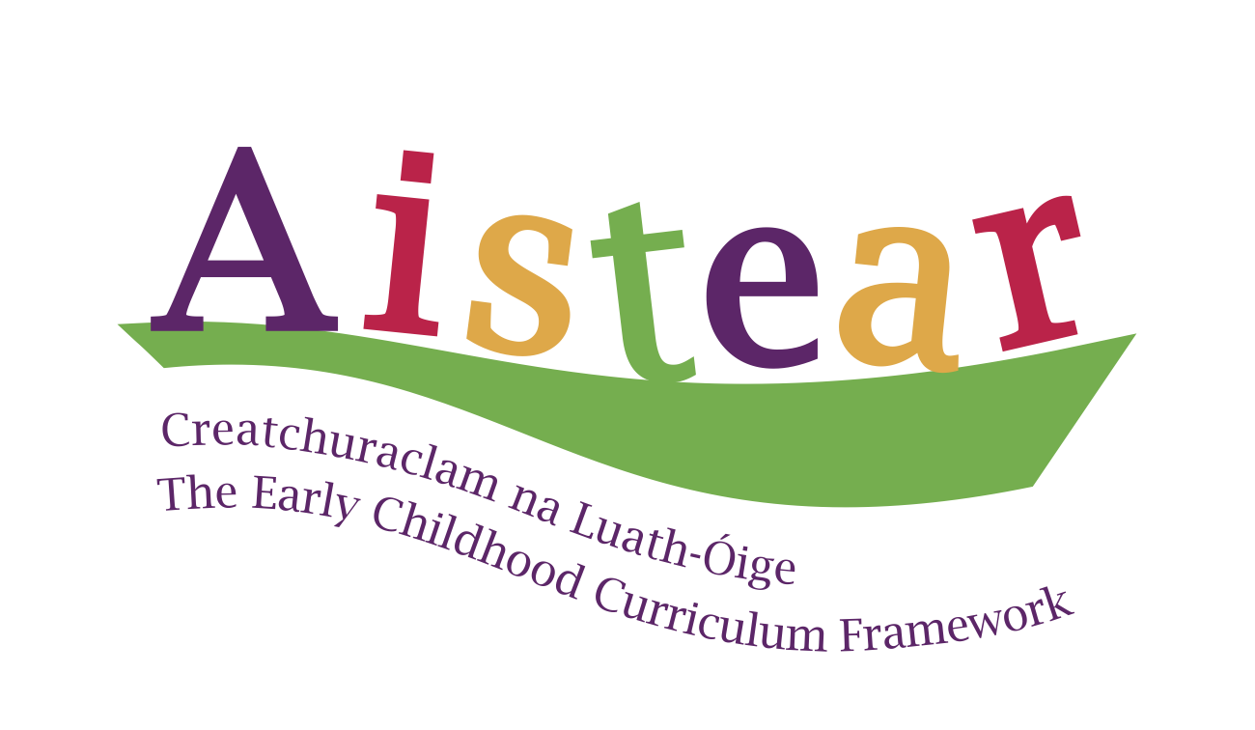  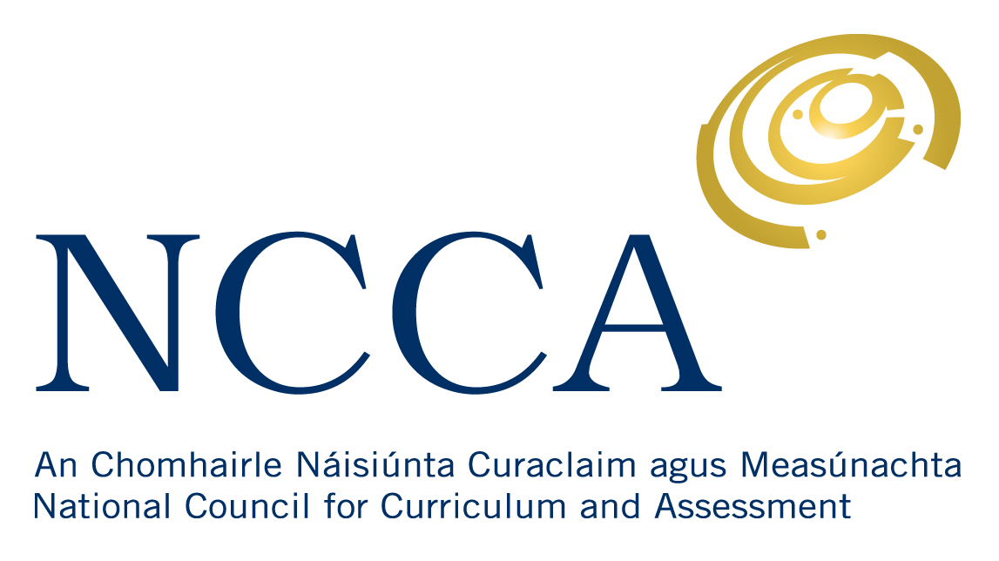 | Planning framework for play
Play topic: |  |  | Timeframe:
Language (taught in discrete lessons):
Maths (taught in discrete lessons):
Play area | Key resources | Curriculum integration |  | Teacher reflections

