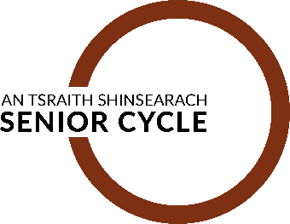 | School-based review: Theme 2 - Pathways and Flexibility  Parent Answer Template  1

Number of parents consulted: _____________________

CODE: ______________
(To be completed by mentor)

To ensure that your discussions are accurately represented in the analysis, please give full answers where necessary.

1. This question is looking for your thoughts on the programmes currently offered at senior cycle.

- What, if any, are the three most positive features of the programme your child/children are following? Please provide specific examples.

- What, if any, are the three most negative features of the programme your child/children are following? Please provide specific examples.

- If there is a programme that is not offered within your school, do you think that there are aspects of this programme that might benefit your child/ children?

2. This question is looking for your thoughts on how Senior Cycle should or could be structured
- How long should Senior Cycle be and what, if any, flexibility should there be for students to complete senior cycle at a different pace?

- Should students be offered a greater choice of curricular components to construct their senior cycle programme?

- Are there some subjects/areas/ learning experiences that should be studied by all senior cycle students? Please explain your thinking.

3. This question is looking for your thoughts on pathways available to students in Senior Cycle
In discussing pathways at senior cycle, there are a number of key considerations including:
- the range of pathways available (academic, technical, vocational, professional)
- whether these pathways can be combined or are ring-fenced
- whether different sites of learning can be used or not

- Do you think your child is following a senior cycle pathway that best suits their needs? Please explain.

- Do you think the learning experiences available to your child best suits their needs? What suggestions would you make in this respect?

4. This question is looking for your thoughts on assessment in Senior Cycle
Please consider how the curriculum and the broad learning experiences of students at senior cycle might be assessed.
- What, if any, are the positive features of current approaches to senior cycle assessment? In your response consider the most positive features of assessment for each programme you are familiar with (TY, LCE, LCVP or LCA).

- What, if any, are the negative features of current approaches to senior cycle assessment? In your response consider the most positive features of assessment for each programme you are familiar with (TY, LCE, LCVP or LCA).

- Consider your answer to Question 3, would you like to see any changes to senior cycle assessment? If so, please outline the kinds of changes you would like to see, the reasons for these changes and the potential challenges in bringing about these changes.

5. This question is looking for your thoughts on reporting
In cycle one, participants highlighted the narrow focus of reporting at the end of senior cycle. Please consider if there is value in reporting the broad learning experience of students during senior cycle.
- What do you think is important to be included in your child’s report at the end of senior cycle?

6. Anything we have missed?
Please use this space to outline your views on anything that you feel you have not had an opportunity to tell us in relation to the review of senior cycle.

