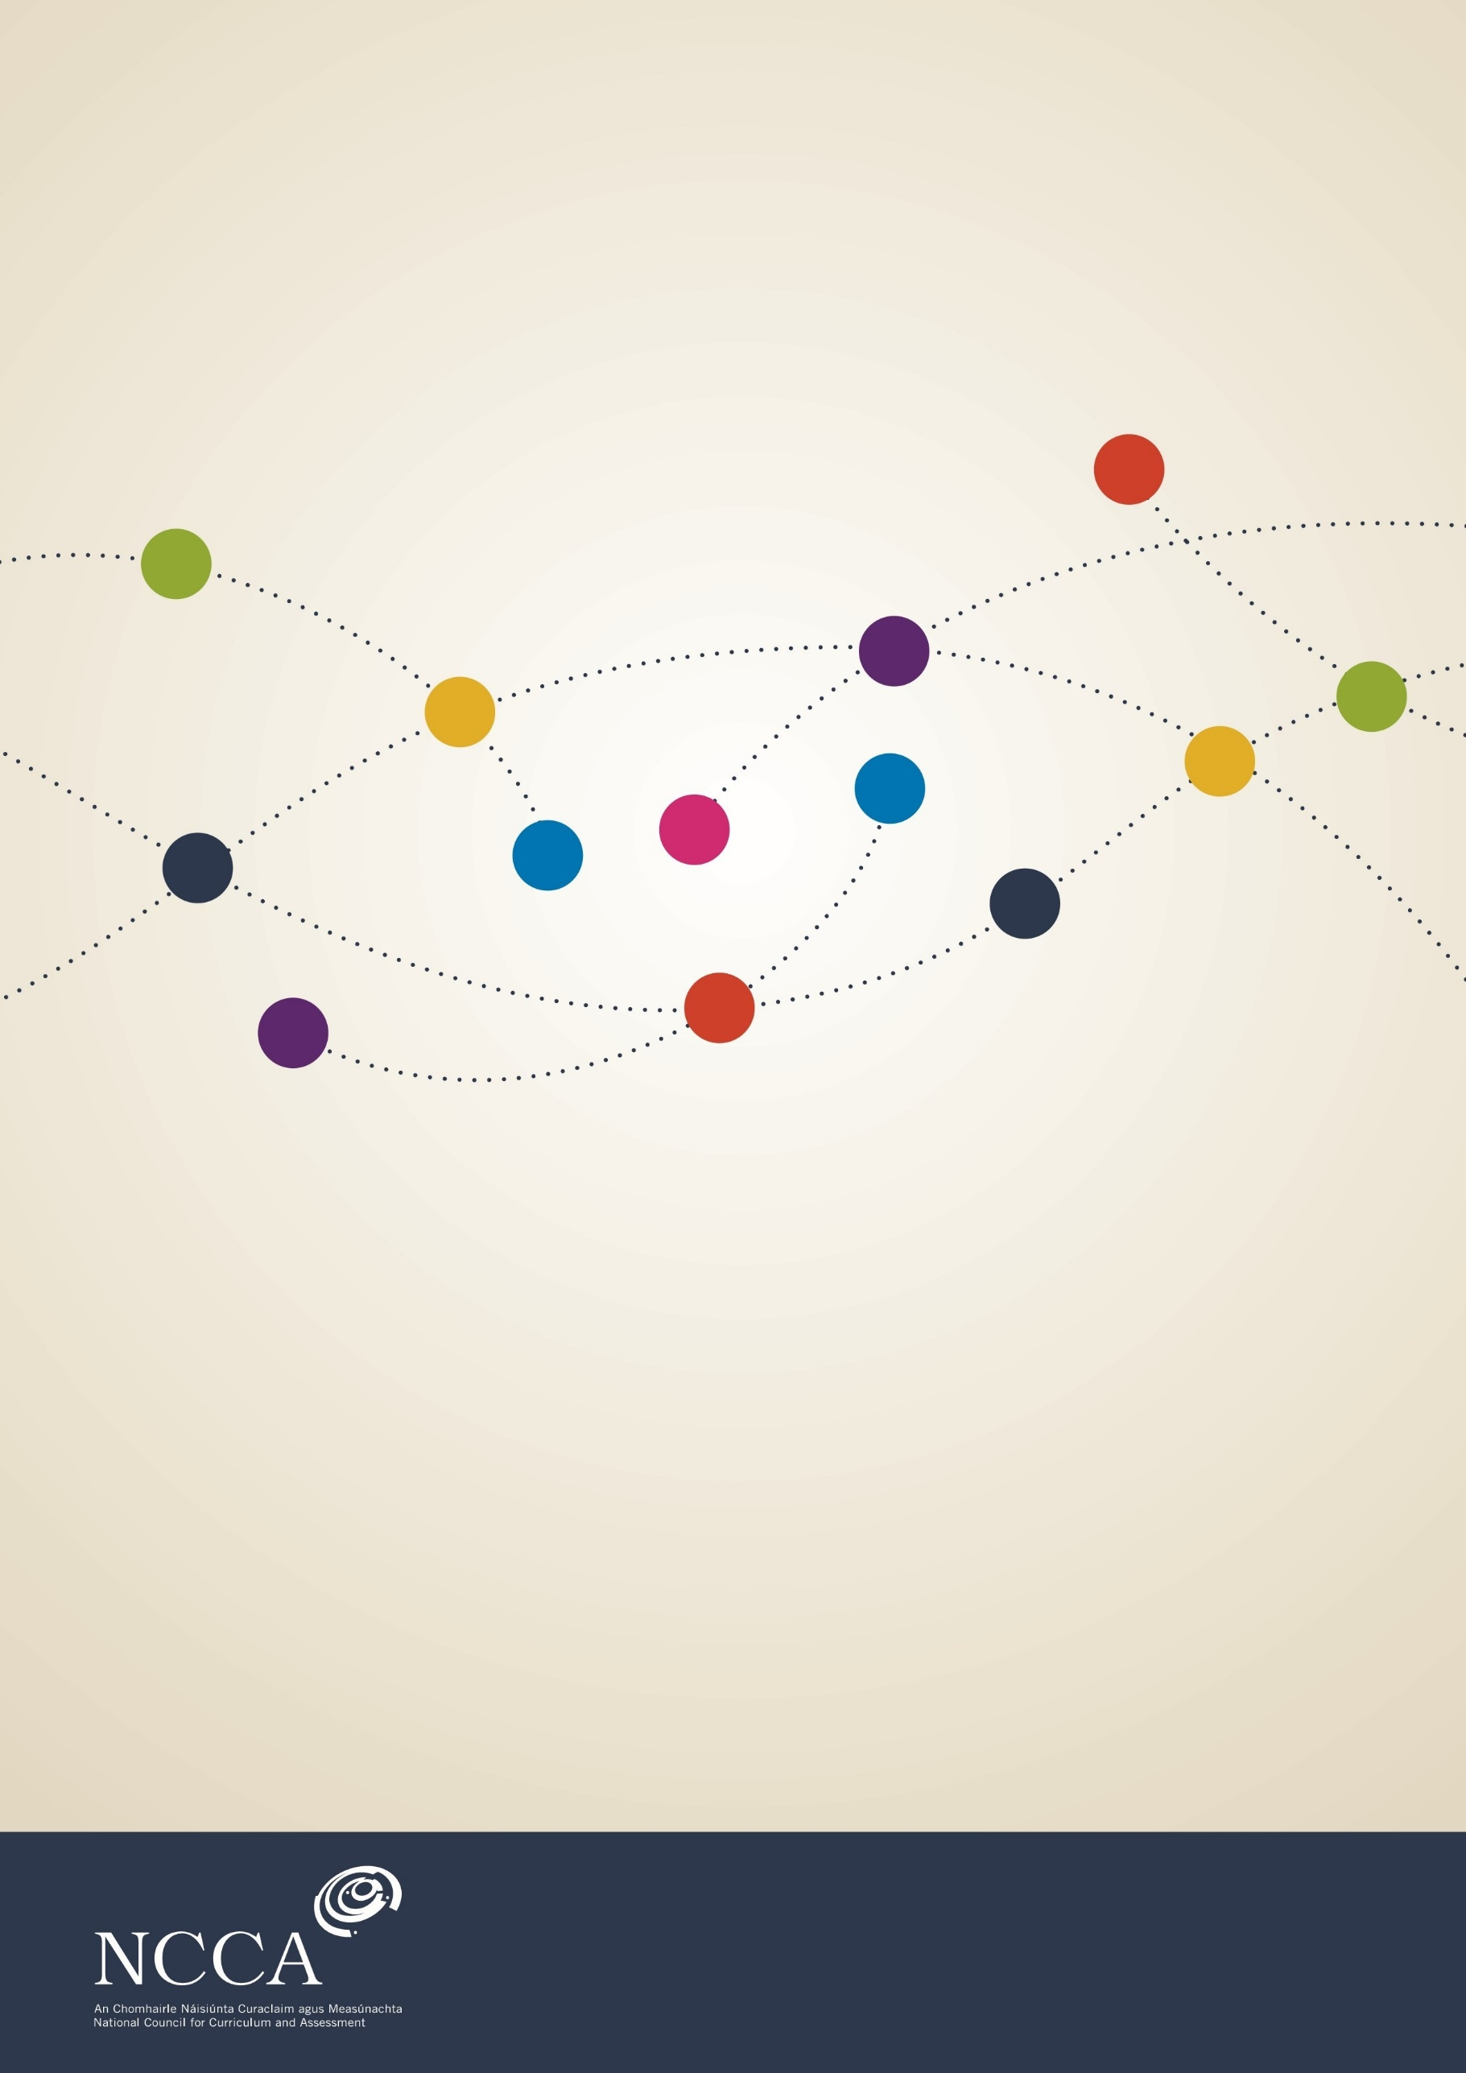

Primary Curriculum Review and Redevelopment

Background paper: Integrating modern foreign languages in a redeveloped primary curriculum

Authored by Dr Katrina Keogh-Bryan

September 2019

Contents
1. Introduction 4
Background 4
Context and rationale 6
Terminology 12
2. Wales 13
Policy and context 13
Teaching and learning: The modern language at primary level 18
3. Canada (British Columbia (BC)) 30
Policy and context 30
Teaching and learning: The modern language at primary level 35
4. Finland 45
Policy and context 45
Teaching and learning: The modern language at primary level 54
5. Belgium 63
Policy and context 63
Teaching and learning: The modern language at primary level 70
6. New Zealand 83
Policy and context 83
Teaching and learning: The modern language at primary level 88
7. Language learning trends across the jurisdictions 95
Languages of schooling 96
National policies and the impetus for languages at primary level 97
Teaching and learning: Integration of a modern language 98
8. Ireland: Existing practice in modern language teaching and learning 104
Introduction 104
Modern languages in primary schools: School trends 123
Legacy of the MLPSI 126
Modern Languages in Primary Schools Initiative (MLPSI): 1998-2012 128
Conclusion 129
9. Impact of learning a third language (L3) on existing language learning (L1 and L2) 130
Introduction 130
Impact of learning a modern foreign language (L3) on L1 and L2: Evidence-based analysis 131
10. Potential routes forward for modern languages in a redeveloped primary curriculum 137
Introduction 137
Stage 3: 3rd and 4th classes: Language Awareness model 139
Stage 4: 5th and 6th classes: Language competence model aligning to the Primary Language Curriculum/Curaclam Teanga na Bunscoile 144
11. Conclusion 145
12. References 148
Appendix 1: Lines of Inquiry for the Jurisdictions Audit 156
Appendix 2: AoLE Design Model (Welsh Government, 2017a) 157
Appendix 3: Vignette Template 159
Appendix 4: Amended Vignette Template 162
Appendix 5: Annotation details for MLPSI Chronology, Figure 8.1 169

  - 1. Introduction

Languages Connect: Ireland’s Strategy for Foreign Languages in Education 2017-2026 (DES, 2017) includes work by the National Council for Curriculum and Assessment (NCCA) in exploring the integration of modern foreign languages for senior classes in the redeveloped primary curriculum (Action 1.E.2, 13). Currently, Ireland does not have an official modern language programme at primary level, although previous work did take place through a national pilot initiative. The NCCA commissioned this background paper to help guide this work.
The paper examines the presence of modern languages at primary level across a number of jurisdictions. These jurisdictions—Wales, Canada, Finland, Belgium and New Zealand—were chosen as they have a similar language context to Ireland with the presence of more than one national or official language. Official languages refer to languages through which governments operate and government services need to be made available.
The initial sections of this paper examine each of the jurisdictions in turn under a number of lines of inquiry (see Appendix 1)—language policy and context, the teaching and learning of languages in their primary school curriculums, and special educational needs (SEN). Section 7 provides a summary of findings across jurisdictions. Section 8 focuses on the Irish context and samples of existing practice in foreign language teaching and learning. The impact of learning a third language on existing languages of the classroom (English and Irish in Ireland) are also examined at this juncture in Section 9. The final section, Section 10, maps out possible routes forward for foreign languages in the primary curriculum. These routes offer an initial proposal for including transferrable language skills through language awareness (LA) at Stage 3 (3rd and 4th classes) which progresses into a language competence model at Stage 4 (5th and 6th classes).

Background

More than ten years have passed since the publication of Modern Languages in the Primary School Curriculum: Feasibility and Futures (NCCA, 2008). The report examined the successes and challenges of the Modern Languages in Primary Schools Initiative (MLPSI) which facilitated and supported modern languages at primary level in 545 schools by 2012. In light of the findings emerging from two phases of Primary Curriculum Review (NCCA, 2005; 2008a), the report concluded that the curriculum was overloaded and that space for an additional subject was not feasible at that time. However, the report established that this did not preclude schools which already had a modern language being supported from continuing with its provision. The MLPSI was concluded in 2012. This was attributed to the policy decision, at the time, to prioritise children’s literacy (English and Gaeilge) and numeracy following the publication of Literacy and Numeracy for Learning and Life: The National Strategy to Improve Literacy and Numeracy among Children and Young People 2011-2020 (DES, 2011) and budgetary cutbacks during the economic downturn.
Recent work on the new Primary Language Curriculum/Curaclam Teanga na Bunscoile has gathered together research and evidence of best practice in language teaching to inform a new and more cohesive approach to language learning and teaching for English and Irish at primary level. The new language curriculum for junior infants to sixth class was published in September 2019. As part of this work and in response to the publication of Languages Connect: Ireland’s Strategy for Foreign Languages in Education 2017-2026 (DES, 2017), NCCA has undertaken an audit of foreign languages in primary curriculums in other educational jurisdictions and a review of Irish practice. This work springs from the section of Languages Connect which outlines how primary modern language learning will be considered by asking
the National Council for Curriculum and Assessment (NCCA) to give consideration to including foreign languages in senior classes as part of its review of the primary curriculum. The Department will consider the recommendations of the review following completion. (DES, 2017: 9)
In addition to this requirement, the Minister for Education and Skills issued a press release which noted his intention to prioritise the teaching of foreign languages, including primary level. The focus in this instance, was to be on
Exploring the possibilities of using CLIL (content and language integrated learning) techniques by teaching aspects of the primary curriculum through Irish and foreign languages which will equip learners with transferrable language skills. Research shows that teaching languages as a means of communication in this way, rather than as an academic subject to be learnt in isolation, can be very effective. (DES, 2017a)

Context and rationale

The following sections explore the context and rationale for the current work examining foreign language provision at primary level in other jurisdictions and a closer examination of the current Irish context.

Ireland’s linguistic diversity

English and Irish are official languages in Ireland, with Irish being the first national language. Since late 2017 and with the Recognition of Irish Sign Language (ISL) for the Deaf Community Bill being signed into law, Irish Sign Language is a third official language in Ireland. English and Irish are also official languages of the EU. A total of 72 migrant languages were reported to be spoken by more than 500 people each in the 2016 Census (O’Connor and Ciribuco, 2017).
The 2016 Census showed that there were 535,475 non-Irish nationals living in Ireland (11.6% of the population). These non-Irish nationals came from 200 different countries, of which 12 make up the majority. The top 12 countries of origin were America, Brazil, France, Germany, India, Italy, Latvia, Lithuania, Poland, Romania, Spain and the UK. The languages spoken by the majority of immigrants, in rank order, were Polish (113,225), Lithuanian (30,502) Romanian (26,645) and Portuguese (16,737). Chinese was the most common language spoken by Asian nationals and Arabic by African nationals (CSO, 2017).
Figure 1.1 shows the proportion of these non-Irish nationals who are primary, secondary and third level students (totalling 18% of non-Irish nationals). Approximately 66% of these students originated in European countries, 14% in Asian countries, 10% in American states and 7% in African countries (CSO, 2017).
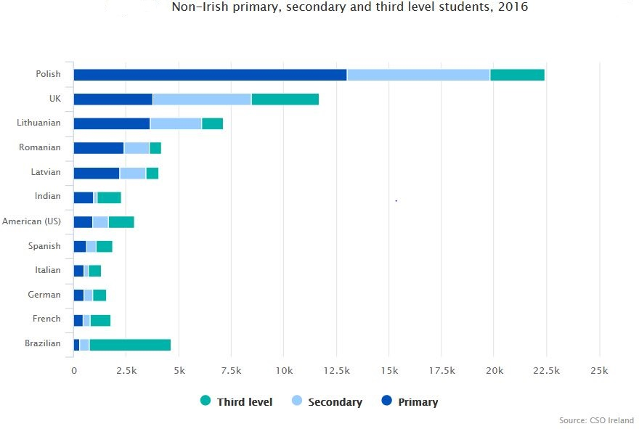
Figure 1.1 Non-Irish nationals in primary, secondary and third-level education (CSO, 2017)

Ireland’s linguistic makeup has not always been so diverse. Around the time that the Primary School Curriculum was being introduced in 1999, the majority of Ireland’s immigrants came from English-speaking countries. Similarly, when the languages to be taught in schools participating in the Modern Languages in Primary Schools Initiative (MLPSI) were chosen in 1998, the non-English languages of the EU15 countries (Austria, Belgium, Denmark, Finland, France, Germany, Greece, Ireland, Italy, Luxembourg, Netherlands, Portugal, Spain, Sweden and the United Kingdom) were the most relevant foreign languages to Ireland. French, German, Italian and Spanish were the languages supported by the MLPSI.
Table 1.1 contains census data from 1996 and 2002 which shows the proportions of people and countries of origin of immigrants to Ireland at that time. In 1996, the highest proportion of these migrants came from the United Kingdom (combining England, Wales and Scotland) and the United States which are English-speaking countries. In 2002, the highest proportion of migrants still came from England and Wales, as before. However, the next highest proportion of migrants came from non-English speaking regions, with Asia, Africa and other Europe featuring in the top four birthplaces of immigrants.
 | 1996 | 2002
England and Wales | 139,330 | 182,624
Scotland | 11,751 | 15,963
France | 3,593 | 6,794
Germany | 6,343 | 8,770
Other EU 15 | 9,296 | 17,237
Other Europe | 3,605 | 26,235
United States | 15,619 | 21,541
Africa | 4,867 | 26,515
Asia | 8,150 | 28,132
Other countries | 9,503 | 16,277
 | 214,053 | 352,090
Total population | 3,626,087 | 3,917,203
Table notes:
EU15: Austria, Belgium, Denmark, Finland, Greece, Italy, Luxembourg, Netherlands, Portugal, Spain, Sweden (excludes Irish-born and those listed separately – United Kingdom (England, Wales and Scotland), France and Germany.
Table 1.1 Population usually resident in the state by birthplace other than the Republic of Ireland (compiled from Census data 1996 and 2002, cso.ie)

Smyth, Darmody, McGinnity and Byrne (2009) described as significant the change in immigration law around 2004 when the 10 Accession States joined the EU—EU15 became EU25 (and subsequently EU28). Ireland, the UK and Sweden were the only countries which allowed citizens from these new EU Accession States full access to their labour market. In 2006, the census showed a marked increase in immigrants from these countries (Smyth et al, 2009).

The importance of language learning

Language is one of the means by which we think, express our thoughts, communicate and connect with others. Knowledge of foreign languages is essential for Ireland’s cultural, social and economic welfare. (DES, 2017: 6)

Language learning is well established in Irish schools with two national languages being learnt in all primary schools. Learning English and Irish, or learning through the medium of English or Irish, provides students with a large repertoire of transferrable language skills, language content knowledge, language awareness and metalinguistic awareness.
Section 1 described the many languages and cultures now helping to make up Ireland’s linguistic and cultural diversity. Smyth et al (2009) estimated that in 2007 ca. 10% of primary school children were newcomer children. Knowledge of other languages aids understanding of other cultures and societies (DES, 2017: 5) and builds intercultural understanding. Intercultural understanding, in turn, aims to develop, among people from different backgrounds, the knowledge, attitudes and skills which are necessary to communicate and collaborate with others who come from a different background (Van Driel, 2008). Acknowledging the importance of other languages and cultures in our schools helps students new to Ireland to value their first language and country of origin and retain confidence in their cultural and linguistic identity. Similarly, from the teachers’ perspectives, Dillon (2011) noted that teachers with proficiency in a second language were more sensitive to issues around diversity (p.281). Knowledge of other languages also helps to develop the skills to function and thrive in our modern global economy (DES, 2017: 5).
Investing in foreign language learning and/or the languages of newcomers, does not constitute a deficit in other areas of learning or school subjects. Finland, one of the jurisdictions under review (see Section 4) has invested heavily in funding and promoting language learning as a national asset. This investment in language learning has not resulted in learning deficits or costs to the Finnish education system; evidence of the success of Finland’s education system can be seen in their impressive PISA scores which rate higher than OECD averages (PISA, 2015).
Another of the jurisdictions, Wales (see Section 2), has experienced falling numbers in students taking up foreign languages at GCSE and A-Level. Tinsley (2018) noted that investing in an earlier start to foreign languages at primary level could positively impact the participation in languages being learnt at post-primary level within 10 years. Ireland has a severe shortage of modern language teachers at post-primary level (Teaching Council, 2017) which is impacting the range of subject choices available for students and creating system challenges such as the availability of teachers to facilitate state oral examinations. More language graduates are required to fill these teaching posts, which in turn, requires a greater number of students to study languages at post-primary and potentially, primary levels. The same positive backwash effect Wales is hoping to achieve for languages, could be a suitable longer-term model to assist with teacher shortages in Ireland.
The majority of students in Ireland have English as a first language or are fluent in English. English has become the language of global business and is the most frequently learnt foreign language at European level (Eurydice, 2012). While an advantageous start to language learning, knowledge of other languages gives us cultural and competitive advantages (DES, 2015: 4). Ibec has highlighted that 75% of the world’s population do not speak English, and only 9% speak English as their first language (Ibec, 2017). With China overtaking the USA as the world’s largest economy the importance of English may not be as significant as a Chinese language like Mandarin or Cantonese. Similarly, the uncertainty of Brexit means that Ireland’s link to our second biggest export market could soon be in jeopardy. Foreign language skills are required to access other local European and international markets as well as service the operational language requirements of large multinational companies residing here.
The Irish education system is already striving to diversify the language teaching and learning options available to students here. This diversification of languages is a key goal in Ireland’s language strategy—Languages Connect (DES, 2017). The strategy recognises the importance of cultivating skills in the languages of the new Irish and increasing the number of students studying languages. At post-primary level, Junior Cycle short courses have been developed in Chinese language and culture (from NCCA) and Polish, Russian, Japanese and Lithuanian (from the Post-Primary Languages Initiative (PPLI)). Transition units have been developed in Chinese language and culture and Japanese Studies. Similarly, Japanese, Russian and Arabic are offered as Leaving Certificate subjects, alongside the longer established modern languages of French, German, Italian and Spanish. New Leaving Certificate specifications are forthcoming in Mandarin Chinese, and Polish, Lithuanian and Portuguese.
The EU encourages all of its member states to work towards “the ambitious aim” of its citizens knowing their native language plus two other languages under the Barcelona Objective (Eurydice, 2017). Data gathered in 2014 showed that 83.8% of primary students in Europe learn a foreign language, with most foreign language learning commencing before the age of eight (Eurydice, 2017). Languages Connect (DES, 2017) recognised the importance of foreign language learning at local level, as espoused in the EU –
Knowledge of at least one foreign language can enrich a person’s life experiences, and the European Framework of Key Competences for Lifelong Learning (2007) recognises the ability to communicate in a foreign language as one of the key competences needed for personal fulfilment and development, active citizenship, social inclusion and employment. In learning a foreign language, a learner opens not only career opportunities, but also the opportunity for cultural engagement and understanding. (DES, 2017: 6).
Learning languages provides cognitive gains which are beneficial beyond the linguistic disciplines. Language learning enhances interpersonal communication skills, adaptability, logical thinking and creativity. It increases the plasticity of the brain allowing the brain to change over time; making it better able to encode new information. These transferrable skills are relevant across all disciplines and subjects.

Curriculum reform: A new language curriculum

The last two decades have seen significant changes in Irish society. As described above, many immigrant languages are now spoken in Ireland. Two phases of Primary Curriculum Review (NCCA, 2005; 2008a) and research during this time have highlighted strengths and challenges associated with the 1999 curriculum for English and Irish. Teachers have called for a less crowded curriculum with a greater emphasis on practice and on supporting progression in children’s language learning and development. Findings highlighted the need for a new Primary Language Curriculum which:
- integrates English and Irish and includes all children and the language knowledge and experiences that children bring to school
- engages teachers and learners and supports children to develop positive dispositions toward language and literacy
- supports teachers to help children to progress in their language learning and development through the primary years
- is more than functional; which enables children to make and explore meaning as well as receive and create it.
The Primary Language Curriculum/Curaclam Teanga na Bunscoile emphasises the importance of respecting the diversity of children’s languages and using this as a resource in the classroom. The curriculum recognises that for non-native speakers of English or Irish, learning another language broadens their linguistic experience and deepens their cultural awareness; experience and knowledge of language are important to enable children to define and express their understanding of national and cultural identity.
The integrated nature of the curriculum is important for primary teachers to plan for and support children’s progression in the L1 and the L2, whether Irish or English. Children transfer certain skills and concepts from their first to their second language and to a third language in some instances. When teachers are aware of opportunities for transfer, they can reinforce these skills and help children to generalise what they have learnt to other languages.
The new Primary Language Curriculum/Curaclam Teanga na Bunscoile for junior infants to sixth class coupled with the impetus arising from the Languages Connect Strategy provides a timely and fitting juncture to examine whether and to what extent foreign languages could be incorporated into language learning at primary level and into the redeveloped primary curriculum.

Terminology

In each of the following chapters, L1 is used for mother tongue or first language descriptions. L1 is also used to describe the medium of instruction in schools. L2/L3 is used for foreign or second languages being learnt. This terminology contrasts with that used at EU level where L1 refers to the first foreign or second language learnt.

  - 2. Wales

Policy and context

Language context

The official languages of Wales are English and Welsh. Both languages are used in the day to day workings of the Welsh Assembly. Welsh has official status, meaning that legislation is in place which provides rights for Welsh speakers to receive Welsh-language services… (Welsh Government, 2017: 6). Welsh is not an official language of the EU but is recognised as a regional or minority language with official status (Eurydice, 2012).
More recent reviews of the curriculum and initial teacher education in Wales (Tabberer, 2013; Furlong, 2015) have pointed to a need to promote and increase the use of Welsh Language in schools. In addition to this, the Welsh Government’s ambition is to increase the number of Welsh speakers to 1 million by 2050 (Welsh Government, 2017). The latest census data from 2011 showed that approximately 10% (562,000) of the population could speak Welsh or had more than a few words of Welsh (Welsh Government, 2017: 11). Figure 2.1 illustrates the numbers and concentrations of Welsh speakers recorded during the last census in 2011.

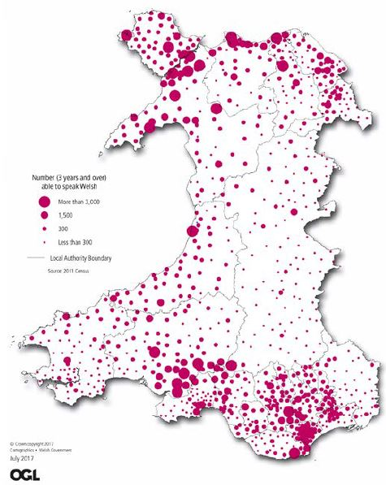
Figure 2.1: Number (3 years and over) able to speak Welsh (Welsh Government, 2017: 10)

Languages of schooling

Which foreign languages do they teach in their primary school curriculum (up to 12/13 years of age)?
In the case of each language, indicate which is L1, L2 and L3 (languages of the school).
Are all the languages compulsory? Is there choice? If so, are guiding parameters given?

The Welsh School System
The structure of the Welsh school system is as follows:
Children’s Ages | Stage | Year Groups
3-7 | Foundation Stage | Nursery, Reception, Years 1-2
7-11 | Key Stage 2 | Years 3-6
11-14 | Key Stage 3 | Years 7-9
14-16 | Key Stage 4 | Years 10-11

English, Welsh and modern languages
English, Welsh and optional modern languages feature in primary schools in Wales. English and Welsh are compulsory from Foundation Stage. Modern languages are optional at Key Stage 2 and compulsory from Key Stage 3.
The place of each language in schools in Wales is determined by each school’s medium of instruction. Schools in Wales can be one of three types:
(1) English-medium schools where English is the language of instruction and Welsh is taught as a second language. At Foundation Stage, Welsh Language Development forms one of the eight areas of learning. English language learning in these schools is outlined in the Language, Literacy and Communication Skills area of learning. At Key Stage 2-4, The Welsh Second Language Curriculum is used.
In English-medium schools, language positioning is as follows: English (L1), Welsh (L2) and optional modern language (L3).
(2) Welsh-medium schools where Welsh is the language of instruction and English is taught as a second language. At Foundation Stage, learning follows the Language, Literacy and Communication Skills area of learning for English and Welsh. There are seven areas of learning in Welsh-medium schools. At Key Stage 2-4, English and Welsh L1 Curriculums are used.
In Welsh-medium schools, language positioning is as follows: Welsh (L1), English (L2) and optional modern language (L3).
(3) Dual stream/bilingual schools offer an English-medium and Welsh-medium stream. The English-medium stream follows the same curriculum as English-medium schools. In these instances, language positioning is as follows: English (L1), Welsh (L2) and optional modern language (L3).
The Welsh-medium stream follows the same curriculum as Welsh-medium schools. In these instances, language positioning is as follows: Welsh (L1), English (L2) and optional modern language (L3).

Modern languages at Key Stage 2
Modern Languages take a non-statutory position at Key Stage 2, where schools can choose to offer a modern language. Evidence from a small-scale survey of 190 schools suggested that ca. 28% of schools offered a modern language at this stage (Tinsley and Board, 2016). It was reported that primary language teaching at Key Stage 2 tended to be on a more informal basis taking the form of extracurricular clubs or informal classes (Tinsley and Board, 2016: 12) (see Section 2 for more details) or else offered in Year 6 in preparation for students moving on to modern language learning at Key Stage 3. French was noted as being the most common language taught, followed by Spanish and German (Tinsley and Board, 2016). Schools reported using existing staff expertise to facilitate modern language learning or sometimes, accessed expertise from a local secondary school (Tinsley and Board, 2016).

Modern languages at Key Stage 3
Modern languages form a compulsory component of the National Curriculum at Key Stage 3.
Schools can choose which modern language to offer children. Schools may offer European or world languages such as Arabic, French, German, Japanese, Mandarin, Russian, Spanish, Urdu. Schools may choose which languages they teach taking into account demand, interest, progression routes and resources (Welsh Assembly Government, 2008: 11).

A new curriculum for Wales
A new Curriculum for Wales is under development with its implementation in schools due by 2022. A draft version was made available in April 2019, entitled Draft Curriculum for Wales 2022, to allow schools and stakeholders to provide feedback. The Draft Curriculum for Wales 2022 offers statutory guidance at a national level, with schools due to design their own curriculum around this guidance (Welsh Government, 2019).
The new curriculum will comprise six new Areas of Learning and Experience (AoLE), as follows:
- Expressive arts
- Health and well-being
- Humanities (including RE which should remain compulsory to age 16)
- Languages, literacy and communication (including Welsh, which should remain compulsory to age 16, and international languages)
- Mathematics and numeracy
- Science and technology.
(Welsh Government, 2018).
The Languages, literacy and communications area will ensure that every learner has an entitlement to learn Welsh, English and an International Language at primary school (Welsh Government, 2017a: 14). Schools will also be tasked with encouraging learners to maintain any other languages in their environment, such as alternative home languages.

Language policies and national impetus for languages

Why has the jurisdiction chosen to include a third language (rationale, policy drivers)?
In what year did this development happen?

Modern languages have been part of the curriculum in Wales at Key Stage 3 for some time. More recent developments which have driven the forthcoming shift to an earlier start for international languages at Key Stage 2 are outlined below.

Language Trends Wales (2015, 2016, 2017, 2018)
An annual series of reports published by the British Council which examine language learning in secondary schools in Wales have reported a gradual decline in the numbers of students taking up languages at GCSE and A-Level. In 2016, this series of research also surveyed primary schools to ascertain the uptake of modern languages as well as teachers’ and principals’ perspectives on the earlier start for languages (Tinsley and Board, 2016).
Tinsley (2018) noted that an earlier start for language learning at primary level (through the forthcoming new Curriculum) should have a backwash effect, with an increased number of learners continuing on their interest in modern/international languages from primary level to GCSE and A-Level.

Global Futures: A plan to improve and promote modern foreign languages in Wales 2015-2020 (Welsh Government, 2015)
The Global Futures plan outlines the Welsh Government’s aims to raise the profile of modern foreign language in Wales… (Welsh Government, 2015: 2).
The five year plan outlines its aims as follows (Welsh Government, 2015: 3):
- To increase the number of young people choosing to study modern foreign language subjects at Level 2 (GCSE level or equivalent), at Level 3 (A level or equivalent) and at higher education level,
- To improve the teaching and learning experience of modern foreign languages for learners from 7-19, with the intention of building towards a ‘bilingual plus 1’ system where the formal teaching of an MFL will begin at Year 5 [age 9-10] as part of the Languages, Literacy and Communication Area of Learning and Experience,
- To maintain and improve on the attainment levels presently being achieved in modern foreign languages subjects.

A new Curriculum for Wales
As mentioned above, the new curriculum will introduce international languages to primary schools from Year 5. The Languages, literacy and communication Area of Learning and Experience conceptualises all language teaching as integrated and highlights the synergies between the teaching of Welsh, English, English as an Additional Language and International Languages (Tinsley, 2018).

Teaching and learning: The modern language at primary level

Details of the current school curriculum are discussed under the subheadings that follow within this section. Where information is available, details of the draft new Curriculum will also be described.

Curriculum aims and structure

What are the curriculum aims for the third language?
How is the curriculum presented for this third language—levels of specificity; structure—strands; learning outcomes/objectives?

Each curriculum area within the current school curriculum comprises a (1) Programme of Study, (2) Guidance and (3) Skills and Learning. Common assessment guidelines are provided for all areas.
The programme of study outlines the skills and range of learning experiences which can be used to develop the skills outlined. It also describes attainment targets for students and eight levels of student performance according to descriptions of increasing difficulty.
The guidance document is for use by teachers for planning. It also contains profiles of learning so teachers can gauge their own students’ achievement against sample profiles. French, German and Spanish are the languages used within the samples of attainment targets for modern languages.
The skills and learning document outlines how areas of any one curriculum area supports the skills and learning of (1) Developing thinking, (2) Developing Communication, (3) Developing ICT and (4) Developing Number, as well as promoting (i) Curriculum Cymreig (Welsh) and Wales, Europe and the world, (ii) personal and social education and (iii) careers and the world of work.

Current School Curriculum: Key Stage 2 Framework (Welsh Government, 2008)
The optional Key Stage 2 modern language framework aims to support schools already delivering modern foreign languages at Key Stage 2 and to encourage other schools to incorporate a modern foreign language into the curriculum (Welsh Government, 2008: 27).
The structure of the framework reflects the programme of study at Key Stage 3 and outlines the skills – oracy, reading and writing – that can be developed and the range of activities and settings in which to develop those skills in the primary context (Welsh Government, 2008: 27). Further learning objectives are outlined under each of the skills. These begin with “Pupils should have opportunities to…”. The range includes (1) intercultural understanding, (2) language learning strategies and (3) activities and contexts. Figure 2.2 provides an excerpt from the Key Stage 2 Framework.
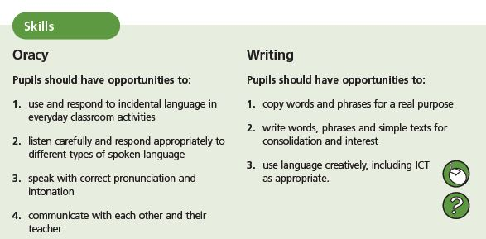
Figure 2.2 Excerpt from Key Stage 2 Non-Statutory Framework (Welsh Government, 2008: 28)

Current School Curriculum: Key Stage 3 (Welsh Government, 2008)
The curriculum layout for Key Stage 3 mirrors the format for Key Stage 2. Learning objectives within the skills are more extensive.

Draft Curriculum for Wales 2022: Languages, Literacy and Communication AoLE (Welsh Government, 2017b; 2019a)
The draft curriculum for Wales comprises (1) guide to the curriculum for Wales, (2) guidance for each of the six areas of Learning and Experience, and (3) assessment guidance (Welsh Government, 2019). Each area of Learning and Experience describes how it supports the four purposes of the curriculum. These are defined as developing children and young people as:
- Ambitious, capable learners, ready to learn throughout their lives
- Enterprising, creative contributors, ready to play a full part in life and work
- Ethical, informed citizens of Wales and the world
- Healthy, confident individuals, ready to lead fulfilling lives as valued members of society
(Welsh Government, 2019: 6).
Statements of “What Matters” in learning and their associated principles of progression with achievement outcomes provide the basis of the curriculum guidance. Titles for the strands of “What Matters” are described in the Draft Curriculum for Wales 2022 (Welsh Government, 2019a: 6-7) as follows:
- Learning about identity and culture through languages prepares us to be citizens of Wales and the world
- Learners who listen and read effectively are prepared to learn through their lives
- Learners who speak and write effectively are prepared to play a full part in life and work
- Literature fires imagination and inspires creativity.

Progression steps are provided at five intervals, corresponding to expected outcomes for children at ages 5, 8, 11, 14 and 16. Achievement outcomes are used to describe the learning outcomes for children through “I have” and “I can” statements (Welsh Government, 2019). Further Experiences, Knowledge and Skills, alongside what Learners need to be able to do, complete the guidance. Figure 2.3 provides an excerpt from the Languages, Literacy and Communication Area of Learning and Experience for What Matters in Identity and Culture at Progression Stage 3.
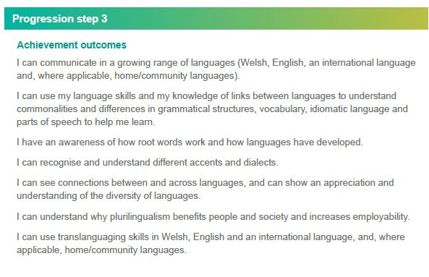
Figure 2.3 Excerpt from AoLE Languages, Literacy and Communication (Welsh Government, 2019a: 21)
A summary of the AoLE design model and format is provided in Appendix 2.

Language integration

How is it integrated in the primary curriculum? (e.g., taught as a separate timetabled subject; as part of a broad languages area; CLIL, extra-curricular; combination of these)?
How many hours does it get per week? And how are these hours fitted into the school timetable (what is sacrificed as a result)?

Current School Curriculum: Key Stage 2 and 3 (Welsh Government, 2008)
For Key Stage 2 and 3, the modern language is taught as a separate subject. However, a cross-curricular approach is espoused in the curriculum and links are to be drawn with Welsh and English where relevant. The modern language curriculum outlines how progression should be sought from one level of the curriculum to another, and across curriculum subjects/areas.
Evidence from Tinsley and Board (2016) outlined that the majority of optional language learning at Key Stage 2 tended to be an extra-curricular activity or a short language programme (systematic teaching for Year 6 students) to aid transition into Key Stage 3. Other types of modern language exposure were reported to be informal exposure and incidental learning embedded in schemes of work. Figure 2.4 below provides an excerpt of the types of language course offered by primary schools.
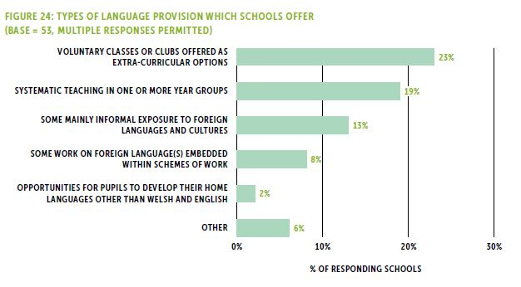
Figure 2.4 Types of language provision which schools offer (n=53) (Tinsley and Board, 2016: 74)
No set time is recommended for optional language learning within the Key Stage 2 Framework but schools can remain flexible to use [time] according to their own resources and time available with any year group (Welsh Government, 2008: 27). At Key Stage 3, a minimum of two hours per week is recommended by the Welsh Inspectorate (Estyn) (Tinsley, 2018: 8).

Draft Curriculum for Wales 2022: Languages, Literacy and Communication AoLE (Welsh Government, 2017b; 2019a)
The Draft Curriculum AoLE of Languages, Literacy and Communication is an integrated language curriculum which draws on all languages in learners’ environment. Welsh and English are referred to in Progression Steps 1 and 2, with international languages added in from Progression Step 3 onwards. One set of achievement outcomes is outlined for Welsh- and English-medium schools, with specific references being made to Welsh-medium achievement outcomes in some cases (see Figure 2.5). A separate set of achievement outcomes is provided for Welsh language learning in English-medium settings/schools/streams. English, Welsh and International languages are accounted for in an integrated way across achievement outcome listings.
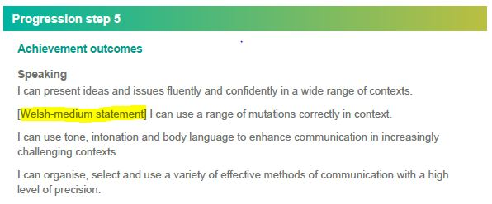
Figure 2.5: Achievement outcomes account for all languages. Specific outcomes are delineated for Welsh-medium schools, with a separate listing of outcomes for Welsh language learning in English medium settings/schools/streams (Welsh Government, 2019a)
No curriculum time has been noted in documentation relating to the draft curriculum.

The language teacher

Who teaches the foreign language L3?
How is their capacity to teach it supported and encouraged? (i.e. are there trained teachers within the school or does the school bring in external teachers)?
What kind of training is given? Is it done in Initial Teacher Education or through CPD, or both?

Current School Curriculum: Key Stage 2 (Welsh Government, 2008)
Tinsley and Board (2016) reported how the language teacher at Key Stage 2 tended to be an existing primary school teacher who had language expertise, or how the school accessed expertise from their local secondary school. Figure 2.6 below outlines the other types of teachers accessed for primary modern language learning, such as specialist teachers and peripatetic specialist teachers (Tinsley and Board, 2106: 75).
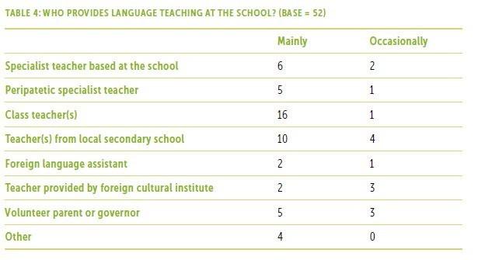
Figure 2.6 Sources of language teachers for primary modern language teaching (Tinsley and Board, 2106: 75)

Current School Curriculum: Key Stage 3 (Welsh Government, 2008)
Specialist language teachers are employed to support modern language learning at Key Stage 3.

Draft Curriculum for Wales 2022: Languages, Literacy and Communication AoLE (Welsh Government, 2017b; 2019a)
No particular details have been provided as yet as to who will be tasked with teaching primary modern languages within the new curriculum. However, reviews of initial teacher education programmes and Continuing Professional Development programmes for teachers in Wales point to more targeted recruitment of high calibre candidates into the teaching profession (Tabberer, 2013). It was also noted that priority incentives will be available for new eligible students starting postgraduate ITT courses in the 2013/14 academic year in mathematics, physics, chemistry, modern foreign languages, Welsh and ICT (Tabberer, 2013: 39).

Language continuity from primary school into secondary school

How are bridges, if any, made between languages taught in primary and in second level (e.g., what if the local post-primary school doesn’t teach that language?)

As noted in Section 1, the current integration of modern languages at primary level is a little ad hoc, with the supply of languages being dependent on the availability of teachers. Where language expertise is sourced from a local secondary school, some continuity in the language being offered will be in place.
In the past, CILT Cymru established a series of pilot projects where clusters of local secondary and primary schools came together to support primary modern language learning (Tinsley and Board, 2016). Teachers shared resources and expertise in common languages. Teachers reported how they had an effective programme across our schools cluster (Tinsley and Board, 2016: 78). Unfortunately, CILT Cymru support became limited due to budgetary cutbacks and schools clusters were no longer supported.

Language assessment

What is assessed in the L3 foreign language curriculum and how?

Current School Curriculum: Key Stage 3 (Welsh Government, 2008)

For each subject, in each of the key stages …, programmes of study set out what pupils should be taught and, for Key Stages 2 and 3, attainment targets set out the expected standards of pupils’ performance. At the end of Key Stages 2 and 3, standards of pupils’ performance are set out in eight level descriptions of increasing difficulty, with an additional description above Level 8 to help teachers in differentiating Exceptional Performance.
At Key Stage 4, external qualifications are the main means of assessing attainment in the national curriculum. The Welsh Assembly Government publishes annually the list of qualifications that, under Section 96 of the Learning and Skills Act 2000, are approved for use with pupils of compulsory school age (Welsh Government, 2008: 2).
The Guidance for Modern Languages at Key Stage 2-4 (Welsh Government, 2008) outlines the many types of assessment which should include ongoing formative assessment—Assessment for Learning, formative feedback, student self-assessment and peer assessment, Assessment of Learning through statutory teacher recording and assessment. A series of assessment guidelines form part of the curriculum.
There is no statutory requirement to assess modern foreign languages at Key Stage 2, however if pupils have been studying a modern foreign language, both primary teachers and secondary teachers will want to have some record and/or evidence of the skills that pupils have acquired, whatever the language. Teachers can use the lower level descriptions for Key Stage 3 to describe their pupils’ attainment or they may wish to adapt them for primary pupils. (Welsh Government, 2008: 30)

Draft Curriculum for Wales 2022: Assessment proposals to inform the development of statutory guidance (Welsh Government, 2019)
As mentioned previously, the draft curriculum for Wales comprises an overview document, guidance for each area of the six areas of learning and experience and assessment guidance. The assessment guidance document outlines how the progression continuum outlined in each of the six areas of learning and experience are to be used to gauge how students are progressing along the continuum and for planning for further progress along the continuum. The Welsh Government (2019b) are moving away from publishing assessment results as a form of accountability at national level (p. 4) and returning to the use of assessment as a classroom-based form of monitoring and planning (Welsh Government, 2019b).
Six key principles for the formulation of assessment guidance are mapped out in the draft assessment guidance document for consultation (Welsh Government, 2019b). The principles centre around placing the student and their progress at the centre of formative, student-focused assessment which employs a variety of assessment techniques (see Figure 2.7 below for more details).
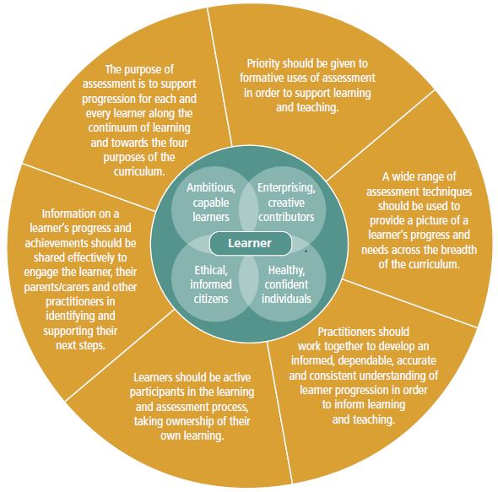
Figure 2.7 Key principles for the formation of assessment guidance (Welsh Government, 2019b: 5)

Special Educational Needs / Additional Learning Needs

In Wales, Additional Learning Needs (ALN) is the term used to encompass children who have special educational needs (SEN) as well as additional needs relating to health, attendance (e.g. long absences or inconsistent attendance), challenging home life or life circumstance (e.g. young parent or pregnancy; employment in performing arts). Guidelines are provided to governing bodies outlining their expected provision for children with ALN.
The Special Educational Needs Code of Practice for Wales (Welsh Assembly Government, 2004) outlines the distinct arrangements, structures and legislation (Welsh Assembly Government, 2004: iii) in place for children with ALN. Local Education Authorities (LEAs) are tasked with supporting children with ALN.
Under the Education Act 1996 and the Welsh Language Act 1993 (for children older than 16 years), all children have the right to access support in English or Welsh. It is noted that the home language of children should be ascertained at an early stage to ensure that all communication and support are provided in their preferred choice of language—Welsh or English (p. 3).
Information is made available in a range of appropriate languages and variety of media for families who speak English and/or Welsh as an additional language (Welsh Assembly Government, 200: 16). Provisions are provided to ensure that statements, annual reviews and Individual Education Plans are linguistically accessible to children and their parents. These provisions include the translation of documents in home languages, use of interpreters for meetings and a language support teacher being available to the child and family (Welsh Assembly Government, 200: 124).
Where a child’s home language is neither English nor Welsh, articles 5.15 and 5.16 provide directions on ensuring that the child’s competence in Welsh or English should not be an indicator of SEN, but equally that for children who make slow progress in their language learning, it should not be assumed that their language status is the only reason for their rate of progress (Welsh Assembly Government, 200: 45/6). Schools are advised to examine children’s progress in other curriculum areas to ascertain whether a child requires additional support. In addition, a full assessment should be made of the exposure they have had in the past to each of the languages they speak, the use they make of them currently and their proficiency in them (Welsh Assembly Government, 200: 46).
A graduated response that encompasses an array of strategies is recommended for those children who do have ALN, in line with their needs on a broad spectrum of abilities and needs (Welsh Assembly Government, 200: 47). The National Curriculum is a statutory requirement for all children, and it is advised that children should be assisted in accessing the curriculum to the full degree of their ability.
Children’s speech, language and communication skills and needs are considered a priority. It is noted that children who experience challenges in this regard, may require some or all of the following:
- flexible teaching arrangements
- help in acquiring, comprehending and using language
- help in articulation
- help in acquiring literacy skills
- help in using augmentative and alternative means of communication
- help to use different means of communication confidently and competently for a range of purposes including formal situations
- help in organising and coordinating oral and written language
- support to compensate for the impact of a communication difficulty on learning in English or Welsh as an additional language
- help in expressing, comprehending and using their own language, where English or Welsh is not the first language.
(Welsh Assembly Government, 200: 85)
Temporary Disapplication can be applied in cases where children cannot fully participate and benefit from the National Curriculum. It is noted that disapplication should be limited to those aspects of the National Curriculum that are inappropriate for the pupil (Welsh Assembly Government, 200: 149).
No particular references are made to modern foreign language learning within the Code of Practice (Welsh Assembly Government, 200). Under the provisions of graduated response, the statutory requirement to access the curriculum and temporary disapplication, it is assumed that all children would be supported in accessing modern foreign language teaching and learning to the best of their abilities.

  - 3. Canada (British Columbia (BC))

Policy and context

Language context

Canada
Canada has a rich linguistic makeup with over 200 languages reported to be spoken in the home (Canada Statistics, 2011). These include English, French, Aboriginal languages and immigrant languages.
Canada has two official languages, English and French which are recognised through the Official Languages Act (1969) (Government of Canada, 2019) and the Constitution. Eight of the ten provinces, including British Columbia, have English as their official language. In contrast, Quebec has French as its official language and New Brunswick has English and French as its official languages. Canada’s three territories each have more than one official language, as follows:
- Northwest Territories: English, French, Chipewyan, Cree, North Slavey, South Slavey, Gwich’in, Inuinnaqtun, Inuktitut, Inuvialuktun, and Tłįchǫ/Dogrib.
- Yukon: English and French
- Nunavut: English, French, Inuinnaqtun and Inuktitut.
All citizens have a right to English and/or French language services regardless of the province in which they reside. As such, different Ministries of Education need to make provision for students’ L1 within their school systems regardless of the official language(s) of the province or territory.
Indigenous/Aboriginal languages also form part of the linguistic tapestry of Canada. The latest data from 2016 reported that there are 70 Aboriginal languages in Canada, including Algonquian, Inuit and Athapaskan language families (Statistics Canada, 2019). Indigenous language prevalence suffered greatly in the past, largely through the residential school system where Aboriginal children were not permitted to speak their Aboriginal mother tongues (Statistics Canada, 2019: unpaginated). Data gathered in 2016 showed a 3.1% increase in the numbers of people who could speak an Aboriginal language in comparison to figures gathered in 2006 (Statistics Canada, 2019).
A new bill—“An Act Respecting Indigenous Languages”—has just been tabled in Canada for its first reading on 15 February 2019. Its aim is to include Indigenous languages alongside other recognised languages in the Canadian constitution as well as support and promote the use of Indigenous languages and support the efforts of Indigenous peoples to reclaim, revitalize, maintain and strengthen Indigenous languages (Parliament of Canada, 2019: 4).
Immigrant languages form another thread in Canada’s linguistic tapestry. Asian (56%) and European languages (40%) make up the largest proportion of languages spoken by Canada’s immigrant community (Statistics Canada, 2018). The most commonly reported immigrant languages, in rank order, are Punjabi, Chinese, Spanish, Italian and German (Statistics Canada, 2018).

British Columbia
The focus of the discussion within the Canadian jurisdiction is on the province of British Columbia. British Columbia is in western Canada with Victoria as its capital city, and Vancouver another major city. Figure 3.1 below shows the percentage of speakers of each of the main languages in this jurisdiction.
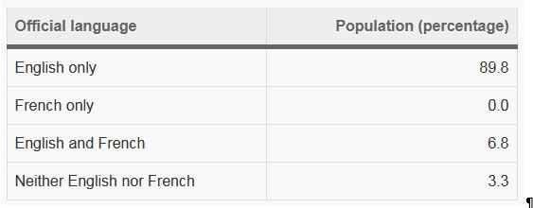
Figure 3.1 Population by knowledge of official languages, British Columbia (Statistics Canada, 2012)
In British Columbia, the proportions of people speaking the most commonly reported immigrant languages varies slightly from the figures for all of Canada. The rank order in British Columbia is Punjabi, Cantonese, Chinese, Mandarin, German, Tagalog and Korean (Statistics Canada, 2012).

Languages of schooling

Which foreign languages do they teach in their primary school curriculum (up to 12/13 years of age)?
In the case of each language, indicate which is L1, L2 and L3 (languages of the school).
Are all the languages compulsory? Is there choice? If so, are guiding parameters given?

The British Columbian School System
The structure of the school system in British Columbia is as follows:
Age | Grade | Stage
5 | Kindergarten (K) | Kindergarten
6-11 | 1-6 | Elementary School
12-13 | 7-8 | Middle School
14-17 | 9-12 | High School
Note: Depending on numbers of students, middle school grades can be absorbed into elementary school or high school.

English, French and Second Languages
English is the official language of schooling for students in British Columbia. Francophone students are entitled to receive instruction through French. French immersion education is also available for French L2 speakers. A second language (L2) must be offered from Grades 5 to 8 (from age 10-13). The languages on offer are: American Sign Language, Core French, German, Italian, Japanese, Korean, Mandarin, Punjabi and Spanish. Boards of education decide which second languages will be offered. Core French will be the language offered if the board does not offer an alternative (British Columbia Ministry of Education, 2004).
Depending on the school type, English and French are taught as first languages (L1) and all other languages are taught as second languages (L2) (British Columbia Ministry of Education, 2004). Students in all schools are expected to gain proficiency in English (British Columbia Ministry of Education, 2004). Schools can be one of three types:
(1) Francophone schools which are attended by students whose L1 is French. The language of instruction is French and English is taught as a second language. A modern language is taught during Grades 5-8.
In Francophone schools, the language positioning is as follows: French L1, English L2 and for Grades 5-8, a language other than French (L3).
(2) Immersion schools offer French as the language of instruction for French L2 speakers.
In immersion settings, language positioning is as follows: French (L1), English (L2) (although the English Language Arts curriculum used is the same as in English language schools) and for Grades 5-8, a language other than French (L3).
(3) English language schools use English as the medium of instruction apart from language classes. A second language must be offered from Grades 5-8. Core French must be offered as the L2 if the school does not have the capacity to teach any other language.
In English-medium schools, language positioning is as follows: English (L1), and for Grades 5-8, a language other than English (L2) (British Columbia Ministry of Education, 2016).
The Language Education Act also specifies that all students should have opportunities to learn Aboriginal language (British Columbia Ministry of Education, 2004), especially those with Aboriginal ancestry. The new curriculum in British Columbia fully integrates areas of Aboriginal language and culture where relevant (see Section 3 for more details of the new curriculum).
Where there is no curriculum in place for a language (international or Aboriginal) for which there is a demand within a school district, a language template development package can be accessed at the BC Ministry of Education’s website. This package provides a template to develop a new language education curriculum, and define what is expected in locally developed programs that will be submitted for provincial approval (British Columbia Ministry of Education, 2019). Once approved, new language curriculums are made available on the Ministry of Education’s website for access by other districts.
Additional international language curriculums available for use from this process included Arabic, Croatian, Italian, Korean and Russian. 17 indigenous languages such as Secwepemctsin (Shuswap Language) and Heiltsuk were also available.

A new curriculum in British Columbia
The curriculum is British Columbia is currently being revised. The curriculum for Kindergarten to Stage 9 (K-9) was implemented in 2016/17 following a three year trial and consultation process. The curriculum for Grades 10-12 was implemented in 2018/19 with Grades 11-12 remaining optional for trial use. The final work on the curriculum for Grades 11 and 12 will be completed and implemented by 2019/20.
The curriculum is based on a Know-Do-Understand curriculum model (see Figure 3.2) which supports a concept-based competency-driven approach to learning (British Columbia Ministry of Education, 2015: 3). ‘Know’ corresponds to the curriculum content, ‘Do’ corresponds to the curriculum competencies and ‘Understand’ corresponds to the Big Ideas outlined in the curriculum.
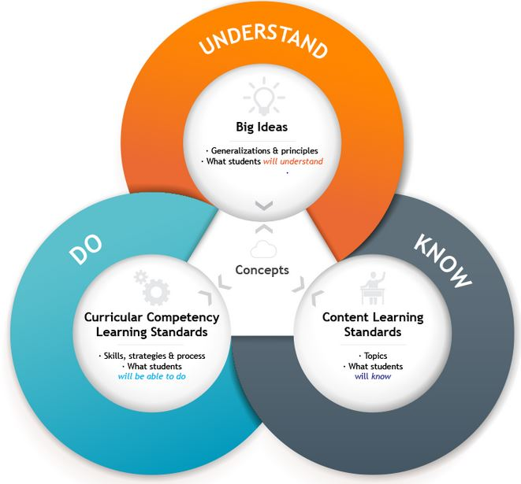
Figure 3.2 Know-Do-Understand Curriculum Model (British Columbia Ministry of Education, 2015: 3)
The areas and subjects of the new curriculum are:
- Applied Design, Skills, and Technologies  - Arts Education  - Career Education  - English Language Arts  - Français Langue Premiere  - French Immersion Language Arts  - Languages | - Mathematics  - Physical and Health Education  - Science  - Social Studies  - Additional Offerings (Work Experience and Youth Work in Trades)

Elements of Aboriginal language and culture are embedded throughout all subjects in the new curriculum and are evident in the rationale statements, goals, learning standards, and some of the elaborations (British Columbia Ministry of Education, 2015: 8). References to ‘First Peoples’ throughout curriculums correspond to elements of learning in Aboriginal language and culture.
Section 3 below examines the new curriculum for second languages.

Language policies and national impetus for languages

Why has the jurisdiction chosen to include a third language (rationale, policy drivers)?
In what year did this development happen?

Canada has had a long history of debate surrounding languages and language learning, with the linguistic makeup comprising English, French, indigenous languages and immigrant languages.
The Official Languages Act (1969, 1988) (Government of Canada, 2019) gave equal status to French and English. Indigenous languages are designated as national languages in some territories in Canada and their status may be further promoted with the new Act Respecting Indigenous Languages passing through government in the coming months. Immigrant languages already appear in the list of language subjects for which there is an established curriculum in British Columbia (e.g. Punjabi and Mandarin). A second language (be it French or a modern language, depending on the language of instruction of the school) is a compulsory subject for Grades 5 to 8 (age 10-13).

Teaching and learning: The modern language at primary level

The details outlined in the following sections all relate to the new curriculum in British Columbia. The new curriculum for Grades 5 to 8 was implemented in 2016/17.

Curriculum aims and structure

What are the curriculum aims for the third language?
How is the curriculum presented for this third language—levels of specificity; structure—strands; learning outcomes/objectives?
The goals and rationale of each language learning curriculum are set out individually but correspond to one another. The German curriculum was used to provide details outlined below. The Core French curriculum was also checked to ensure details aligned in both curriculums.
The goals for German language learning were outlined as follows:
- use German as a form of self-expression
- communicate with purpose and confidence in German
- explore a variety of German-language texts
- appreciate the interconnectedness of language and culture
- expand their understanding and appreciation of other cultures
- deepen their understanding of their first language(s) and of their own cultural identity
- understand the educational, travel, and career opportunities that acquiring an additional language offers
- recognize the benefits of language-learning.
(British Columbia Ministry of Education, 2019a).

The language curriculums encourage an interconnected view of the elements of language learning, rather than each one being learnt individually. The elements of language learning referred to are (1) Reading, writing, listening, speaking, and interacting, (2) Grammar, (3) Culture and (4) Language-learning strategies.
Three core competencies traverse all curriculum documents in the new curriculum. They are listed as (1) Communication, (2) Thinking, and (3) Personal and Social.
The curriculum description for languages (and other subject areas) comprises (1) Big Ideas, (2) Curricular Competencies, (3) Content, and (4) Elaborations.
Big ideas are described as generalizations and principles discovered through experiencing the Content and Curricular Competencies of the Curriculum…Big Ideas represent the ‘aha!’ and the ‘so what?’ of the curriculum (British Columbia Ministry of Education, 2018) which lead to deeper learning. Progression is seen across the big ideas from one grade to the next, as understanding and knowledge of the ideas extend.
Curricular Competencies are grouped under the core competencies headings and describe what students should be able to do with their content knowledge (British Columbia Ministry of Education, 2018). Again, the curricular competencies progress in scope and depth across the grades, as the big ideas do. The content knowledge is described alongside the competencies. Figure 3.3 below provides an excerpt from the German second language curriculum which shows the listing of curricular competencies and the interplay of the curriculum elements described.
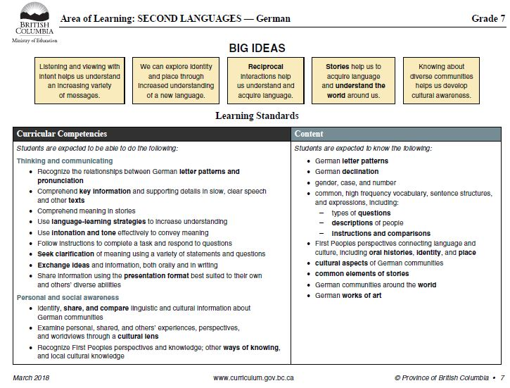
Figure 3.3 Excerpt from the German Second Language Curriculum for Grade 7 (British Columbia Ministry of Education, 2018)
Elaborations are provided to extend the detail of the curricular competencies and content by including definitions and examples. They do not represent an exhaustive list of all of the content which is to be covered.
The language curriculums recognise that language learning in any one language also builds transferrable skills and linguistic ability for all learning, including other languages. These skills are listed as:
- improved overall cognitive development and creative thinking
- the development of cultural awareness and understanding
- a deepened understanding of their own identity
- an enhanced understanding of their first language
- language-learning strategies that can be transferred to additional languages.
(British Columbia Ministry of Education, 2018).

Language integration

How is it integrated in the primary curriculum? (e.g., taught as a separate timetabled subject; as part of a broad languages area; CLIL, extra-curricular; combination of these)?
How many hours does it get per week? And how are these hours fitted into the school timetable (what is sacrificed as a result)?

Language is taught during the school day, usually by a generalist teacher but sometimes by a specialist teacher. The curriculum emphasises the importance of the target language being used as the language of instruction.
Language curriculums note that students may learn their second language in many different school contexts. The Core French curriculum describes how the amount of language time to be spent learning Core French will differ from school to school within the environs of these varied contexts.
Carr (2007) reported on the amount of time recommended in the National Core French Study (NCFS) being 40 minutes per day, a duration which British Columbia was unable to meet. Instead, teachers reported varying amounts of time being spent on Core French, ranging from 80 minutes per week in Grades 5 to 7 and 185 minutes per week in Grade 8 (Carr, 2007: 10). Carr (2007) recommends an optimum time of 100 minutes in Grades 5 to 7 and 185 minutes in Grade 8 to achieve ideal proficiency in Core French.

The language teacher

Who teaches the foreign language L3? How is their capacity to teach it supported and encouraged? (i.e. are there trained teachers within the school or does the school bring in external teachers)?
What kind of training is given? Is it done in Initial Teacher Education or through CPD, or both?

The diverse contexts in schools outlined in the curriculum highlights how the language teacher can range from beginning generalists to highly experienced specialists (British Columbia Ministry of Education, 2018). The section on Diverse Contexts describes how the curriculum is flexible enough to cater to all levels of language learning regardless of the ability of the teacher.
Carr (2007) noted that colleges offering initial teacher education for generalist teachers tended to have a language elective. However, trainee teachers reported that their timetable did not provide any openings for elective classes (Carr, 2007). This resulted in the majority of trainee teachers graduating without any
specialized training in second language methodology … therefore, many teacher candidates, with a background of Grade 11 French or lower, become certified generalist teachers with methods coursework in all subject areas except French. (Carr, 2007: 6)

Language continuity from primary school into secondary school

How are bridges, if any, made between languages taught in primary and in second level (e.g., what if the local post-primary school doesn’t teach that language?)

The Language Education Policy outlines the Second Language Requirements for Grades 5 to 8 and specifies that Boards of education should attempt to coordinate the second languages offered to ensure there is continuity of instruction in the same language for a student in Grades 5 to 8 (British Columbia Ministry of Education, 2004).

Language assessment
What is assessed in the L3 foreign language curriculum and how?

As the new curriculum is still under development, some areas of the assessment guidelines are as yet, incomplete. Specific details for second languages are unavailable. However, details of the emerging assessment framework are outlined below (with an assessment resource pack for second languages still required), along with the established optional performance standards (for English, Francophone French and Immersion French) which were developed around the previous curriculum.

Classroom Assessment
A new framework for classroom assessment is under development. The framework focuses on using the Curricular Competencies as a basis for assessment. Classroom assessment resource packages have been completed for English Language Arts, Maths, Science and Social Studies thus far. Further work is to be completed in developing assessment resource packages for other areas of the curriculum, including languages.
The assessment framework outlines how the curricular competencies alongside five teacher-chosen cross curricular criteria categories (e.g. questioning, analysing or reflecting) and subject specific criteria can be used to make judgements on students’ levels of ability.
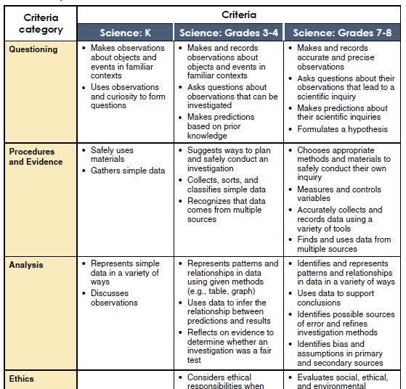
Figure 3.4 Sample Criteria from Science (British Columbia Ministry of Education, 2019b: 9)

Once the curricular categories and criteria have been established for the subject, these may be used for a variety of different assessment applications.

Performance Standards for English, French Francophone and French Immersion
British Columbia has developed a set of optional Performance Standards for Reading and Writing (among other key areas) in English, Francophone French and Immersion French. They have not yet been updated to align to the new curriculum. The standards outline how, Together, curriculum and performance standards describe what students are expected to know and the levels they should achieve (British Columbia Ministry of Education, 2009: 10).
The Performance Standards describe levels of achievement in key areas of learning (British Columbia Ministry of Education, 2009: 10). The performance standards guidelines outline how they can be used in Assessment for Learning (formative assessment), Assessment as Learning (self-assessment) and Assessment of Learning (summative assessment), as well as planning (British Columbia Ministry of Education, 2009).
They are organised into four levels of performance around the learning outcomes in the key areas of focus. The four levels are (a) Not yet within expectations, (b) Meets expectations (minimal level), (c) Fully meets expectations and (d) Exceeds expectations (British Columbia Ministry of Education, 2009). Aspects of learning in the specific performance standards (e.g. English Reading) are listed alongside the four levels in a grid-like table. As an example, aspects for English reading are (a) Strategies, (b) Comprehension, and (c) Response and Analysis. Figure 3.4 below shows an excerpt from Performance Standards for English Reading Grade 7.
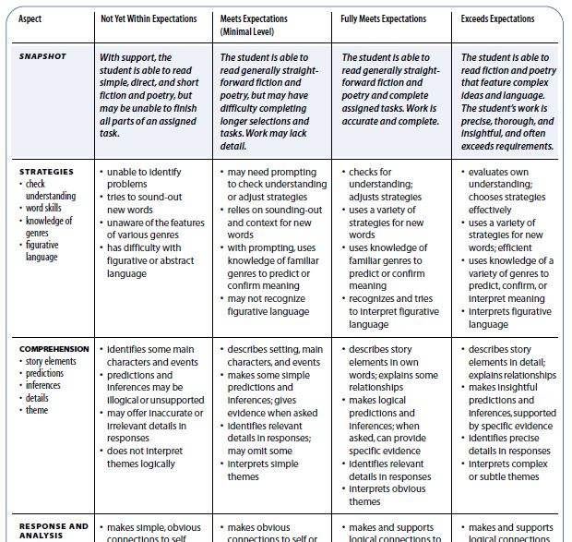
Figure 3.3 Sample Quick Scale Performance Standard for English Reading Grade 7 (British Columbia Ministry of Education, 2009: 209)
Note: The Quick Scales are a shortened version of the scales. A more detailed Rating Scale is also detailed in the performance standards.

Special (Educational) Needs

British Columbia’s Special Needs guidelines are set out at the federal level in a document entitled Special Education Services: A Manual of Policies, Procedures and Guidelines (British Columbia Ministry of Education, 2016a). Local school boards are responsible for using these guidelines in an appropriate way at local level and drafting their own set of local policies and procedures.
Special education services extend to children who have special educational needs, are gifted, have behavioural needs, are physically dependent or have physical disabilities, have visual and hearing impairments and children with Autism Spectrum Disorder.
Students with special needs are expected to achieve some, most, or all provincial curriculum outcomes with special support (British Columbia Ministry of Education, 2016a: 3). Where children require support in achieving these learning outcomes then programme adaptation and/or modification is required (British Columbia Ministry of Education, 2016a: 3/4). These adaptations and modifications are set down in Individual Education Plans for children.
As in Wales, when considering children with different cultural and linguistic backgrounds, authorities are advised to consider the cultural and linguistic requirements of the child first and their impact on learning, before assuming the presence of a disability or impairment (British Columbia Ministry of Education, 2016a: 21). It is recommended that children should be provided with adequate time for second language learning and local adjustment. Where children with English as a second language do have special needs, then teachers are advised to:
- communicate with the parents regarding the student's progress and discuss the factors which may be affecting learning. It is important to obtain a developmental and educational history, and parental perceptions and expectations regarding schooling.
- (when language is a barrier), use an interpreter for communicating with the parent or the student to assist with meetings, assessments and planning sessions. The interpreter should be an adult who is familiar with the language and the culture of the parents and student.
- request testing of the student's vision and hearing, and, if appropriate, a medical examination. Examiners should be alerted to cultural, linguistic or experiential factors.
- be aware of and sensitive to cultural factors that may influence the relationship between the teacher and parents, the developmental and educational expectations as well as parental beliefs about special needs.
(British Columbia Ministry of Education, 2016a: 21/22)
Specialist staff and teachers’ assistants may be employed where children with special needs require them to remain in the mainstream school. Other resources are available for children with special needs as required, including funding for Aboriginal Education and English as a Second Language, or enrolment in Distributed Electronic Learning (DEL) programs (British Columbia Ministry of Education, 2016a: 139).
Specific references to modern languages or specific subjects are not mentioned in the Special Education Services guidelines, but it is assumed, as for Wales, that children with special needs are supported in accessing the curriculum to the best of their abilities and provided with adaptations and modifications to do so. Where children require more personalised educational programmes, then modern language learning may not be accessible to them.

  - 4. Finland

Policy and context

Language context

Finland has two official languages – Finnish and Swedish. The Language Act (Ministry of Justice, 2003) provides for language rights of citizens. Some 87.9% of the population speaks Finnish as a first language and 5.2% speaks Swedish as a first language (Statistics Finland, 2018). Sami is an indigenous language spoken in Lapland by ca. 0.036% of the population (1,992 people) (Statistics Finland, 2018).
Finland has 19 regions, which are in turn divided up into 311 municipalities. Each region is governed by a regional council. Municipalities define linguistic areas (Ministry of Justice, 2003). Some are unilingual (Finnish or Swedish) while others are bilingual. Provision is made under the Language Act for state services to be provided in Finnish and Swedish. Regional bilingual services must also be provided in bilingual municipalities. Unilingual municipalities provide services in the language of the municipality.
Other languages spoken in Finland include Russian, Estonian, Arabic and Somali. Schools can apply for funding to offer education through the migrant language of a student (Finnish National Agency for Education, 2017: 8).
Much value is placed on language proficiency and multilingualism in Finland where multilingualism is referred to as a national language reserve (Ministry of Education and Culture, 2017: 6). Figure 4.1 outlines the percentages of citizens, by age range, who speak 1, 2, 3 or 4 languages. The proportion of citizens, in each age range listed, who know two or more languages is 86%, 84%, 80%, 77% and 62% respectively. Across the age ranges, an average of 19% of citizens know four or more languages (Statistics Finland, 2017).
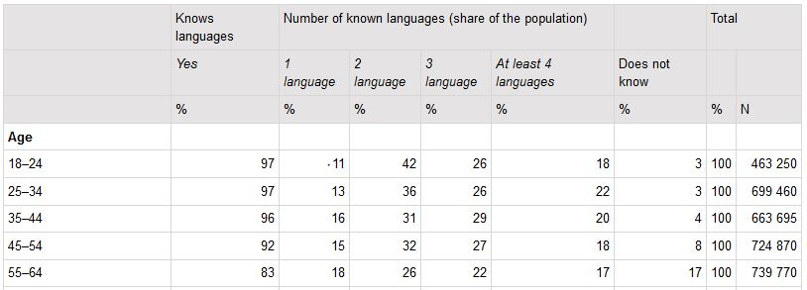
Figure 4.1 Knowledge of foreign languages and number of languages known in 2017 (population aged 18 to 64) (Statistics Finland, 2017)

Languages of schooling

Which foreign languages do they teach in their primary school curriculum (up to 12/13 years of age)?
In the case of each language, indicate which is L1, L2 and L3 (languages of the school).
Are all the languages compulsory? Is there choice? If so, are guiding parameters given?

There is some variation in how, when, and to what extent foreign languages are introduced and taught to pupils in Finnish basic education in different schools. (Ministry of Education and Culture, 2017).

National Core Curriculum for Basic Education (2014)
Within Curriculum Reform 2016, the Finnish core curriculum for pre-primary and basic education was revised in 2014. Basic education refers to Grades 1-9 and constitutes primary and lower secondary education.
After 2014, local education authorities in municipalities were tasked with developing local curriculums based on the new core curriculum (Halinen, Harmanen and Mattila, 2015). Local authorities and schools are given much autonomy in using the core curriculum as a foundation for the development and customisation of local curriculums. At best the curriculum provides teachers and school communities with tools to build and renew pedagogical practices (Vitikka, Krokfors and Hurmerinta, 2012: 88).
The new local curriculums have been implemented in schools for Grades 1-6 since autumn 2016, with Grade 7 following in 2017, Grade 8 in 2018 and Grade 9 in 2019.
The curriculum format becomes important at this stage of discussion as local education authorities have the scope to add any L2 and/or foreign language to the local curriculum as long as it follows the guidelines set out in the basic core curriculum. Details of ‘local additional’ language options are also outlined in the coming sections.

The Finnish School System
The structure of the Finnish school system is as follows:
 | Grade | Age | Duration (Years)
Early Childhood Education and Care | - | 0-5 | 0-5
Pre-Primary Education | - | 6 | 1
Basic Education: Comprehensive Schools  (Primary and Lower Secondary Education) | 1-9 | 7-16 | 9
Voluntary additional year of basic education | - |  | 1
Matriculation Examination - General Upper Secondary Schools  Or  Vocational Qualifications – Vocational Institutions | - |  | 3
Table 4.1 the Finnish school system (Compiled from Finnish National Agency for Education, 2017: 3)

All citizens in Finland have the right to access education through the medium of Finnish, Swedish, Sami, Roma or sign language (Folktinget, 2019; Ministry of Justice, 2003). The majority of Swedish-medium education is concentrated in the autonomous region of Åland where more than 90% of the population speaks Swedish as a first language. Sami-medium education is predominantly in Sami-speaking areas of Lapland (Finnish National Agency for Education, 2017). The core curriculum also supports educational opportunities for other minority languages through additional funding (Finnish National Agency for Education, 2017).
Linguistic rights in education extend to the language of instruction, language as an educational subject and the language of examination (Ministry of Justice, 2003: 2).

Language Curriculums
The basic core curriculum defines 12 different “mother tongue and literature” curriculums which traverse Grades 1-9, as follows:
- Finnish language and literature (L1)  - Swedish language and literature (L1)  - Sámi language and literature (L1)  - Roma language and literature (L1)  - Sign language and literature (L1)  - Other mother tongue of the pupil (L1) | - Finnish as a second language and literature (L2)  - Swedish as a second language and literature (L2)  - Finnish (L2) for Sámi speakers  - Swedish (L2) for Sámi speakers  - Finnish (L2) for sign language users  - Swedish (L2) for sign language users.
Finnish National Board of Education (2016: 165) (L1/L2 annotations added)

“Other mother tongue of the pupil” (#6 above) indicates the flexibility of the basic core curriculum to allow any L1 language at local level, once chosen by the student’s guardian. In this instance, the L1 is taught during the hours allocated to ‘mother tongue and literature. In addition to these hours, separately funded instruction of the mother tongue of the pupil (Finnish National Board of Education (2016: 165) can also be accessed.
After the “Mother tongue and literature” curriculums, there are four different curriculums for language teaching in Finland—A1, A2, B1 and B2. Two of these, A1 and B1, are compulsory at different grade levels and two are optional, A2 and B2, as outlined in Table 4.2.
Curriculum | Level | Options (dependent on the local education authority, and language choices available to students)
A1 | Advanced | Foreign language (usually English) OR Native level Swedish/Finnish (second national language)
B1 | Intermediate | Native level Swedish/Finnish (second national language) OR Foreign language (if national language studies at A1 level)
A2 | Advanced | Optional / free choice (usually German, French or Russian)
B2 | Intermediate | Optional / free-choice
Table 4.2 Language curriculums and choices in Finnish schools (compiled from Ministry of Education and Culture, 2017)

Optional subjects are subjects which are chosen by the student. The local education provider decides which subjects are to be offered in this manner. At a minimum, a total of nine annual weekly lessons (one annual weekly lesson equals 38 lessons) are allocated to optional subjects during grades 1–9 (Finnish National Board of Education, 2016: 154). A common set of objectives and core content are outlined in the basic core curriculum for all foreign language optional or free-choice curriculums.

Mandatory and optional language learning: Mother Tongue plus Finnish or Swedish and foreign languages
The basic education system provides students with teaching and learning in their mother tongue, a national language and a foreign language (Ministry of Education and Culture & Finnish National Agency for Education, 2018). English has become the dominant foreign language (chosen by 80% of Finns (Ministry of Education and Culture, 2017)), but others are offered. The most frequently learnt foreign languages are English, followed by Swedish/Finnish, then German, French and Russian (Statistics Finland, 2017). More recent initiatives around multilingualism in Finland are attempting to diversify the languages learnt after the two national languages (Ministry of Education and Culture, 2017).
 | Level | Grades | Age | Foreign Language Details
 | Early Childhood Education and Care | - | 0-5 | Optional foreign language sensitivity programmes such as language showers, gamification, playfulness, etc.
 | Pre-Primary Education | - | 6
Basic Education | Primary Education | 1-2 | 7-8 | Optional A1 language learning (directed by an age-appropriate interpretation of the Grade 3-6 curriculum, including language showers)
 |  | 3-6 | 10-12 | Mandatory A1 language  Mandatory B1 language  Optional A2 language
 | Lower Secondary Education | 7-9 | 13-15 | Mandatory B1 language  Optional B2 language
Table 4.3 Language learning according to the Basic Core Curriculum (2014)
(Compiled from Finnish National Board of Education, 2016; Ministry of Education and Culture, 2017; Ministry of Justice, 2003)

The basic core curriculum outlines that students’ “personal study plan” should include
at least one advanced and one intermediate language syllabus. One of these shall be the second national language (Swedish or Finnish) and the other a foreign language or Sámi. Advanced syllabi include A syllabi and native-level syllabi in Swedish and Finnish. B1 syllabi are intermediate syllabi. (Finnish National Board of Education, 2016: 200)

Languages may also be offered as optional and free-choice curriculums, as decided upon by the local education provider.
These language requirements are optional for students in early years, pre-primary and Grades 1-2 and become mandatory at Grade 3 (age 10). However, local educational providers and government key projects may both result in earlier experiences with language learning, as described in the coming sections.
At Early Childhood Education and Care and Pre-Primary Education levels, optional foreign language instruction can begin. Language learning at this level has been described as providing a spark for studying foreign languages (Ministry of Education and Culture, 2017: 12).
Language sensitisation programmes provide the learner with bite-sized amounts of language learning. The focus is on providing opportunities for language and cultural awareness rather than competence models. At this level, language is experienced through games, song and play. Language Showers are also used and are another form of language sensitisation. The Language shower offers only short-term exposure to the foreign language and focuses more on speaking and communication in a foreign language in authentic situations for short periods than content or language learning (Pynnönen, 2013). The focus can be on one or more languages over time.
Since the publication and implementation of the basic core curriculum, the government have initiated a number of Key Projects. One strand of one of these projects is the Government Key Project for Language (Ministry of Education and Culture & Finnish National Agency for Education, 2018). This key project offers subsidies to 95 municipalities and private education institutions to take part in national experiments or pilots around (1) an earlier start in language learning, (2) diversification of languages and (3) creating a positive attitude towards language learning (Ministry of Education and Culture & Finnish National Agency for Education, 2018). The earlier start in language begins at Early Childhood Education and pre-primary level and examines methods of implementing language learning at this stage of learning (e.g. through language showers) and establishing a language path which makes positive beginnings in the early years and spans all levels of education (Ministry of Education and Culture & Finnish National Agency for Education, 2018).
At Grades 1-2, optional A1 syllabus (second national language or foreign language) learning may form part of the local curriculum. The core curriculum outlines instruction in the A syllabus may begin before the third grade. In that case, the instruction follows the core curriculum of the A syllabus, taking the pupils’ age into account (Finnish National Board of Education, 2016: 204).
Initial introductions to languages such as English, Sami or other languages through language showers or CLIL may also begin in Grades 1-2. Some municipalities, particularly larger ones like Helsinki, already introduce a foreign language at Grade 1.
Forthcoming changes announced by the Minister for Education suggest that more formal language learning in the ‘A’ curriculum will commence at an earlier stage at Grade 1. These changes are being trialled through 46 of the 95 key projects with the earlier introduction of A1 or A2 language curriculums to Grade 1 and 2 students (from Autumn 2017)(Ministry of Education and Culture & Finnish National Agency for Education, 2018). More recently, the Minister for Education announced that foreign languages will form part of the basic core curriculum for Grade 1 from 2020 (Suomi, 2018).
At Grades 3-6 the core curriculum introduces one mandatory A (advanced) language learning curriculum, one mandatory B1 (intermediate) language learning curriculum and an optional A2 language (Finnish National Board of Education, 2016). The options outlined in the core curriculum include those listed below.
Second national language curriculums | Foreign language curriculums
- Advanced (A) syllabus in Swedish  - Advanced (A) syllabus in Finnish  - Intermediate (B1) syllabus in Swedish  - Intermediate (B1) syllabus in Finnish  - Native-level Swedish  - Native-level Finnish | - Advanced (A) syllabus in English  - Advanced (A) syllabus a foreign language  - Advanced (A) syllabus in Sámi  - Intermediate (B1) syllabus in a foreign language  - Basic (B2) syllabus in a foreign language  - Basic (B2) syllabus in Sámi  - Basic (B2) syllabus in Latin
(Finnish National Board of Education, 2016: 302).
Local education authorities can also develop other language curriculums than those supplied in the core curriculum. These must be defined according to the generic advanced syllabus in a foreign language and/or intermediate syllabus in a foreign language (Finnish National Board of Education, 2016).

Bilingual and Plurilingual Education
The basic core curriculum supports and promotes the languages and cultures of all students to help reinforce the pupils’ linguistic awareness and metalinguistic skills (Finnish National Board of Education, 2016: 138). The core curriculum encourages the use of all languages known in the classroom through the creation of multilingual teaching situations (Finnish National Board of Education, 2016: 138).
The language of the school is officially defined as the language used to teach the Mother Tongue and Literature curriculum. Other languages may also be used in instruction, as long as students can access the instruction through this language and the language of the school is used at least 50% of the time (Finnish National Board of Education, 2016). These instances are referred to as large-scale bilingual education where at least 25% of the curriculums must be delivered in the target language.
Bilingual education can also be referred to as early immersion if it begins up to or including pre-primary level and the immersion language is the second national language (Finnish or Swedish) or Sami. In these cases, the immersion language is usually not the native language of the students.
Small-scale bilingual education, or language-enriched education can also form part of the language makeup of a school. In these cases, the L2 is used as the medium of instruction less than 25% of the time (Finnish National Board of Education, 2016). Language enrichment can be incorporated into any school type.
Both large-scale bilingual and language-enriched education use a CLIL format, where the immersion/target language is usually the same as the pupil’s A1 language (Finnish National Board of Education, 2016: 145).

Language policies and national impetus for languages

Why has the jurisdiction chosen to include a third language (rationale, policy drivers)?
In what year did this development happen?

Three main factors (existing and more recent) have contributed to Finland’s strong language learning culture:
- The linguistic makeup of Finland and the Core Curriculum for Basic Education (2014)
- Multilingualism as a Strength: Procedural recommendations for developing Finland’s national language reserve (Ministry of Education and Culture, 2017)
- Government initiatives stemming from Multilingualism as a Strength: Key projects

Linguistic makeup and the Core Curriculum
Finland has always had a strong language learning focus with two national languages and additional languages such as Sami, Roma and sign language contributing to the linguistic makeup of the country. Foreign languages form a mandatory component in the core curriculum for all municipalities from Grade 3 onwards, with options for introducing foreign languages at an earlier stage. Some municipalities already do this.

Multilingualism as a Strength: Procedural recommendations for developing Finland’s national language reserve (Ministry of Education and Culture, 2017)
The multilingualism policy document sets out the importance of languages, language awareness and cultural awareness in Finland as a national asset. It describes the country’s language wealth at different levels of education and initiatives to improve further. It highlights the prevalent languages being learnt—the two national languages and English—and the need for an earlier start to lengthen the language path for all learners.
The Multilingualism policy document will also serve as a basis for drawing up a national language strategy (Ministry of Education and Culture, 2017a).

Government Key Projects
The Key Projects outlined in Section 4 under the heading of Mandatory and optional language learning described the government initiatives to increase language learning (by starting at an earlier stage) and to diversify the languages being learnt.
The Multilingualism policy document outlined the map for changes to language education in Finland. In response, the Minister for Education’s brief for the term of her office outlined these key projects. Under the heading of Knowledge and Education, she outlined key projects as follows:
The provision of language studies will be increased and diversified. A regional experiment will be launched on beginning the study of the first foreign language in grade one and another regional experiment will be arranged to expand the range of languages in accordance with a resolution approved by Parliament. (Prime Minister’s Office Finland, 2015: 18)

The desired outcome of these projects was
integrating early language learning into Finnish education with a much wider scope than before, providing pupils with a wider language repertoire, and creating a welcoming and encouraging attitude towards language learning. (Ministry of Education and Culture & Finnish National Agency for Education (2018: 1)
More recent press releases relating to language learning indicate the positive outcomes of these key projects and the resulting change—that mandatory foreign language learning will commence within the core curriculum from Grade 1 (rather than Grade 3) from 2020 for all municipalities (some larger municipalities already commence at this earlier stage) (Suomi, 2018).

Teaching and learning: The modern language at primary level

National Core Curriculum for Basic Education: Background
The core curriculum describes the mission and national goals for education in Finland, along with the newer addition of transversal competence. These precede the objectives, content and assessment criteria of each individual subject curriculum. The subject curriculums are presented in grade bands, Grades 1-2, Grades 3-6 and Grades 7-9. Figure 4.2 illustrates the foci of the core curriculum in Finland.
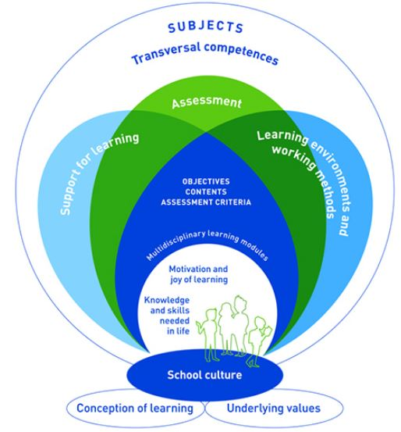
Figure 4.2 The New National Core Curriculum (Finnish National Agency for Education, 2019)
Seven transversal (cross-curricular) areas of competence are described in the core curriculum. These were developed in response to changes in the surrounding world and the need to meet the challenges of the future (Halinen, Harmanen and Mattila, 2015: 139). Transversal competence refers to the knowledge, skills, values, attitudes and will (Halinen, Harmanen and Mattila, 2015: 140) which are required in today’s world.
The transversal competencies weave through all of the subject curriculums, and extend and progress across the grades. A key outline of each competence forms part of each subject curriculum. The seven transversal competencies are:
T1: Thinking and learning-to-learn
T2: Cultural competence, interaction and self-expression
T3: Taking care of oneself and managing daily life
T4: Multiliteracy
T5: ICT competence
T6: Working life competence and entrepreneurship
T7: Participation, involvement and building a sustainable future.

The core curriculum has a greater and more positive focus on language than its predecessor. Specific chapters refer to ‘Special questions of language and culture’ and ‘Bilingual education’. These operate alongside the individual language curriculums – 12x mother tongue and literature curriculums, 6x second national language curriculums and 7x foreign language curriculums. Each of the language curriculum specifications for each grade band begins with a common introduction on the importance of language learning and the development of language skills, student appreciation of their plurilingualism and intercultural competence across all languages being learnt.
The development of Transversal Competencies progresses through each grade band in the basic core curriculum, resulting in a continuum from pre-primary education to secondary school.
The following subjects form the core curriculum for all students:
- mother tongue and literature: Finnish or Swedish  - the other national language: Swedish or Finnish  - foreign languages  - environmental studies  - health education  - religion or ethics  - history  - social studies  - mathematics | - physics  - chemistry  - biology  - geography  - physical education  - music  - visual arts  - crafts  - home economics.

Students may have the option to study other subjects according to the provisions of the local curriculum (Eurydice, 2019c).

Curriculum aims and structure

What are the curriculum aims for the third language?
How is the curriculum presented for this third language—levels of specificity; structure—strands; learning outcomes/objectives?

Some of the key aims of the core curriculum are:
- developing schools as learning communities
- emphasising the joy of learning
- emphasising a collaborative atmosphere
- promoting student autonomy in studying and in school life.
(Eurydice, 2019c).
The curriculum aims for each type of language (mother tongue and literature, second national language and foreign languages) are outlined as subject tasks and grade tasks at the start of each language curriculum. These differ across the different types of language curriculums in the core curriculum.
For mother tongue and literature curriculums, subject tasks focus on some of the following sample key points (extracted from the narrative):
- develop the pupils’ literacy, language proficiency, and interaction skills
- guide pupils towards developing an interest in language, literature, and other forms of culture and gaining awareness of themselves as communicators and language users
- help students to build their cultural and linguistic identities
- encourage students in constructive and responsible interaction in different communication environments
- support and develop language awareness and language observation skills.
(Finnish National Board of Education, 2016: 168-9).
In the core curriculum,
the tasks, the objectives, and the content areas related to the objectives are specified for each subject. Objectives that concern the particular perspectives related to learning environments and working methods, guidance, differentiation, and support, as well as assessment of learning are also defined for each subject. (Finnish National Board of Education, 2016: 165)

Figure 4.3 shows an excerpt for English (foreign language), for Grades 3-6. It illustrates the alignment of the objectives of instruction, the content areas related to the objectives (e.g. C1, C2, …) and the transversal competence areas (e.g. T1, T2, ...).
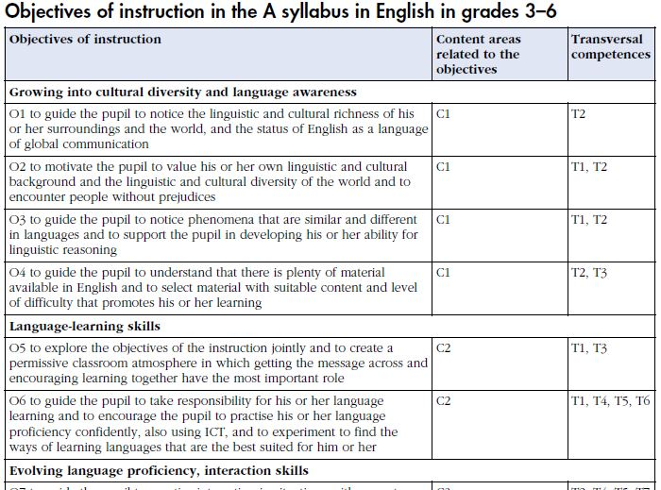
Figure 4.3 Excerpt from the core curriculum showing objectives for English foreign language at Grade 3-6 (Finnish National Board of Education, 2016: 335)

The content areas related to the objectives for this excerpt are:
- C1 Growing into cultural diversity and language awareness
- C2 Language-learning skills
- C3 Evolving language proficiency, interaction skills, text interpretation skills, text production skills.

Assessment criteria are also provided for each curriculum, as shown in Figure 4.4. Levels of proficiency in the latter sections of the assessment criteria are aligned to the levels of the Common European Framework of Reference for Languages (CEFR).
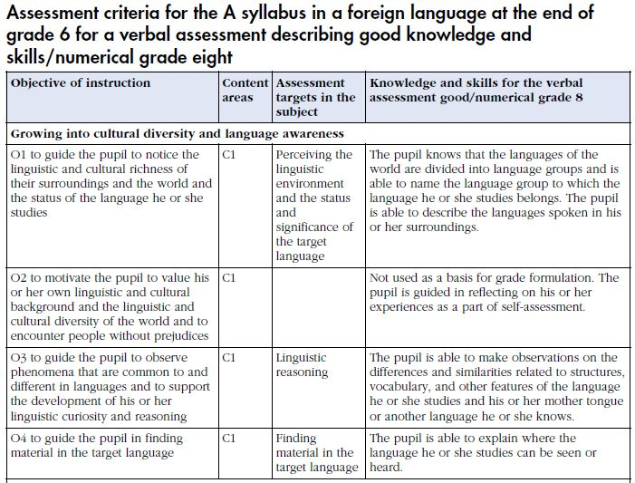
Figure 4.4 Assessment criteria for English A foreign language curriculum

Language integration

How is it integrated in the primary curriculum? (e.g., taught as a separate timetabled subject; as part of a broad languages area; CLIL, extra-curricular; combination of these)?
How many hours does it get per week? And how are these hours fitted into the school timetable (what is sacrificed as a result)?

The three types of languages (mother tongue and literature, second national language and foreign languages) are integrated as subjects at the varying grades of the core curriculum. They are taught as separate subjects. Different languages of instruction can also be used for non-language curriculums as outlined in Section 4 under ‘Bilingual and plurilingual education’.
The government decides on the amount of time which should be allocated to each curriculum in the core curriculum. This must be adhered to at local level. The most recent distribution of lesson hours was finalised in 2012 (Finnish National Agency for Education, 2012). The hours for the language subjects per grade are outlined in the table below.
Subjects Grades | 1 2 | 3 4 5 6 | 7 8 9 | Total
Mother tongue and literature | 14 | 18 | 10 | 42
A1-language | 9 |  | 7 | 16
B1-language | 2 |  | 4 | 6
Optional subjects | 9 |  |  | 9
(Optional A2-language)³ | (12) |  |  | (12)
(Optional B2-language)³ | (4) |  |  | (4)
--- = Subject is taught in the grades if stated in the local curriculum.
³ The pupil can, depending on the language, study a free-choice A2 language either as an optional subject or instead of the B1 language.
The pupil can study the B2 language as an optional subject. The free-choice A2 and B2 languages can, alternatively, be organised as instruction exceeding the minimum time allocation. In this case their instruction cannot be organised using the minimum time allocated in the distribution of lesson hours for optional or B1 language as defined in this paragraph. Depending on the language the pupil receives instruction in a B1 language or optional subjects instead of this B1 language. The distribution of lessons hours would be a minimum of 234 annual lessons for a pupil studying the A2 language as instruction exceeding the minimum time allocation. The corresponding number of annual lessons is a minimum of 226 for a pupil with the B2 language. The total number of annual lessons would be a minimum of 238 for pupils studying both the A2 and the B1 languages as instruction exceeding the minimum time allocation.
Table 4.4 Allocated hours of instruction for language curriculums (Finnish National Agency for Education, 2012)

The language teacher

Who teaches the foreign language L3? How is their capacity to teach it supported and encouraged? (i.e. are there trained teachers within the school or does the school bring in external teachers)?
What kind of training is given? Is it done in Initial Teacher Education or through CPD, or both?

Teaching in Finland attracts high-calibre students. The university intake for class teachers is around 10%. The intake varies from 10% to 50% for specialist teachers, depending on their subject. Teachers in Finland are given a huge amount of autonomy in deciding on teaching methods, teaching materials and student assessment. They are often involved in setting the local curriculum (Finnish National Agency for Education, 2017).
Teachers at Kindergarten level must hold a Bachelor’s degree. Teachers in basic education hold a Master’s degree. Teachers in Grades 1-6 are generalist teachers and Grades 7-9 (and upper secondary education) are specialist teachers. Specialist teachers hold a Master’s degree in their subject as well as having covered pedagogy.
CPD forms an important part of teacher education. Teachers themselves, schools and local educational authorities are responsible for teacher CPD.

Language continuity from primary school into secondary school

How are bridges, if any, made between languages taught in primary and in second level (e.g., what if the local post-primary school doesn’t teach that language?)

Basic education spans Grades 1-9, which includes lower-secondary school. Learning in the language curriculums forms a continuum which traverses the grades outlined in the core curriculum for basic education.

Language assessment

What is assessed in the L3 foreign language curriculum and how?

Chapter 6 of the core curriculum outlines how assessment should be carried out in schools. Assessment criteria form part of the basic core curriculum for each subject specified (as outlined in Section 4), including the language curriculums. The development of competence is seen as a cumulative process throughout the pupil’s years in basic education (Finnish National Agency for Education, 2017: 78).
Two types of assessment are outlined in the core curriculum - Assessment for Learning and Assessment as Learning. Students are encouraged to learn how to assess their own learning and progression (Finnish National Agency for Education, 2017).
In basic education, all students are assessed by their teacher through continuous assessment. Continuous assessment is provided to guide and help pupils in their learning process. Each student receives a report at least once every school year (Finnish National Agency for Education, 2017: 16). According to the core curriculum, assessment must always be based on the objectives set in the core curriculum and the more detailed objectives of the local curriculum (Finnish National Board of Education, 2016: 75). The curriculum assessment criteria are also used to facilitate this assessment.
A final assessment is conducted at the end of basic education (usually Grade 9, but can be conducted at the end of Grade 7 or 8), also by the teacher. The outcome of this assessment determines the student’s options for further study.

Special Educational Needs

The Finnish National Core Curriculum for Basic Education document (Finnish National Board of Education, 2016) provides details of provisions and supports for children who have special educational needs. Support is provided for learning and school attendance. Three levels of provision are provided for—(a) General, (b) Intensified and (c) Special support. General support incorporates differentiation of instruction, cooperation between teachers and with other staff, guidance and flexible modifying of teaching groups (Finnish National Board of Education, 2016: 99). Intensified support is offered to children who require regular support in learning or school attendance. Support in this instance is guided by a pedagogical assessment and a learning plan. Special support is provided to pupils who otherwise cannot adequately achieve the goals set for their growth, development or learning (Finnish National Board of Education, 2016: 105).
If a child cannot access particular curriculum areas, then it is recommended that the subject should be differentiated for the child as a first form of support. If differentiation is provided and children cannot at least acceptably achieve the objectives related to the key contents of the subject, the curriculum for that subject can be individualised (Finnish National Board of Education, 2016: 110). An individualised curriculum is one which has been matched to the abilities of the child, while remaining sufficiently challenging (Finnish National Board of Education, 2016: 110). The decision on whether subject individualisation is required for any one child is taken on a subject by subject basis. Children can also be exempted from subjects if differentiation or individualisation would not be sufficient to allow the child to access and achieve in a subject.
If children are unable to access the subjects of the curriculum, then learning is arranged by topic, rather than subject. These topics include motor skills, language and communication, social skills, skills in activities of daily living, and cognitive skills (Finnish National Board of Education, 2016: 113). These activity areas help to provide children with knowledge and skills that allow them to cope in their lives as independently as possible (Finnish National Board of Education, 2016: 113).
As mentioned previously, children are entitled to access education through the medium of Finnish, Swedish, Sámi, Roma or Sign Language. Where children come from other cultural or linguistic backgrounds, their language and culture are taken into account in basic education. Bilingualism and plurilingualism are promoted and encouraged, with the aim to enhance every child’s linguistic awareness and metalinguistic skills. Each pupil’s linguistic and cultural identity is supported in a versatile manner. The pupils are guided to know about, understand and respect each citizen’s right to their own language and culture (Finnish National Board of Education, 2016: 138). Some lessons may include all of the languages that the children and teachers know, resulting in multilingual teaching situations.
As with Wales and British Columbia, there are no particular references to children who have special educational needs accessing modern foreign languages. However, the specific subject differentiation, individualisation or exemption would be applied appropriately to each individual child’s needs.

  - 5. Belgium

Policy and context

Language context

The Kingdom of Belgium is a federal state and has three official state languages—Dutch, French and German. Language census data is not permitted to be gathered in Belgium (Chopey-Paquet, 2007), but approximate figures show that 54% of the population speaks Dutch, 36% French and 1% German. Belgium has been divided by many different categories—by language, by region and by community. Each category holds a linguistic, federal or legislative importance.
Belgium has four language areas, three of which are unilingual and the fourth of which is bilingual. The linguistic regions correspond somewhat to geographical locations, with their proximities being close to neighbouring countries where the same language is spoken. Figure 5.1 illustrates the geographical position of each language area. The four language regions and their provinces/municipalities are:
- Dutch language area: Flanders (provinces of Antwerp, Limburg, Vlaams-Brabant, Oost-Vlaanderen, West-Vlaanderen)
- French language area: Wallonia (provinces of Mons, Liège, Luxembourg, Namur and Brabant Wallon)
- German language area (the nine municipalities of the East Cantons)
- Bilingual area Brussels-Capital (the 19 municipalities of Brussels).
(Flemish Ministry of Education and Training, 2010: 15-16)

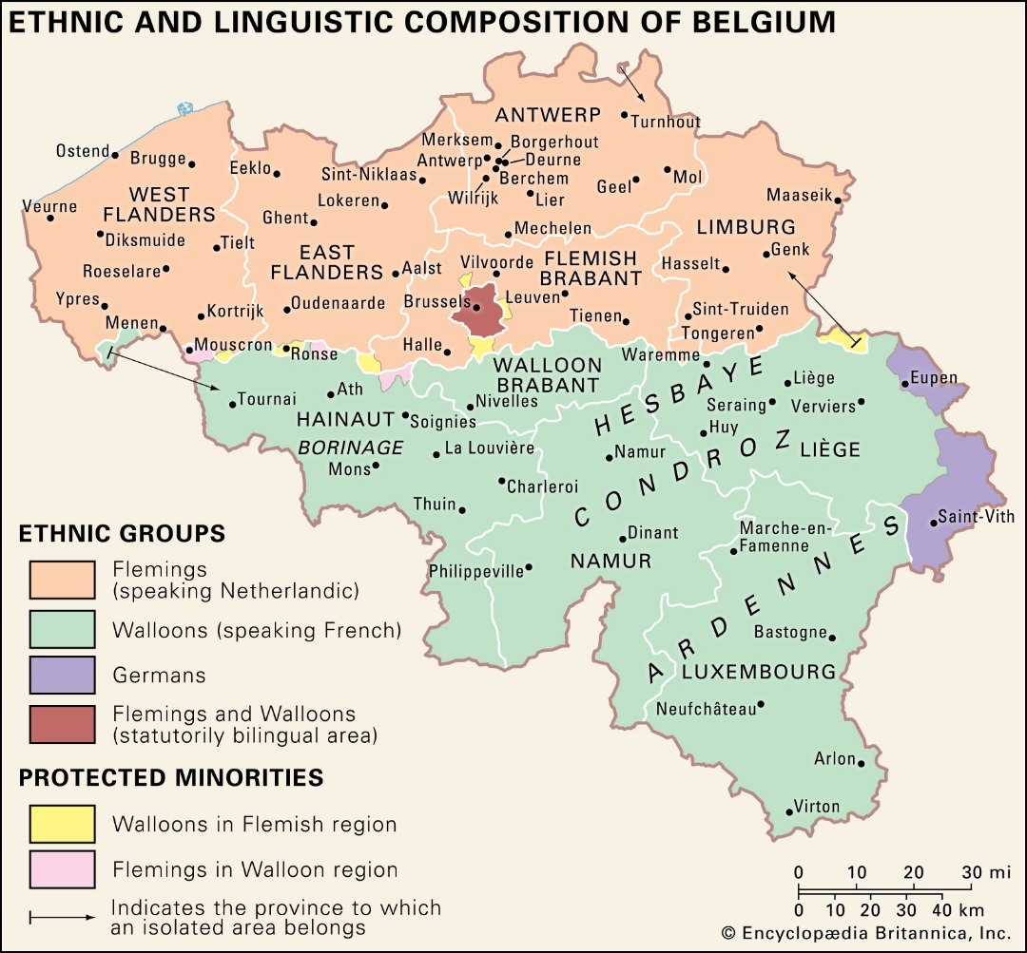
Figure 5.1: Ethnic and linguistic composition of Belgium
(Source: Encyclopaedia Britannica, https://www.britannica.com/place/Belgium/Ethnic-groups-and-languages)

Belgium is also divided into three regions and three communities, making it a double federation, each with its own parliament and government (aside from the Flemish Community/Region) (Flemish Ministry of Education and Training (2010). The federal government sets the span of compulsory education, the minimum qualification requirements and administers teachers’ pensions. All other administrative matters relating to education are made at the community level.
The regions are (1) the Flemish Region, (2) the Walloon Region and (3) the Brussels Capital Region. These regions are used to delineate federal powers for economic affairs (e.g. economy, transport and public works (De Vries, 2010: 4)).
The three communities are (1) the Flemish Community, (2) the French Community and (3) the German-Speaking Communities. These communities have responsibility for cultural, educational and person-related matters (De Vries, 2010: 4).
There are also two administrative levels that are important for education: the provinces and the municipalities (Ministry of the Flemish Community Department of Education, 2001: 14). There are 10 provinces and 589 municipalities.
Educational authority beyond the federal functions outlined above, falls to communities. For this reason, each of the communities administers its own education system and curriculum, resulting in three different educational systems in Belgium (corresponding to each of the three communities), albeit with small differences between them. However, in each case, much autonomy falls to the local organising authority for education, which determines how the education is organised, and draws up a school work plan outlining the content and organisation of teaching (Ministry of the Flemish Community Department of Education, 2001: 27).

Languages of schooling

Which foreign languages do they teach in their primary school curriculum (up to 12/13 years of age)?
In the case of each language, indicate which is L1, L2 and L3 (languages of the school).
Are all the languages compulsory? Is there choice? If so, are guiding parameters given?

The Belgian Education System
The structure of the Belgian school system is outlined in the table below. The only difference between the three communities in this instance is the starting age of pre-school/Kindergarten education. This is differentiated in Table 5.1. Four possible routes (listed under i-iv in Table 5.1) are available for students to choose from once they have completed Stage 1 of secondary education.
 | Education Type | Stage | Grade/Year | Age
Elementary/Basic Education | Flemish/French: Pre-School (age 2.5)  German: Kindergarten (age 3) |  | - | 2.5 or 3  -6
 | Primary Education | 1st Cycle | Grades 1-2 | 6-8
 |  | 2nd Cycle | Grades 3-4 | 8-10
 |  | 3rd Cycle | Grades 5-6 | 10-12
Secondary Education | Common Curriculum for all | Stage 1 | Grade 1-2
 | i. General Secondary Education  ii. Technical Secondary Education  iii. Arts Secondary Education  iv. Vocational Secondary Education | Stage 2 | Grade 3-4
 |  | Stage 3 | Grade 5-6
Table 5.1 The school system in the Flemish Community (Note: Some sources refer to the 6 ’Years’ in primary education rather than ‘Grades’)

Medium of Instruction
The language of instruction of the school is determined by the language of the community—Dutch in the Flemish Community, French in the French Community and German in the German-Speaking Communities. In bilingual Brussels, students can choose between Dutch-medium or French-medium schools. In some German Language Communities, where French is the majority language, French can be the language of instruction of the school. The language of instruction is used for non-language subjects, and for language subjects, the language of the subject can be used. Private schools can teach in a language of their choosing.

Immersion/CLIL Approaches
Until relatively recently, an official language policy in Belgium only facilitated monolingual education through the language of the community (Buyl and Housen, 2014). Since then, all of the Communities have created legal structures to allow CLIL/immersion approaches in schools. The following table outlines the guidelines for the use of CLIL across the three Communities.
Community | Official CLIL allowed since | Time or percentage allowed |  | Language(s) permitted
 |  | Pre-Primary | Primary
Flemish Community | 2014 | 20% | 20% | French
French Community | 1998  Updated 2003, 2007 | 50-66%  (Year 3 pre-primary to year 2 primary) | 25-66%  (Year 3-Year 6) | Language other than French (usually German, English or Dutch), or sign-language
German-Speaking Communities | 2004 | 50-200 minutes of play activities per week | Only for education, artistic, creative and physical education activities | French
Table 5.2 (Compiled from Chopey-Paquet, 2007; Eurydice, 2019, 2019a, 2019b; Hiligsmann and Van Mensel, 2016)

As each of the communities offers different second or foreign languages in their school systems and differ on when and how they can be introduced, the next sections examine each community in turn.

Second/foreign languages in primary schools in the Flemish Community
 | Level | Cycle | Year/Grade | Age | Language(s) offered
Elementary Education | Pre-School |  | - | 2.5-6 | Optional French language awareness  Optional ‘other language’ language awareness
 | Primary Education | 1st Cycle | Grades 1-2 | 6-8 | Optional French language awareness  Optional French from Year 1 or 2, depending on the municipality (e.g. Brussels)
 |  | 2nd Cycle | Grades 3-4 | 8-10 | Optional French from Grade 3 since 2014
 |  | 3rd Cycle | Grades 5-6 | 10-12 | Compulsory French from Grade 5
Table 5.3 Foreign language learning in the Flemish Community (compiled from De Vries, 2010, Eurydice, 2019; Flemish Ministry of Education and Training, 2010)

French is considered a foreign language in the Flemish Community. Table 5.3 above outlines the foreign language learning which takes place in Elementary Education in the Flemish Community.
At pre-school level, optional French language awareness can be implemented. Other language awareness programmes may also be implemented, as long as one in French has already been established.
In primary education, optional French language awareness or other language awareness programmes may be offered (or continued on from pre-school) from Grade 1. Some municipalities along border regions have the option of offering French from Grade 1 or 2. From 2014, all schools have been able to offer French from Grade 3. Compulsory French commences for all students in Grade 5.

Second/foreign languages in primary schools in the French Community
 | Level | Cycle | Grade | Age | Types of Education Offered
Elementary Education | Pre-School |  | - | 2.5-6 | Optional early foreign language learning (e.g. linguistic immersion)
 | Primary Education | 1st Cycle | Grades 1-2 | 6-8 | Optional Dutch*
 |  | 2nd Cycle | Grades 3-4 | 8-10 | Compulsory Dutch* from Grade 3
 |  | 3rd Cycle | Grades 5-6 | 10-12 | Compulsory Dutch*  Compulsory “Communication in a Language” learning (German, English or Dutch) (2 periods per week)
Table 5.4 Foreign language learning in the French Community (*German is also offered in some municipalities (Eurydice, 2019a))

Table 5.4 above outlines the foreign language learning which takes place in Elementary Education in the French Community.
At pre-school level, optional early foreign language learning can commence through CLIL and early immersion programmes.
At primary level, optional foreign language learning may commence from Grade 1. Instruction in the first foreign language is compulsory from Grade 3. Hours of instruction in the compulsory foreign language increase as the student progresses into Grades 5-6. From Grade 5, the first foreign language can also be used through CLIL when instruction can include review exercises for other subjects in the curriculum (Eurydice, 2019a).
Dutch is the language taught as the first foreign language in the majority of the municipalities in the French Community. Dutch or German can be offered as the first foreign language in the municipalities of Malmédy, Waimes, Baelen, Plombières and Welkenraedt (where German is a minority language or the municipality has close proximity to the German border). “Special schemes” which delineate the first foreign language are in place for municipalities around Brussels.
An additional language can be experienced in Grades 5-6 through the teaching of communication in a modern language other than French (German, English, or Dutch) (Eurydice, 2019a). This language exposure should be a minimum of two (90 minute) periods per week.

Second languages in primary schools in the German-Speaking Communities
 | Level | Cycle | Grade | Age | Types of Education Offered
Elementary Education | Kindergarten |  | - | 2.5-6 | Activities taught through French (50 to 200 minutes/week) in Sprachbad/Language shower.
 | Primary Education | 1st Cycle | Grades 1-2 | 6-8 | Compulsory French from Grade 1
 |  | 2nd Cycle | Grades 3-4 | 8-10 | Compulsory French
 |  | 3rd Cycle | Grades 5-6 | 10-12 | Compulsory French
Table 5.5 Second languages in the German-Speaking Communities

Table 5.5 above outlines the foreign language learning which takes place in Elementary Education in the German-Speaking Communities.
German is the language of instruction in schools in the German-speaking communities, apart from schools which need to protect the minority language (French) which corresponds to the language spoken along its borders. Sport, Music or Art may be taught through the second language (CLIL) where firm language learning aims are set out. French must be the first foreign language taught in German-Speaking Communities (Ministerium der Deutschsprachigen Gemeinschaft Belgiens, 2008).
Foreign languages are introduced at Kindergarten level. French is taught within the framework of the activity plans which includes Foreign-language activities: (1) Listening and comprehending and (2) Speaking (Eurydice, 2019b) in the format of a “Sprachbad” or Language Shower.
At primary level, French is compulsory from Grade 1 and must be taught each day. The time allocated to foreign language learning increases as the student progresses through the Grades of Primary Education. Second language studies have an obligatory portion of this time assigned to them - only a few subjects have an obligatory number of weekly hours. The local school authority distributes the remaining time across the other subjects (aside from Religious Education which also has set hours).

Language policies and national impetus for languages

Why has the jurisdiction chosen to include a third language (rationale, policy drivers)?
In what year did this development happen?

The first foreign language offered in each community during the elementary years tends to be one of the other national languages. This is reflected in the most popular languages chosen for study at primary level. In the French Community, Dutch is the most popular language studied (36% of students) (Eurydice, 2012). In the Flemish Community, French is the most popular language studied (27.4% of students) (Eurydice 2012).
As outlined in Section 5 above, legislation in Belgium declared the languages or medium of schools needed to be the language of the Region/Community (apart from bilingual Brussels). For quite some time, this legislation led to few opportunities for immersion/CLIL or other languages to form part of the languages of the school, especially for a country with such a rich linguistic makeup. Later changes to local legislation allowed immersion and CLIL methods to be used, which helped to diversify the languages on offer somewhat and facilitate earlier introductions to foreign languages.
Each of the communities do allow an optional pre-primary foreign language element in the form of language awareness, sensitisation or CLIL formats.

Teaching and learning: The modern language at primary level

Curriculum aims and structure

What are the curriculum aims for the third language?
How is the curriculum presented for this third language—levels of specificity; structure—strands; learning outcomes/objectives?

For each of the communities, a core curriculum is defined at community level. This is then used as a basis for the development of local curriculums for each of the areas of learning/subjects. The core curriculum is outlined for each of the communities in the coming sections. A more detailed examination of the second language curriculum is provided within the subsection on the German-Speaking Communities.

The Flemish Community
Both the pre-primary and primary curriculums are aligned to allow continuity across the levels. The common core curriculum consists of Areas of Learning and Cross-Curricular Themes (De Vries, 2010).
Five areas of learning are specified at primary level, as follows (Eurydice, 2019; De Vries, 2010):
- Physical education: motor skills, healthy and safe lifestyle, self-awareness and social integration
- Art Education: visual arts, music, drama, dance, media and attitudes
- Language
  - Dutch (L1 for the majority): listening, speaking, reading, writing, strategies, linguistics, (inter)cultural focus
  - French (L2 for the majority): listening, reading, speaking, oral interaction, writing
- Introduction to the world (nature, people, society, technology, time and space, and use of resources)
- Introduction to mathematics (numbers, measuring, geometry, strategies and problem-solving skills, attitudes).
In addition to the five areas of learning, two constitutional requirements are also outlined. At least two teaching periods of philosophy-of-life education (levensbeschouwelijke vorming) need to be incorporated and a choice between non-confessional ethics and religion must also be available (De Vries, 2010).

The Cross-Curricular Themes are:
- Learning to learn
- Social skills
- ICT.

The common core curriculum is extended and explicated for all curriculum areas at local level.

The French Community
A common core curriculum (decree on the missions) is also in place in the French Community. Local curriculums are developed by the pouvoirs organisateurs (organising authorities) and must align to the general objectives of education and be consistent with the requirements of the Decree on the missions of the school (Eurydice, 2019a). By law, the local authority is free to choose its own pedagogical methods and aims, which are then submitted for approved by the Minister and the Curriculum Commission. The school plan translates the local authority’s pedagogical plan into concrete terms in the light of its specific context (Eurydice, 2019a).
The core curriculum, defines domains rather than subjects, within which competencies are to be developed. Priority is given to (1) the teaching of reading centred on the mastery of meaning, (2) to the production of written and oral communication, as well as to (3) the mastery of the basic mathematical tools within the framework of problem solving.
The following domains form part of the compulsory common core:
- Structure of time and space  - Psychomotricity and physical education  - Discovery, initiation to history and geography  - Artistic education  - Education through technology | - Scientific initiation  - Discovery of the environment  - Education to the media  - Learning about social behaviours and citizenship  - Communication skills in a language other than French.

Within this framework, the Core Skills distinguish eight domains:
- French (L1)
- Mathematics
- Discovery – initiation to science (including introduction to social and economic life)
- Modern languages (L2)
- Physical education
- Education through technology
- Artistic education
(Eurydice, 2019a).

The local curriculums extend these core competencies and domains with course content and methodological details. All local curriculums must be developed to ensure that the Core Skills can be achieved (Eurydice, 2019a).

The German-Speaking Communities
The Core curriculum outlined in the German-Speaking Communities is defined within curriculum frameworks (Rahmenpläne). The curriculum frameworks and core competencies form the requirements for teaching and learning in schools. The local curriculum can be developed around these frameworks and core competencies to set and implement their own pedagogical goals and objectives.
The following curriculum frameworks with their respective core competencies were established in 2008. Their inclusion in local curriculums is mandatory.
- German as the language of instruction (L1)
- French as first foreign language (L2)
- Mathematics
- History and Geography
- Natural Science and Technology
- Music and Art
- Sport.
(Ministerium der Deutschsprachigen Gemeinschaft Belgiens, 2008: 30).
Religion or non-denominational ethics must also be incorporated into teaching and learning in all schools, to a minimum of two (50 minute) classes per week (Ministerium der Deutschsprachigen Gemeinschaft Belgiens, 2008: 33).

Curriculum for French as a foreign language
French is the first foreign language taught in schools in the German-Speaking Communities. The following sections detail the contents of the Curriculum Framework for French as a foreign Language.
The French (L2) curriculum spans the three levels of primary education (Grades/Years 1-6) and the first level (Grades 1-2) of secondary education. This ensures the continuity of language learning from one level of education into another and during the transitionary period between primary and secondary school. It also serves as a starting point for the commencement of French foreign language learning in Grades 3-6. The first level of secondary education also represents the initial common curriculum for all students before they branch into one of the four secondary education options.
The curriculum defines competencies as enabling students to solve problems successfully and responsibly. Multiple types of competencies are detailed within the initial sections of the curriculum—(1) Subject-based competencies which are related to the acquisition of subject-specific knowledge, (2) Transverse/Cross-curricular competencies which encompass method, social and personal competencies, (3) Core competencies which are the central competences for all learning and (4) Competence Outcomes (Kompetenzerwartungen) which describe the learning outcomes a student has achieved.
The core competencies for French foreign language are:
- Listening
- Speaking
- Reading
- Writing
- Gaining an understanding of our neighbour’s living environments (Intercultural awareness)
- Fostering an understanding of cultural difference.
(Ministerium der Deutschsprachigen Gemeinschaft Belgiens, 2008a).
The curriculum presents condensed Competence Expectations (learning outcomes/achievements) which outline the level of ability the student should have reached at two points in time: (1) at the end of the primary years (after the six years of primary education) and (2) at the end of the first stage of secondary education (Grades 1-2). These are sub-divided according to three parts and different competences.
- PART I: Communicative Competence (listening, speaking, reading, writing)
- PART II: Spoken medium (vocabulary, grammar, spelling and phonology)
- PART III: Intercultural Competence (Understanding of neighbour’s living environments, Understanding of cultural difference
The competence expectations (learning outcomes) are aligned to the Common European Framework of Reference for Languages (CEFR) levels. Figure 5.2 shows an excerpt of these competence expectations from the core curriculum.
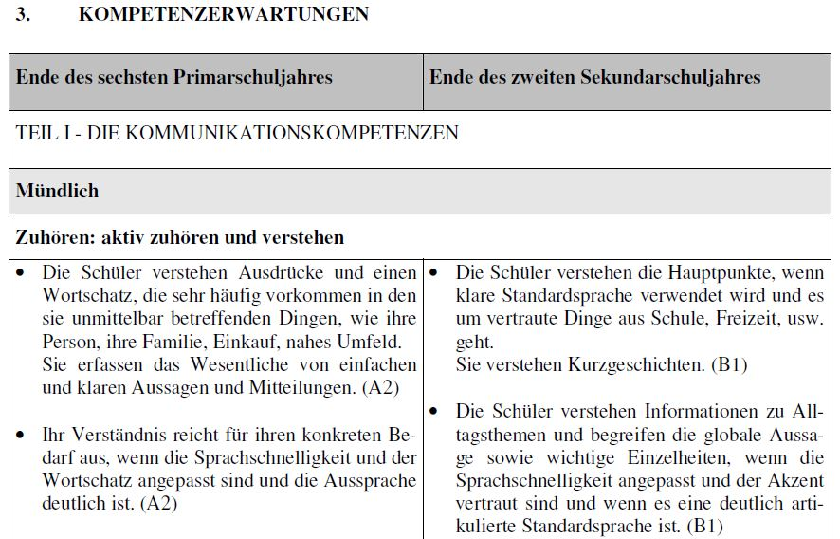
Figure 5.2 Excerpt from the German-Speaking Communities core curriculum: Competence Expectations (Learning Outcomes) (Ministerium der Deutschsprachigen Gemeinschaft Belgiens, 2008a: 49)

Detailed Competences and Content form the final component of the curriculum. The curriculum describes them as the important stages for developing language competence and the best way to prepare the students to achieve the learning outcomes outlined for the end of each level of education. Content for all of the stages is outlined in the final sections. The overview of the competences and content is arranged according to the three primary school levels and the first secondary school level. It illustrates how learning in each of the skills overlaps across these levels. The full content of the language lessons follows and the curriculum details the learning outcomes with associated samples/vocabulary of French language for each outcome. Figure 5.3 shows an excerpt from the competences and content section of the curriculum.
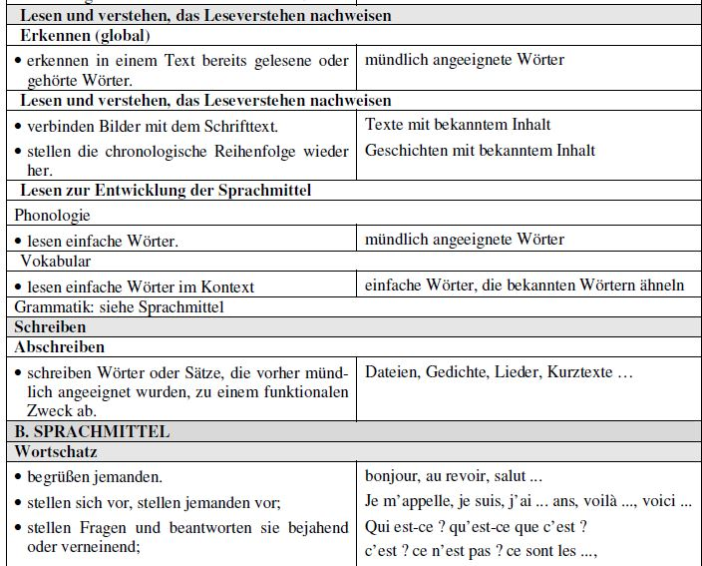
Figure 5.3 Excerpt from the German-Speaking Communities core curriculum: Competences and content (Ministerium der Deutschsprachigen Gemeinschaft Belgiens, 2008a: 58)
Note: There is also a French version of the curriculum available.

Language integration

How is it integrated in the primary curriculum? (e.g., taught as a separate timetabled subject; as part of a broad languages area; CLIL, extra-curricular; combination of these)?
How many hours does it get per week? And how are these hours fitted into the school timetable (what is sacrificed as a result)?
Note: Across each of the Community descriptions, there was a mixture of the words ‘periods’ (50 minutes in each community) and ‘hours’ used to describe the time allocations to language. In the discussion below, it was assumed that references to ‘hours’ had been used interchangeably with ‘periods’ (i.e. both referring to 50 minute periods) as otherwise, the total amount of time allocated in the case of a 60-minute hour would have exceeded the weekly time allocation. The interchangeable use of these words may have been due to translation errors; for example, the German word ‘Stunde’ can refer to class periods or hours of the day.

The provision for CLIL and immersion settings across the three communities was briefly discussed in Section 5. Opportunities are provided across the three communities.
In each community, the first foreign/second language is taught as a separate timetabled subject (aside from the language showers of pre-primary and early primary levels). The CLIL/immersion opportunities offer additional language learning openings to these core ones.
The hours of instruction in the first foreign/second language for each of the three communities are outlined below.

The Flemish Community
The full school week in this community comprises 28-29 teaching periods, each of 50 minutes duration (Eurydice, 2019). The local school is free to decide on the amount of time to be dedicated to French language learning; there are no timetable requirements from the community-level (De Vriers, 2010; Ministry of the Flemish Community Department of Education, 2001).

The French Community
The weekly timetable in the French Community is the same as the Flemish one. The week comprises 28 periods, each of 50 minutes duration. Certain subjects have community-defined periods allocated to them. Language is one such subject—zero to five periods of modern language courses (depending on the grade and the geographical area) (Eurydice, 2019a) are allocated.
Following the optional early language learning (immersion/CLIL) of the pre-primary level, optional Dutch learning in primary Grades 1-2 can only extend to two periods (50 minute duration) per week. At primary Grades 3-4 compulsory Dutch must be timetabled for three periods per week. At primary Grades 5-6, Dutch language learning extends to a required five periods per week. This latter period can include the use of Dutch through CLIL in other subjects.
One period per week can be added to Grades 5-6 in those Walloon municipalities which do not have special linguistic status (Eurydice, 2019a).

The German-Speaking Communities
The school week in the German-speaking Communities also comprises 28 periods, each of 50 minute duration.
At Kindergarten/pre-primary level, a minimum of 50 minutes and a maximum of 200 minutes per week can be spent on French (Ministerium der Deutschsprachigen Gemeinschaft Belgiens, 2008).
In primary Grades 1-2, at least two or a maximum of three periods a week are allocated to the second language. In primary Grades 3-4, a minimum of three or a maximum of four periods are allocated a week. In primary Grades 5-6, a minimum of five periods a week are allocated, but can extend to six periods maximum. The local school authority distributes the remaining time across the other subjects (aside from Religious Education which also has set hours) (Eurydice, 2019b; Ministerium der Deutschsprachigen Gemeinschaft Belgiens, 2008).

The language teacher

Who teaches the foreign language L3? How is their capacity to teach it supported and encouraged? (i.e. are there trained teachers within the school or does the school bring in external teachers)?
What kind of training is given? Is it done in Initial Teacher Education or through CPD, or both?

The Flemish Community
Generalist teachers teach the foreign language in schools in the Flemish Community. Specialist teachers are required for some subjects like physical education and music, but they are not required for foreign language teaching (De Vries, 2010).
Integrated teacher education programmes which cover content knowledge and pedagogy qualify teachers to teach all subjects, except for those specified as requiring a specialist teacher.

The French Community
Generalist teachers also teach the foreign language in the French Community. Teachers learn foreign language content and pedagogy as part of the generalist initial teacher education programmes.

The German-Speaking Communities
Generalist teachers teach the foreign language in the German-Speaking Communities. Initial teacher education facilitates learning in the content and pedagogy of all of the curriculum subjects. In some institutions, First foreign language French and didactic’ can be offered as an elective.

Language continuity from primary school into secondary school

How are bridges, if any, made between languages taught in primary and in second level (e.g., what if the local post-primary school doesn’t teach that language?)

Language teaching arrangements across the three communities are generally limited to one foreign language. Limited CLIL/immersion, Language Awareness or the ‘Communication in Language’ subject can offer additional scope for other languages with the primary level sphere, namely, German, English or Dutch.
Section 5 highlighted how the most commonly taught foreign language in any community at primary level was usually one of the other national languages or the language of the border countries in municipalities close to the border. In the Flemish Community, French is generally the foreign language taught. In the French Community, Dutch is taught. In the German-Speaking Communities, French is taught. With such little variation across the languages taught, continuity into second level would not present as much of a challenge.
The German-Speaking Communities offer one additional assurance for continuity across the primary and secondary levels through its core language curriculum for French. As mentioned in Section 5, the French (L2) curriculum spans the three levels (Grades 1-6) of primary education and the first level (Grades 1-2) of secondary education. This continuity of core curriculum content across levels ensures that language learning is linear, coherent and progressive across the primary and secondary school levels.

Language assessment

What is assessed in the L3 foreign language curriculum and how?

All three communities offer autonomy on matters of assessment to the local school teacher. Regular formative assessment is encouraged with reporting to parents forming part of their remit. In each community, the core language curriculum presents ‘pre-set’ or detailed learning objectives for students to attain. They are used as a benchmark for teachers to assess their students and plan for further teaching. The following sections outline some of the more structured assessment requirements, which would include foreign languages given their place in the core curriculum of all communities.

The Flemish Community
At primary level, teachers are encouraged to practise a pedagogy of success and positive stimulation (Flemish Ministry of Education and Training, 2010: 162) in their assessment strategies. Alongside formative assessment, summative assessment tests are carried out in December and June (Flemish Ministry of Education and Training, 2010).
The Elementary Education Certificate can be awarded at the end of primary education. If the final objectives (Eindtermen) of the curriculum have been met, the Class Council can rule to award the certificate. The standards and the procedure for the assignment of a primary school certificate are subject to central education regulation (Eurydice, 2019).

The French Community
The core skills outlined in the French Community’s core curriculum are used as a basis for mandatory formative assessment. Certificate assessments are carried out at the end of the primary period (Eurydice, 2019a).
A Committee on Assessment Tools relating to the Core Skills is responsible for producing sets of assessment tests corresponding to the Core Skills (Eurydice, 2019a). These assessments help teachers to gauge the level of student learning according to the core skills of the curriculum.
External non-certificate assessments are organised by an “Administrative Steering Unit” at the start of Grade 3 and Grade 5 at primary level. These are used by teachers to check in on student attainment and progress and devise teaching approaches accordingly (Eurydice, 2019a).
External certification of primary education (‘certificat d’études de base’) is conducted with all students in Grade 6. The certificate assessment examines student attainment in the core skills set out in the core curriculum (Eurydice, 2019a).

The German-Speaking Communities
Autonomous formative assessment is carried out by the teacher in the classroom to ensure skills and competencies are being met. The French foreign language curriculum outlines the learning outcomes which should be attained at the end of primary education and after the first stage (Grade 1-2) of secondary education which help guide summative testing.
The primary school leaving certificate is awarded by the Governing Body (comprising the student’s teacher(s), principal and the teacher who conducted the assessment). It is awarded on merit of the student achieving success in acquiring the competencies set out in the core curriculum (Eurydice, 2019b).

Special Educational Needs

As in other jurisdictions under examination, each of the three communities offer a staged approach to supporting learning which is differentiated according to the needs and abilities of the individual child.

The Flemish Community
The Flemish Community offers a continuum of care which encompasses three stages of support. The first stage is called Broad Basic Care (Eurydice, 2019) and provides extra support for children with special educational needs through reasonable adjustments and support such as differentiation, compensatory or dispensing measures. The local school provides a learning environment suitable for all children in this instance.
The second stage is called Increased Care (Eurydice, 2019). Children are supported through a report on access to special educational needs education or an individualized curriculum in mainstream school (Eurydice, 2019: unpaginated).
The final stage on the continuum of care is referred to as Care Expansion (Eurydice, 2019). This stage supports children either in mainstream education with the assistance outlined in an individual substantiated report (Eurydice, 2019: unpaginated) which is compiled from action-oriented diagnostics, or with the assistance outlined in a report for access to special educational needs education which describes an individually adapted curriculum (Eurydice, 2019: unpaginated). Individually adapted curriculums aim to support children in developing the self-reliance, the communication possibilities, the sensory motor skills and the social education of the pupils in the contexts of living, working and leisure (Eurydice, 2019: unpaginated).

The French Community
In the past, the education of all children with special educational needs was supported in special schools. This practice has been more recently adapted to allow for children with mild, moderate or severe learning needs to be accommodated and supported in mainstream education where possible (Eurydice, 2019a). This is being achieved through strengthening support for students with learning disabilities in ordinary education (Eurydice, 2019a: unpaginated). Separate provision is also provided for children from other linguistic and cultural backgrounds, unless their needs extend beyond linguistic needs to special educational needs. In this case, they are supported as above.

The German-Speaking Communities
Three levels of support are again offered through the German-Speaking Communities, through their individual support (Eurydice, 2019b: unpaginated). The capabilities and limitations of children are examined and appropriate supports are put in place to facilitate each child’s learning. If children attend mainstream education, they are supported in their learning through differentiated teaching, as well as supporting courses.
For children from other linguistic and cultural backgrounds,
support is integrated into the natural environment of the pupil, as close as possible to his place of origin, preferably in a general education class and if needed, conveying educational measures take place by the granting of an integration project or by schooling in a special school. (Eurydice, 2019b: unpaginated)

In the case of each of the three communities, varying guidelines are in use to support children with special educational needs. In each case, provisions are provided within the mainstream setting where possible, or special schools where further support is required. In each case, there was not any particular reference to modern foreign languages, but all subjects can be differentiated or adapted according to children’s needs and abilities.

  - 6. New Zealand

Policy and context

Language context

Some general information on the language context of the jurisdiction

New Zealand has three official languages—English, Maori and New Zealand sign-language. Maori is the minority language of the indigenous population in New Zealand. While English is a de facto first language, it has not yet officially been made a national language. Maori became an official national language in 1987 and New Zealand sign language in 2006.
Pacific Languages also form part of the linguistic makeup of New Zealand; Samoan, Tongan and Cook Island Maori belong to this language family in New Zealand.
The most commonly spoken languages in New Zealand as reported in the 2013 census were as follows:
- English – 96.1%
- Te reo Māori – 3.7%
- Samoan –2.2%
- Hindi –1.7%
- Northern Chinese (including Mandarin) –1.3%
- French – 1.2%.
(StatsNZ, 2014).

Languages of schooling

Which foreign languages do they teach in their primary school curriculum (up to 12/13 years of age)?
In the case of each language, indicate which is L1, L2 and L3 (languages of the school).
Are all the languages compulsory? Is there choice? If so, are guiding parameters given?

The New Zealand Education System
The structure of the New Zealand education system is as follows:
 | Year | Age | Duration (Years)
Early Childhood Education and Care | - | 3/4 | 1-2
Primary Education | 1-8 | 5-12 | 8
Secondary School | 9-13 | 13-17 | 5

A brief overview of the New Zealand curriculum follows, as it becomes relevant to the discussion surrounding language learning and language subjects. Additional details on the Language Learning area of learning of the curriculum will be provided in Section 6 on curriculum aims and structure.

The New Zealand Curriculum for English-Medium Schools, 2007
There are two primary curriculums in New Zealand. One has been developed specifically for Maori-medium education (called Te Marautanga O Aotearoa) which is used in schools where more than 51% of the language of instruction is through Maori. The second, the New Zealand Curriculum for English-medium teaching and learning in years 1–13 (Ministry of Education, 2007) outlines the learning framework for English-medium schools across primary and secondary education.
The New Zealand Curriculum is developed around eight learning areas, as follows:
- English
- The Arts
- Health and Physical Education
- Learning Languages
- Mathematics and Statistics
- Science
- Social Sciences
- Technology.
(Ministry of Education, 2007).

The Languages area provides a framework for developing a language curriculum for any level of learning at primary level (Years 1-8) and secondary level (Years 9-13). Maori (Te Reo Māori) can also be taught as a language subject in English-medium schools within the Learning Languages learning area.
The curriculum describes how it gives teachers flexibility to apply their professional knowledge. They can personalise learning to the needs of their students and communities (Ministry of Education, 2019: 21). The New Zealand curriculum, is therefore, a framework curriculum which can be customised locally by schools and teachers to develop their own curriculums.
The curriculum describes how all schools with students in years 7–10 should be working towards offering students opportunities for learning a second or subsequent language (Ministry of Education, 2007: 44). This means that language learning (L2) beyond English (L1) is optional in years 7-10, where students are between 11 and 14 years old. This period spans upper primary level and lower secondary level.
The flexibility that schools and teachers have to develop local language curriculum(s) from the curriculum framework means that the local setting has the autonomy to choose the language to be taught. Figure 6.1 outlines the most commonly chosen languages at primary level (excluding Maori). In rank order for the most recent year, French, Spanish, Chinese, Japanese, and German were the most frequently chosen languages.
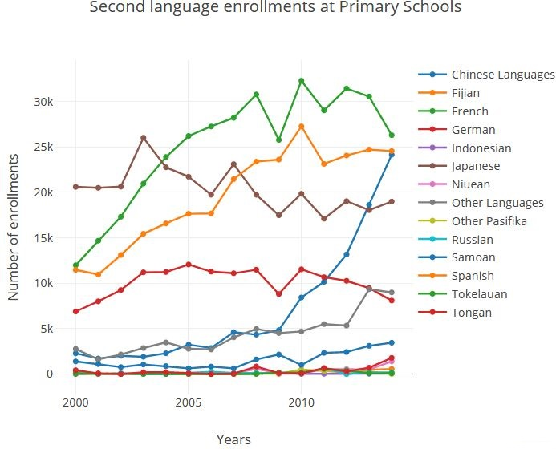
Figure 6.1 L2 languages chosen at primary level
Image source: https://www.nzherald.co.nz/nz/news/article.cfm?c_id=1&objectid=11438943

Factors which can affect the language chosen include the personal choice of students and their families, the availability of teachers, and decisions by school boards (The Office of Ethnic Communities, 2014: unpaginated).

Aside from language learning through the medium of English, schools can also offer Maori-medium and Pacific-medium education. In 2018, 2.5% of the school population attended a Maori-medium school (Ministry of Education and New Zealand Government, 2019). Of the school population, 21.1% studied Maori language in English-medium schools in 2018 (Ministry of Education and New Zealand Government, 2019). Conversely, in 2018, 76.4% of the school population were not learning through the medium of Maori or learning Maori as a language subject in an English-medium school.
Pacific-Medium Education accounts for students who learn through the medium of a Pacific language for three hours per week (12% of typical classroom time). Samoan, Tongan, Cook Island Maori, Niuean and Tokelauan were reported to be the most frequently chosen Pacific languages for Pacific-medium education (Ministry of Education and New Zealand Government, 2019a). As with Maori, Pacific language can also be learnt as a separate language subject in English-medium schools (minimum of 15-20 hours per year, depending on the primary school year). Figure 6.1 above featured some of these languages (Ministry of Education and New Zealand Government, 2019a).

Language policies and national impetus for languages

Why has the jurisdiction chosen to include a third language (rationale, policy drivers)?
In what year did this development happen?

School Governance
Schools in New Zealand have a high level of devolution as a result of Tommorrow’s Schools reforms and The Education Act (1998) (Ministry of Education, 2019: 17 and 43). Devolution means that the administration and management of individual schools is carried out by Boards of Trustees. The Board of Trustees for any school is mostly made up of parents. Devolved, self-managing schools, governed primarily by parents and competing for students, were expected to foster better teaching and learning, and a higher performing education system (Ministry of Education, 2019: 17). This devolution has resulted in local schools choosing the stage, level and language to be taught (if any) at local level, and use of the New Zealand curriculum framework as a basis for this development.

New Zealand Curriculum, 2007
The New Zealand English-medium curriculum was revised in 2007. As outlined above, this curriculum allows decisions regarding the time, level and years of optional language learning to be determined at local level.

Strategy for Languages in Education in Aotearoa New Zealand 2019-2033
The recently published strategy for language in New Zealand (Auckland Languages Strategy Working Group, 2018) outlines a proposal for strengthening languages education in New Zealand (p. 1). The strategy describes the challenges within the present system for languages. The broad curriculum framework (one double-sided page (Auckland Languages Strategy Working Group, 2018: 8)) and lack of supporting guidelines for local school communities to develop their own curriculums, has hindered the greater integration of languages.
Strategic actions to improve language uptake are outlined within three 4-year stages. At the primary level, these include extending Maori language learning to all Year 1-4 students by 2020, Year 1-8 students by 2028 and Year 1-10 students by 2033. Details of phased improvements to teacher training to facilitate an increase in language learning are also outlined (Auckland Languages Strategy Working Group, 2018).

New languages bill
A new member’s bill on strengthening language learning at primary and intermediate level, Education (Strengthening Second Language Learning in Primary and Intermediate Schools) Amendment Bill, has had its first reading at parliament. The bill aims to strengthen primary and intermediate schools’, including Communities of Learning, access to language learning through additional resources provided by the government to fund professional development, language specialists and online resource” (New Zealand Parliament, 2019: 1). The bill aims to improve access to languages in all school by providing additional resources for them. 10 priority languages, to include Maori and New Zealand Sign Language will constitute the ten priority languages. Schools will then need to develop their own Priority Languages Programme which can be implemented locally (New Zealand Parliament, 2019).

Teaching and learning: The modern language at primary level

Curriculum aims and structure

What are the curriculum aims for the third language?
How is the curriculum presented for this third language—levels of specificity; structure—strands; learning outcomes/objectives?

All schools with students in years 7–10 should be working towards offering students opportunities for learning a second or subsequent language. Teaching programmes should be based on the learning languages statement found on pages 24–25 and the achievement objectives for this learning area. Teaching programmes for students in years 11–13 should be based, in the first instance, on the appropriate national curriculum statement” (Ministry of Education, 2007: 44).

Section 6 provided an introduction to the New Zealand English-medium curriculum (2007). This section focuses on the Language learning area of the Curriculum.
The Language Learning Area of the curriculum describes language learning under the headings of (1) What is learning languages about?, (2) Why study a language? and (3) How is the learning area structured? (Ministry of Education, 2007). It describes the three strands for learning—the Communication Strand is the core strand and is supported by two other strands – Language Knowledge and Cultural Knowledge (Ministry of Education, 2007).
Development of a local Language learning curriculum is supported online through the New Zealand Curriculum Online Website. It describes language learning around the same headings as in the Language Learning Area of the curriculum itself, with the addition of Achievement Objectives. The curriculum notes that the achievement objectives are generic in order to encompass all languages that may be offered for learning in schools. Language-specific guidelines [online] provide further information (Ministry of Education, 2007: 25). Achievement objectives are set out across levels 1-6 with each level comprising two years of the curriculum. For example, Level One corresponds to the learning which should take place in Years 1 and 2 of primary education. Level 1 of the curriculum is the entry level for students with no prior knowledge of the language being learned, regardless of their school year (Ministry of Education, 2007: 24). It is advised that the achievement objectives for the Communication strand for leach level can be used as a basis for assessment. The CEFR framework is used as a reference point for the proficiency descriptor. Figure 6.2 below provides an excerpt from the Level 1 Achievement objectives.

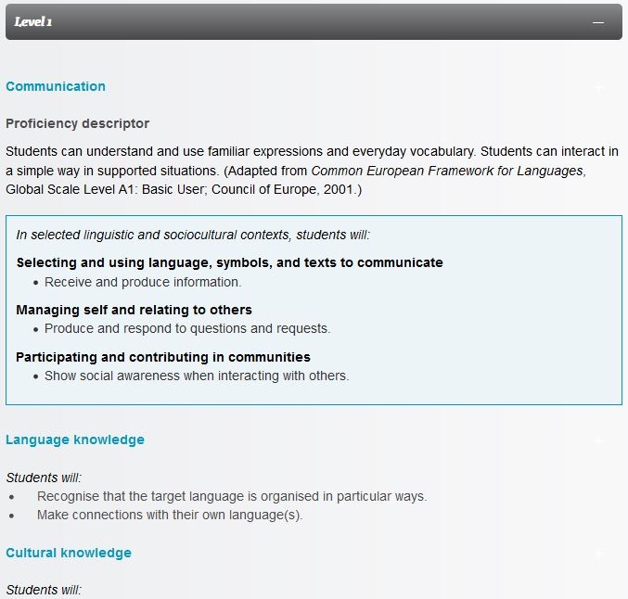
Figure 6.2 Excerpt from Achievement Objectives for Level 1 Communication Strand

Another section of the curriculum online website provides the Language Specific Guidelines for developing local language curriculums. These guide the curriculum developer through the achievement objectives by level bands (Levels 1-4 and Levels 5-8) for particular languages. Chinese, French, German, Japanese, Latin and Spanish are the languages available. The achievement objectives outlined for each language in this section are the one double-sided page guidelines (Auckland Languages Strategy Working Group, 2018) referred to within the language strategy. Support Materials are also provided at this juncture to illustrate language activities at different levels and the associated language learning which would take place. Figure 6.3 below shows the Level 1-4 Achievement Objectives for German alongside the listing for example support materials.
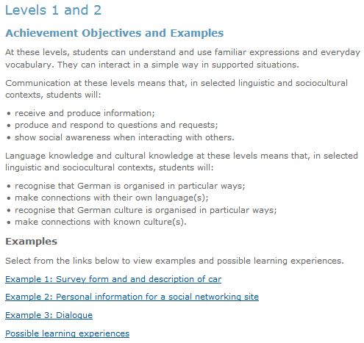
Figure 6.3 Level 1-4 Achievement Objectives for German

Language integration

How is it integrated in the primary curriculum? (e.g., taught as a separate timetabled subject; as part of a broad languages area; CLIL, extra-curricular; combination of these)?
How many hours does it get per week? And how are these hours fitted into the school timetable (what is sacrificed as a result)?

Factors relating to how and when the language would be taught if adopted, would be within the remit of the local school.

The language teacher

Who teaches the foreign language L3? How is their capacity to teach it supported and encouraged? (i.e. are there trained teachers within the school or does the school bring in external teachers)?
What kind of training is given? Is it done in Initial Teacher Education or through CPD, or both?

Devolution of school governance means there are no norms for who the language teacher would be if an L2 language was integrated. Details from the Language Strategy suggest that fluent speakers of languages, first language speakers of other languages and language graduates will be attracted into the teaching profession under their strategic actions to move ahead with language learning (Auckland Languages Strategy Working Group, 2018).
In the case of Maori, local native speakers are sometimes accessed to teach the language if capacity is not already available in the school staff. As mentioned in Section 6, the current choice of language for L2 learning is determined by the availability of a teacher, among other factors.
Strategic actions for moving ahead with greater provision for language learning examined ways to upskill teachers through professional development and access more personnel with language competency (Auckland Languages Strategy Working Group, 2018). The first of these, teacher professional development, included an outline for a one year immersion programme in Maori. Similar opportunities already exist for international languages. The second one of these, accessing more personnel with language competency, included initiatives such as establishing a
combination of National Language Advisers and a language assistant programme (such as currently exists with European and Asian language advisers and language assistants), itinerant teachers, online learning and sharing expertise through Kāhui Ako (Communities of Learning) as well as other networks (Auckland Languages Strategy Working Group, 2018: 20).

New Zealand’s Correspondence School (now named Te Aho o Te Kura Pounamu), provides access to education for those who cannot attend a local school. It provides distance learning using multimedia and online learning for early childhood, primary, secondary and special needs students (Ministry of Education, 2019: 11). The correspondence school serves students in remote areas and those with special needs who are unable to attend a physical school building. It also provides programmes for students who cannot access certain subjects in their local state school.
Such online facilities, alongside teacher professional development and the provision of language specialists, are being suggested as ways to resource greater language provision at primary and intermediate levels (New Zealand Parliament, 2019).

Language continuity from primary school into secondary school

How are bridges, if any, made between languages taught in primary and in second level (e.g., what if the local post-primary school doesn’t teach that language?)

The New Zealand curriculum spans Years 1-13 (age 5-17) of education which encompasses primary and secondary years. While local curriculums are developed using the New Zealand curriculum as a framework, curriculum developers would have the potential to factor in the language(s) available within their local primary and secondary school when developing the curriculum across these years.

Language assessment

What is assessed in the L3 foreign language curriculum and how?

Formative assessment to measure and monitor student achievement (Ministry of Education (2019: 21) is within the remit of the local teacher. It involves the focused and timely gathering, analysis, interpretation, and use of information that can provide evidence of student progress (Ministry of Education, 2017: 39). The Communication strand within the achievement objectives for each level are used as a guide to benchmark student progress in their language learning.
A series of National Curriculum assessment tools and resources are available for use in the classroom.

Special Educational Needs

In New Zealand, the New Zealand Curriculum (Ministry of Education, 2007) and Te Arautanga o Aotearoa (Ministry of Education, 2008) form the basis for all teaching and learning. Within the context of special educational needs, learning within the bounds of the established curriculums is supported according to Individual Education Plans (IEP), as necessary, for children with special educational needs. IEPs are a way of adapting the school programme to fit the student rather than expecting the student to fit the school programme (Ministry of Education, 2011: 4).
The first line of recommended support is to use class- and school-wide strategies. If further support is required, this should be outlined according to an IEP. IEPs form the second line of support and are informed by appropriate assessments. The third line of support is provided through adaptations and differentiations to school and classroom curriculums.
Adaptations are defined as changes to the school and classroom environment, teaching and learning materials, and associated teaching strategies… (Ministry of Education, 2011: 12). Differentiations, on the other hand, are changes to the content of the school and classroom curriculum and expected responses to it (Ministry of Education, 2011: 11). Examples of differentiations include omitting difficult content from the curriculum and reducing the size or breadth of the school and classroom curriculum (Ministry of Education, 2011: 12).
The IEP guidelines make reference to the importance of other languages and cultures in the classroom and school--Language, identity and culture count. Knowing where learners come from, and building on what they bring with them, is essential (Ministry of Education, 2011: 4)—in keeping with New Zealand policies on inclusion.
Using the IEP as a guide, children may or may not access a modern foreign language, depending on their ability and the special need they may have.

  - 7. Language learning trends across the jurisdictions

The five jurisdictions chosen each have one or more national languages in their linguistic makeup and offer different levels of second language provision at primary level. The following sections examine the trends which emerge across the five jurisdictions—Wales, Canada (BC), Finland, Belgium and New Zealand.

Languages of schooling
Jurisdiction | Languages context |  | Foreign/International Language(s) | Curriculum
Wales | English and Welsh |  | Optional entitlement at Key Stage 2 (age 7)  Mandatory at Key Stage 3 (age 11)  Language: Local choice of European or world languages | National curriculum;  New curriculum under development
Canada (BC) | English and French; Aboriginal languages; Languages of the NW Territories |  | Mandatory from Grade 5 (age 10)  Languages: American Sign Language, Core French, German, Italian, Japanese, Korean, Mandarin, Punjabi and Spanish. | New Core curriculum (2017), local interpretations
Finland | Finnish and Swedish; Sami, Roma and Sign Language |  | Optional from Grade 1 (age 7)  Mandatory A1 and B1 languages from Grade 3 (age 10)  Language: One national language and one foreign language or Sami. | Basic core curriculum (2014), local interpretations
Belgium | Dutch, French and German
Flemish Community |  |  | Optional from Grade 1 (age 6)  Mandatory from Grade 5 (age 10)  Language: French | Common core curriculum, local interpretations
French Community |  |  | Optional from Grade 1 (age 6)  Mandatory from Grade 5 (age 10)  Language: Dutch | Common core curriculum, local interpretations
German-Speaking Communities |  |  | Mandatory from Grade 1 (age 6)  Language: French | Core curriculum, local interpretations
New Zealand | English, Maori, NZ Sign language; Pacific Languages |  | Optional in Year 7 (age 10)  Language chosen locally; Maori an option in English-medium schools | Curriculum Framework (2007), local interpretations
Ireland | English and Irish |  | Mandatory Irish is learnt from Junior Infants onwards, but is considered a national language rather than a foreign language. | National Curriculum (1999, phased revisions)
Table 7.1 Summary of jurisdictions: Native and taught languages, and curriculum type
Table 7.1 above summarises the national languages in each of the jurisdictions explored, alongside the stage at which foreign or second language learning commences in each case. The type of curriculum in place is also included. It is a simplified view, as other languages can also be taught alongside the initial second language, and optional language learning can also take place from pre-primary stage through language showers or other types of language sensitisation programmes.
In four of the five jurisdictions, a second language is a mandatory component of primary level education. Half of these jurisdictions (Finland and Belgium) commence mandatory second language education from early primary level (age 6/7), and the other half (Wales and Canada BC) commence at upper primary level (age 10-11). New Zealand is the only jurisdiction explored which retains a second language as an optional component of primary level education. Increased provisions and resourcing for second languages are being planned for New Zealand (New Zealand Parliament, 2019) and strategies to foster a greater uptake of second languages are also being put in place (Auckland Languages Strategy Working Group, 2018).
Of the four jurisdictions with a mandatory second language at primary level, Belgium is the only country in which the second language being learnt is another national language. However, within Belgium’s three educational communities, the second language is treated as a foreign language. The second language is also referred to as a foreign language at European level in educational reporting (e.g. Eurydice). In British Columbia in Canada, many languages can be taught at primary level but the most prevalent one in English-medium schools is French (Carr, 2007), its second national language.
In Europe, the majority of early primary second language learning commences at an early stage and is progressively getting earlier (Eurydice, 2017). The majority of school systems start second language learning at the age of 6-7 (Eurydice, 2017). Some 83.8% of all primary-level students in the EU are learning a second language (Eurydice, 2017). The most popular second language being learnt at primary level in Europe is English, followed by countries’ national language(s) (Eurydice, 2017).

National policies and the impetus for languages at primary level

Strategies for leading and supporting change in schools must be characterised by foresight and innovation, a strong sense of direction and coherence, detailed planning, the identification of key milestones to be agreed, reached and attained, and decisions based in evidence and evaluation. Strategies generated around these elements are most likely to gain the support of schools for change. (NCCA, 2008: 21)
The majority of the jurisdictions experienced some change in their primary language learning policy as a result of a language strategy or plan. These changes have seen
- the addition of languages through a language entitlement (e.g. Wales),
- the promotion of language learning through professional development and additional resourcing (New Zealand),
- the evolution of language learning legislation to allow more flexibility in languages to be taught (e.g. Belgium),
- additional value placed on language and multilingualism as a national asset, resulting in greater investment in language learning projects (Key projects in Finland)
- the potential extension of a country’s national language status to include more indigenous languages (Canada).
Where new strategies place value on language learning, their impact results in (1) changes to curriculum (where the curriculum is being revised at that juncture) or (2) projects and initiatives to improve language situations identified as requiring additional attention.
For any educational change to happen at a system level, a government-led policy or push is required (NCCA, 2008).

Teaching and learning: Integration of a modern language

The previous sections examined the second language(s) at primary level in the five jurisdictions reviewed and when they become a mandatory element of the curriculum. Some focus was placed on the political basis for the presence of these second languages and the impact that national strategies can have on their educational systems. The next sections examine some of the more practical elements of integrating second languages at the local level.

How is the language integrated?

In each jurisdiction, the second language had its own curriculum which outlined learning objectives, content and learning outcomes to be achieved. In most instances, a national or federal core, basic or framework curriculum delineated the areas of learning to be achieved by all local systems. Regional and local educational systems were then required to develop their own language curriculum(s) using the national core curriculum as its basis.
In the majority of the jurisdictions, a second language is well established at the primary level. As such, the processes and resources (including teachers) are in place for facilitating language learning. There are few systems which are in a transitionary phase from which we could learn how the change is being implemented. However, initiatives and strategies which are devised to continually improve provision in these jurisdictions, can offer insights.
In each instance, the second language was taught as a separate subject, with designated time allocated to it (see Section 7 below). Language immersion and CLIL also formed part of the language provision. Some jurisdictions encouraged a cross-curricular approach to language learning (e.g. Wales).

Curriculum time

The amount of curriculum time allocated to mandatory second language teaching ranged from two hours per week to nine hours per week for more advanced language levels (e.g. A1 in Finland). The amount of time allocated to language learning increases as students progress across the grades.
In other cases, the amount of time for language learning could be determined at local level (New Zealand, Canada and The Flemish Community in Belgium).
Figure 7.1 below illustrates the instruction time per subject at primary level across OECD countries. The yellow portions of the bars indicate second and other foreign language learning.
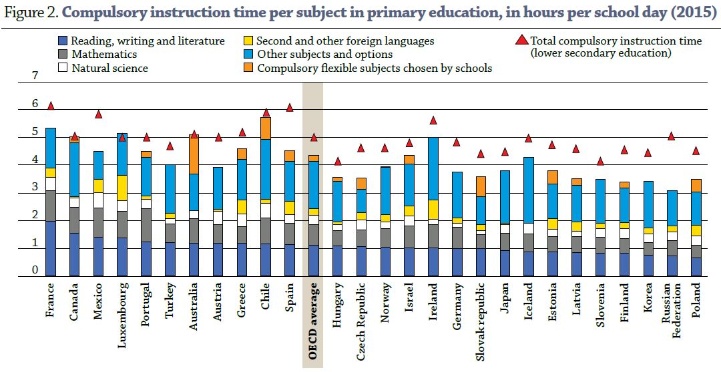
Figure 7.1 Time allocated to subjects across OECD countries (OECD, 2015)

The language teacher and teacher training

In most of the jurisdictions, the language teacher is a generalist teacher (Finland, Belgium and New Zealand). In Canada, the teacher can be either a generalist or specialist teacher and in Wales, the teacher is a specialist teacher. In some jurisdictions, shortages of language teachers have led to fluent personnel from the community being used as language teachers (e.g. New Zealand for teaching Maori).
New Zealand provides other suggested solutions to a shortage of language teachers such as one-year immersion courses in the target language(s), using a National Language Advisers and a language assistant programme, itinerant teachers, online learning and sharing expertise through Communities of Learning and other networks (Auckland Languages Strategy Working Group, 2018). With a long history of running correspondence schools, New Zealand also put forward online courses and learning as a way to assist teachers with their language competency (Auckland Languages Strategy Working Group, 2018).
In most instances, languages have been part of the primary system for so long that generalist teachers receive training as part of initial teacher education. Some countries specifically target high calibre teachers (e.g. Finland).

Language continuity

For each of the jurisdictions with a core/basic/framework curriculum, local educational factors are decided at local level. Some of these curriculums span primary and lower secondary education (e.g. Finland and New Zealand), in which case, some level of planning may be carried out locally to ensure continuity of provision between school levels. In Canada BC, this is stipulated in the Language Education Policy (British Columbia Ministry of Education, 2004).
Across all three communities in Belgium, the second language is usually the other national language. This would provide continuity across levels.

Language assessment

In all jurisdictions, the core/basic/framework curriculum or national curriculum outlines learning objectives/outcomes/core skills/performance standards which are used as a basis for formative classroom assessment by the teacher. Teachers are provided with autonomy on all matters related to assessment. Different jurisdictions make reference to Assessment for Learning, Assessment as Learning and Assessment of Learning (self-assessment).
Some jurisdictions offer assessment tools (New Zealand) or frameworks (Canada BC) to assist teachers in assessment.

Special Educational Needs

Each of the jurisdictions was re-examined in the context of modern foreign languages and their place with children who have special educational needs (SEN). The SEN classifications provided within each jurisdiction differed slightly in their labelling and in their inclusion of differing target groups. Some jurisdictions included gifted children or those who suffer absences due to illness or those who partake in the performing arts.
Each jurisdiction offered a three-staged approach to support, scaffolded by Individual Education Plans (IEPs).
- All support and provision for children with SEN began at the school- and classroom-level, with supports put in place to facilitate children to access the full curriculum.
- Where additional supports were required, a differentiated/adapted/customised curriculum was tailored to children’s individual needs.
- Children could also be exempted from subjects in cases where they would not be able to access the curriculum. In some cases (e.g. Finland), the curriculum was adapted to a topic-based one which focused on skills such as motor skills, language and communication, social skills, activities of daily living and cognitive skills.
Provisions were made in some jurisdictions for translated documents, translators and interpreters so that families from other linguistic or cultural backgrounds could access all of the information relating to their child.
These provisions followed for all curriculum subjects, including any modern foreign language curriculum in place.

Conclusion

The focus of discussion thus far has been on international jurisdictions, their policies and existing modern foreign language teaching and learning practices. Canada, Finland and Belgium offered glimpses into the format of long-established modern foreign language teaching and learning programmes and how they constantly evolve to provide greater provision for more languages and/or earlier starts in modern foreign language learning. Wales provided a sample of an established language teaching and learning programme at upper primary level with proposals for an earlier language entitlement led by a national strategy. New Zealand was the only jurisdiction examined with an optional primary modern foreign language component. It too had a national strategy in place with a phased implementation plan to improve Maori provision and professional development for teachers. An accompanying bill reinforced the strategy with the appropriate resources to fund and support these changes.
The trends which emerged across the jurisdictions were explored in this section. Much can be learnt from these jurisdictions:
- How national strategies can formulate new processes and foci for improved modern foreign language teaching and learning provision and how they can impact varying levels of change.
- How local factors can influence the uptake, format and choice of modern foreign language(s).
- How different types of resourcing can be made available to promote, diversify and improve modern foreign language uptake and teaching.
- How primary modern foreign language learning can and has been done successfully elsewhere (Canada, Finland and Belgium).
- How challenges can emerge in more recent introductions of primary modern foreign language teaching and learning (Wales and New Zealand).
- How the logistical challenges associated with teacher expertise, curriculum time, continuity of learning and language choice have been factored in in other jurisdictions.

Indeed, logistical challenges, have been and remain among the stumbling points for foreign language provision at primary level in Ireland. Some efforts were made in the past to begin to overcome some of these challenges and work towards a national provision through the MLPSI. The completion and ongoing implementation of the Primary Language Curriculum/Curaclam Teanga na Bunscoile with its support for other languages and a cohesive language strategy which promotes diversity of languages and greater uptake of language learning make it timely to re-examine foreign language provision at primary level.
The next section brings the focus of discussion back to Ireland and examines samples of autonomous foreign language provision in a small number of schools which integrate modern foreign languages into the school day. These schools have overcome some of these logistical challenges. The legacy of the MLPSI is evident throughout these samples or vignettes and its chronology from 1997 to 2012 is briefly examined.
  - 8. Ireland: Existing practice in modern language teaching and learning

Introduction

Some Irish schools include modern language teaching and learning during the course of the school day. Many more offer modern language classes as an after-school activity. The focus within this section is on the former—those schools or programmes which integrate a modern language into the primary school day.
In order to gain a snapshot of different models of modern language teaching and learning, schools and individuals known to NCCA staff were contacted and asked to share details of the modern language teaching and learning taking place in their school. A vignette template (see Appendix 3 and Appendix 4) was developed to ensure consistency across the details gathered from each setting. Any photographs included were sourced from Twitter or the school website and used with the teachers’ or principals’ permission. The following sections describe the school backgrounds and the foundations for and format of the language teaching and learning taking place in each setting.

Vignette 1: Lucan Community National School, Dublin - Mandarin Chinese

School background

Lucan Community National School was established in 2013 and was the fifth community national school to open in the Dublin area. It is now one of fourteen community national schools. Lucan CNS is a mixed English-medium school with classes from junior infants up to fourth class. It also has a small special educational needs class for children with ASD. Approximately 55% of the children in the school speak English as an additional language. The home languages of these children are those spoken in Eastern Europe, as well as Urdu, which is spoken in India and Pakistan.

Modern language learning and the language teacher

Lucan CNS facilitates Mandarin lessons at all class levels. The school has a future-focused ethos which provides a model of primary education that reflects life in the 21st century. Mandarin is the native language of 1.2 billion people. It is the language spoken by the largest cohort of native speakers in the world. Mandarin was also chosen as the modern language to be taught as the principal had participated in a Mandarin language learning programme in Galway prior to taking up her position in Lucan.
The Galway project began in 2008. It is a collaboration between the Confucious Institute, Han Ban Institute, Nangjing China and NUI Galway. Chinese third level students studying English arrive from China each year and facilitate the language learning in a cluster of eight Galway schools. The two Chinese institutes fund the project in Galway. The cluster of schools collectively pay a nominal fee to support the accommodation costs and travel expenses of one student to travel from Cork each week.
One visiting native speaker of Mandarin visits the school once per week to teach Mandarin to 5th and 6th class children in each of the schools for one year and then returns to China. The homebound and incoming students liaise on language teaching and learning achieved in the schools prior to their change-over.
Prior to the project commencing, school teachers were provided with the opportunity to learn Mandarin so that the language could also be integrated into the day to day routines of the classroom, as English and Gaeilge already were. Mandarin is also taught in some of the local post-primary schools in Galway, so continuity of language learning could be facilitated.
The same model of Mandarin teaching has been adopted in Lucan. In Lucan, all children from junior infants up to fourth class (with fifth class coming on stream in September 2019) learn Mandarin. There are children with special educational needs in most of the classes and half of the ASD class take part in the mainstream class for lessons with the assistance of their SNAs. Two children have exemptions from Irish but continue to learn the language, alongside Mandarin. All children access the Mandarin classes.
Differentiation is the same for all children, regardless of whether they have a special educational need or not. Children are assisted in their Mandarin language learning through the use of visuals, cues and revisiting language learnt during the previous lesson before the Mandarin teacher arrives for the subsequent lesson. The Individual Education Plan (IEP) for these children does not place much emphasis on Mandarin. Support teaching time focuses on one language only.
Different amounts of time are allocated to the Mandarin classes, with the amount of time increasing as the classes progress. Curriculum time for language, English and Gaeilge, is shared with Mandarin.
Classes | Time allocation per week
Junior and senior infants | 20 minutes per week
1st and 2nd classes | 35 minutes per week
3rd and 4th classes | 40 minutes per week
5th and 6th classes (from September 2019) | 45 minutes per week
Table 8.1 Time allocated to Mandarin learning at each class level
The Mandarin teacher provides all language teaching resources and uses the interactive whiteboard, flashcards, games, songs, poems and tongue twisters. The language teaching and learning approach complements the Communicative approach of the Primary Language Curriculum/Curaclam Teanga na Bunscoile and the play-based approach espoused in it and in Aistear. Planning is aligned with Gaeilge language learning, whereby children learn thematically.
The school principal reported that Mandarin, as a tonal language, is very musical. The Mandarin teacher uses speaking, moving and dancing during her lessons. Myths and legends are used to help teach the children about History, the meaning behind the language, and learning new vocabulary. The approach taken by the Mandarin teacher is similar to Story-line teaching and is very engaging for the children. The focus is on the spoken language up to 1st class. Reading and writing are introduced from 2nd class onwards.
Lucan CNS is linked up with a new primary school in Nangjing, China. Children share information around local festivities and day to day language. The children and their parents/guardians are very positive about Mandarin teaching and learning at the school.
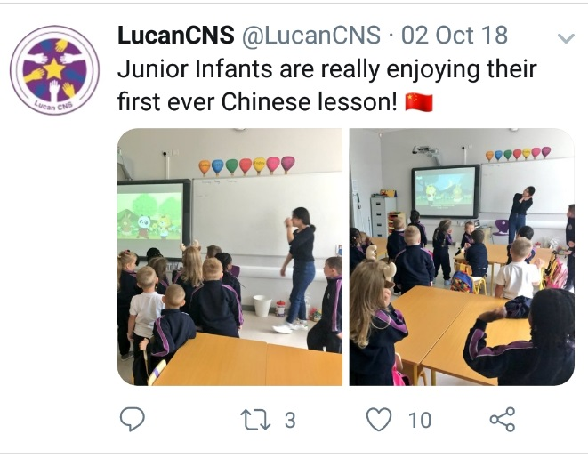 | 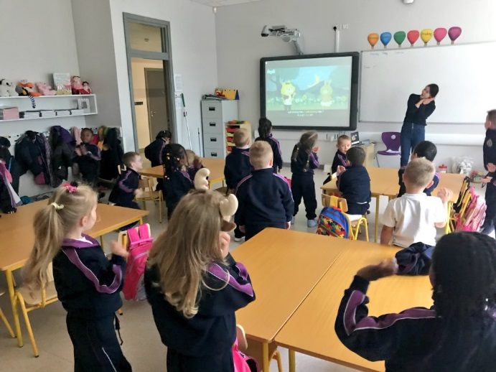
Mandarin is taught at all class levels in Lucan Community Schoool. The pictures illustrate Junior Infants’ first Mandarin class in 2018.
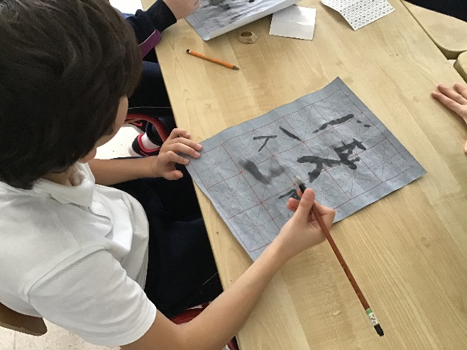 | 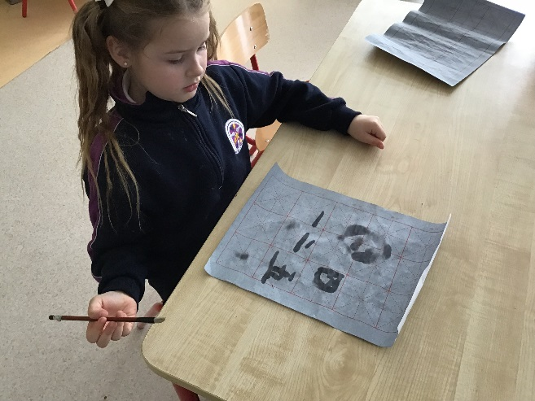
Children practising their Mandarin characters
Source: Twitter feed for Lucan CNS: https://twitter.com/LucanCNS/

Vignette 2: Gaelscoil de hÍde, Ros Comáin - German

I find it has a positive effect on pupils not only linguistically and academically (language learning is easier) but also socially in terms of their self-esteem, confidence and in assisting their preparation for secondary school. (School teacher and German language teacher, Coláiste de hÍde)

School background

Gaelscoil de hÍde is an Irish-medium school located in Roscommon town. The school is mixed gender with classes spanning from Junior Infants to 6th Class. There is a multi-grade infant class for Junior and Senior Infants, single stream 2nd, 3rd and 4th Classes, a multi-grade 4th/5th Class and a multi-grade 5th/6th Class. There are 250 children in the school. The majority of children in the school speak Irish or English at home. The medium of the school is Irish and there are few children who speak English as an additional language.

Modern language learning and the language teacher

German is the modern language taught at Gaelscoil de hÍde. The language was chosen, as one of the teachers, currently a special education teacher in the school, holds a primary degree in German and is a fluent German speaker. The school had previously participated in the Modern Languages in Primary Schools Initiative (MLPSI) and had been supported in their German language teaching through the MLPSI. The teacher had also participated in in-career training with the MLPSI at that stage and she had a personal interest in continuing to teach German in the school.
5th and 6th Classes learn German at Gaelscoil de hÍde. This is in keeping with the classes which took part in language teaching and learning through the MLPSI. Currently where children have special educational needs, they take part in the German lesson with their classmates in the same way they do the Irish lesson. In attending an Irish-medium school, children with special educational needs do not have an exemption from Irish. They excel in German language learning and were noted by their teacher as being some of the best in the class. The German lessons focus on listening and speaking skills, so differentiation is achieved through targeted questions, learning outcomes and tasks. All children are scaffolded in their language learning and production.
German is also taught at local post-primary schools, so continuity of language learning is facilitated. A two year resource grant was provided by the MLPSI during the school’s participation. The German resources purchased at that time are still in use in the school. The school uses Early Start German 1 and 2 which includes language assessment. German resources from the Goethe Institut are also used.
Classes | Time allocation per week
5th Class | 40 minutes per week
6th Class | 40 minutes per week
Table 8.2 Time allocated to German learning at 5th and 6th Class
German is taught as a separate subject. It follows the Communicative method of the Primary Language Curriculum and the legacy draft curriculum developed by NCCA for schools participating in the MLPSI. The focus is mainly on oral language skills and children do very little writing at this stage. It was estimated that children reach A1 level of the CEFR (Breakthrough or Beginner Level) by the end of their two years of language learning. As an example, the CEFR definition for Level A1 Spoken Interaction: Conversation is
Can understand and use familiar everyday expressions and very basic phrases aimed at the satisfaction of needs of a concrete type. Can introduce him/herself and others and can ask and answer questions about personal details such as where he/she lives, people he/she knows and things he/she has. Can interact in a simple way provided the other person talks slowly and clearly and is prepared to help. (Council of Europe, 2002)

The school has embraced German language learning and its presence is evident throughout the school. The school is also heavily involved in the eTwinning programme and is paired with other German schools through the eTwinning portal. The school participates in many projects through the portal.
The in-house school and language teacher also participated in an Erasmus+ programme which facilitated her visit to a German school to teach there. A visiting English teacher from Sulzbach am Main in Germany then spent time in Gaelscoil de hÍde in return. She spent time with each class and the 5th/6th Class also had a Skype call with her English class in Germany. The local and German school developed close ties through the Erasmus+ programme and continue to communicate with one another on a regular basis. The teacher in Gaelscoil de hÍde also works closely with Léargas and is an Ambassador for eTwinning. She has won an eTwinning European Quality Label Award for her work through eTwinning.
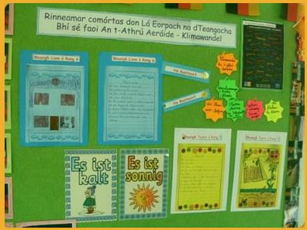
Gaeilge, English and German used in the classroom to participate in an eTwinning project on Climate Change.
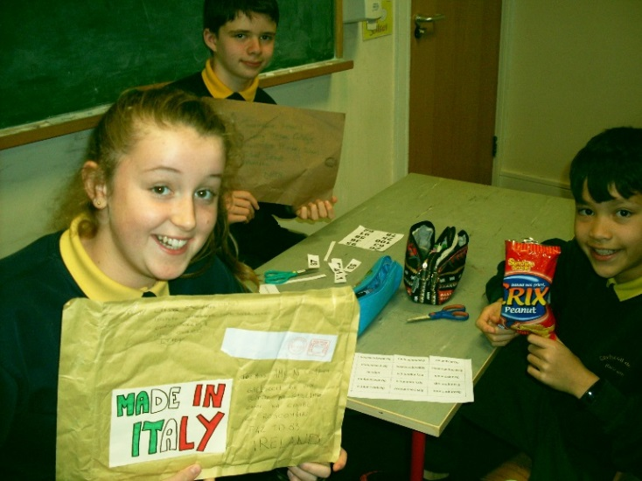
Package sent from the partner school in Italy
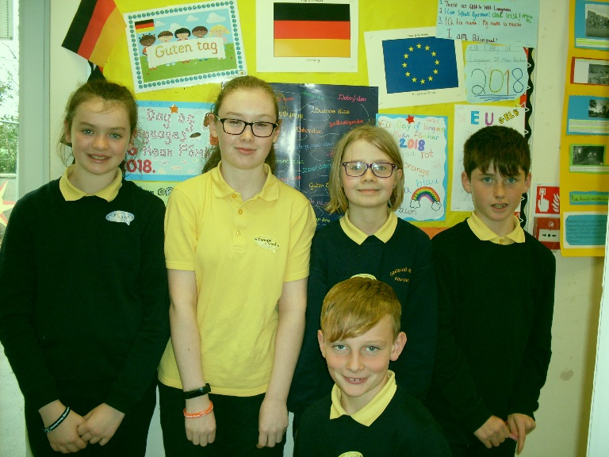
Children in front of their German work celebrating European Day of Languages which falls on 26th September each year.
Source: School website http://www.gaelscoildehide.ie/ and the German language teacher

Vignette 3: St. Comán’s Wood Primary School (& Scoil Mhuire Convent Primary School), Co. Roscommon - French

School background

St. Comán’s Wood Primary School is an English-medium mixed gender urban school. The school is newly amalgamated and is now one school on two separate sites. 645 children comprise the amalgamated total. The Junior Infant to 3rd Class cohort are housed at the first site, and one mile away, the 4th-6th Class cohort are housed at the second site. Each site has its own special needs team and SNAs.
St. Comán’s Wood has a diverse range of languages spoken by its children. Polish, Portuguese, Russian, Pakistani, Spanish, Slovakian, Latvian, Lithuanian, Czech, Italian and Romanian are the home languages of some of the children. There is a strong appreciation for and acknowledgement of children’s home languages in the school.

Modern language learning and the language teacher

St. Comán’s Wood has been incorporating modern language learning in different ways over the past number of years. The school originally participated in the MLPSI. French was taught to 5th and 6th Class children by parents who were French teachers and offered their services. When the teachers moved away and the MLPSI was discontinued, the French programme at the school ceased. Discretionary time was used to facilitate language teaching and learning at this stage. Spanish is currently offered as an after-school activity to 4th, 5th and 6th Classes, and Mandarin was also offered in the past.
During the 2017/18 school year, local 5th Year students participated in a programme to teach French in St. Comán’s Wood Primary School. They worked with 2nd Class during the third school term. The 5th Year students were graded by their French teacher on their French competence and teaching methodology and feedback was also provided by the primary class teacher.
During 2017/18, where children had special educational needs, SNAs were employed to assist and support their learning. Children were well supported during their French lessons. As the majority of teaching and learning centred around audio-visual resources, children’s understanding of new French words was aided by the visual resources. The class teacher during this time had previously participated in the MLPSI in this school. She noted that children with special educational needs or accessing learning support at this stage did not experience any challenges with accessing the French language learning.
The project was so successful that the current 5th Year students have again come to the school to teach the same class as the previous year – now in 3rd Class. The 5th Year students taught the class basic vocabulary and phrases using a play-based approach. Games, pictures, IT and online apps like Duolingo were employed in class.
French is taught at all three of the local post-primary schools and Spanish is taught at one of the local post-primary schools so continuity of language learning has been considered. Continuity in the language being taught has been built into the primary modern language teaching and learning programme, with the students coming from a local post-primary school.
A combination of language and discretionary time are used for the 30 minutes of weekly French language teaching.
Classes | Time allocation per week
3rd class in 2018/19 third term | 30 minutes per week
Table 8.3 Time allocated to French language learning through the French programme
The school principal was very positive about the MLPSI, noting that the children had really enjoyed learning another language alongside Gaeilge.
In 2010, the school won a European Language Label Award in recognition for its work on a Dual Language Book project. Children wrote dual language books in their home language and English. Other children wrote books in Irish and English. Parents of children who spoke English as an additional language were able to access the books and learn from their children’s writing.

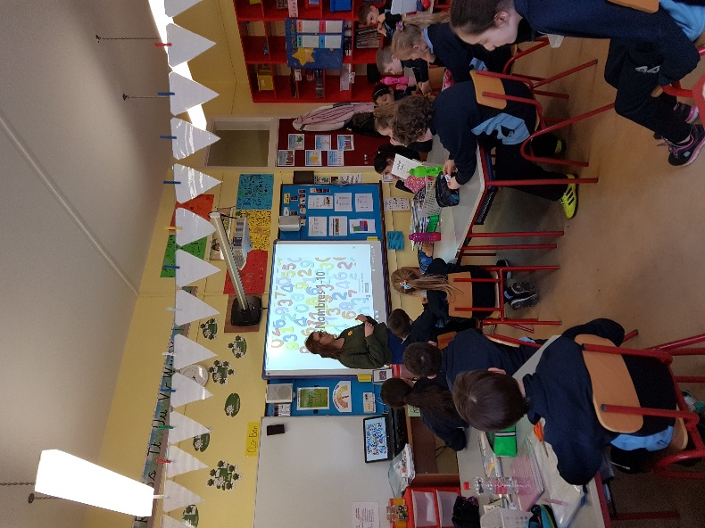 | 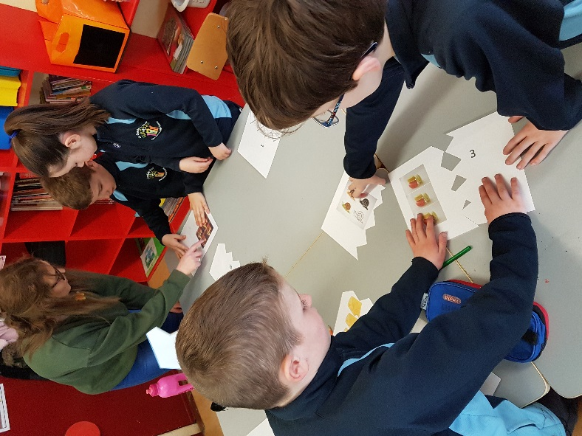
Local post-primary school students teach French at Comán’s Woods Primary School
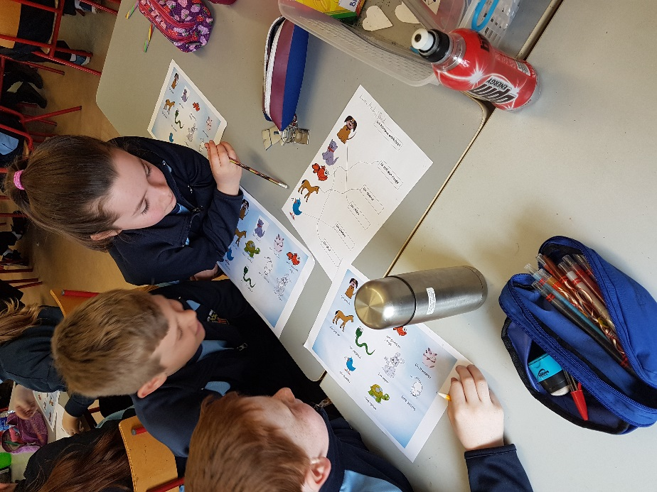 | 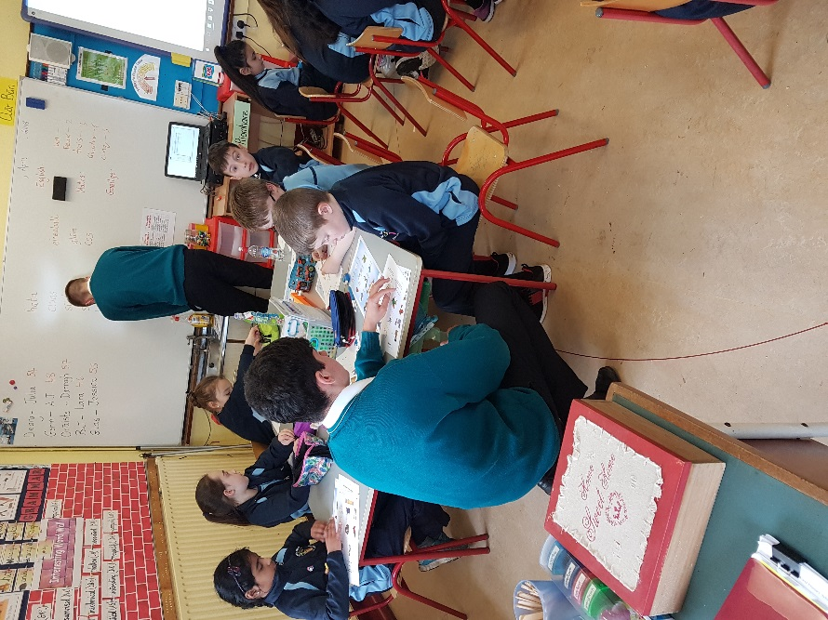
Children work together to match phrases and words to the corresponding images. | Children’s work is supported in the classroom by the 5th Year students.

Vignette 4: Eglish National School, Galway

School background

Eglish National School is a Changemaker school. It is a rural English-medium school located in Ballinasloe, Co. Galway. The school has DEIS status. Eglish NS is a multi-grade school with 44 children enrolled. Many of the children come from the Travelling Community and speak Cant and English. Approximately one third of children have special educational needs.

Modern language learning and the language teacher

French was taught in Eglish NS up until 2014. With the cessation of the MLPSI in 2012, it was felt that there was a reduced emphasis on modern language learning. As a result, and coupled with staff rotation, the school concluded their French language provision. A recent parental questionnaire indicated that parents would like their children to learn a modern foreign language in primary school. The school intends to restart their French provision in September 2019. Two of the school’s teachers have third level qualifications in French and two other teachers are confident in their French language proficiency and enjoy teaching French.
The school principal and another teacher in the school had both participated in the MLPSI in other local schools. They have access to resources which were purchased using the two-year resource grant from the MLPSI. These will be reemployed in Eglish NS in September and comprise CDs, flashcards, posters and language learning games.
French is taught in the local post-primary schools, so continuity of language learning can be facilitated.
During prior French language provision at Eglish NS, all classes learnt French—the senior room with 4th, 5th and 6th Classes, middle room with 1st, 2nd and 3rd Classes and junior room with Junior and Senior Infants. The amount of time allocated to French increased as the classes progressed through their years.
Classes | Time allocation per week
4th/5th/6th Classes (Senior Room) | 1-1½ hours per week
1st/2nd/3rd Classes (Middle Room) | 30 minutes per week
Junior and Senior Infants (Junior Room) | 30 minutes per week
Table 8.4 Time allocated to French language learning at all class levels

A Communicative Approach was adopted for French language teaching in the school, in line with the draft curriculum for the pilot project on modern languages (NCCA, 1999), the English Curriculum and Curaclam na Gaeilge (1999). Emphasis was predominately placed on oral and aural skills, and on ensuring a fun and positive introduction to French was achieved. Songs, games and drama were used to explore and reinforce language being learnt. Language teaching and learning was centred on language functions, also in keeping with Curaclam na Gaeilge (1999). These included basic conversations on topics like introducing yourself, numbers, days of the week, food, hobbies and clothes.
In 2013/14, the school secured a Comenius Assistant from Normandy, France through the Comenius Programme, which made a French language teacher available to the school. All classes were taught French, and language learning was integrated with music, social skills. Literacy, SESE and Arts. The Comenius Programme ran from 2007 to 2013 at EU level and was an education and training programme. Its aims included encouraging the learning of modern languages and increasing the mobility of language learners and teachers. The programme was replaced by Erasmus+ in 2014.
Eglish NS currently participates in Erasmus+ Programmes. The key actions the school is partaking in relate to availing of training in other countries and the school partnership project. The school is partnered with schools in Finland, UK, Poland, Italy, Romania and Spain. Senior room students accompany teachers in travelling to these countries to explore collaborative projects. Ahead of any of these trips, the senior room children do conversational classes in the language of the partner country.

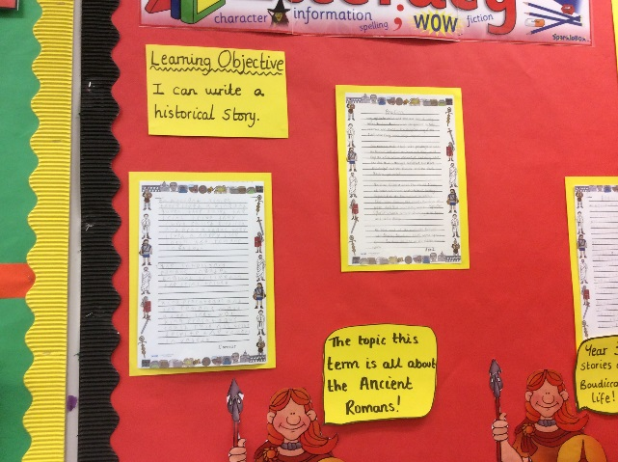 | 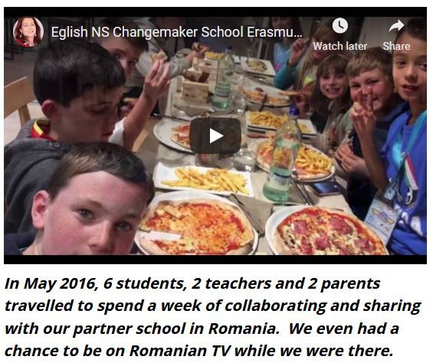
Project work on the Erasmus+ joint project on “Invaders, how they shaped the Europe of today”
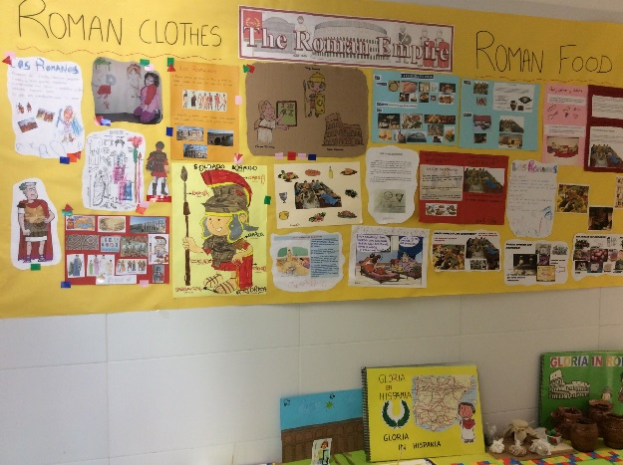 | 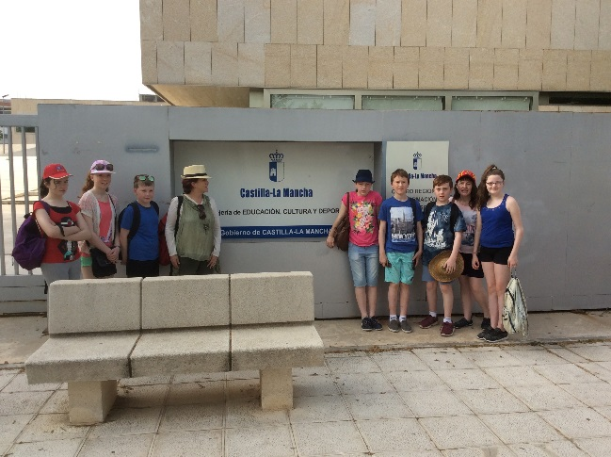
Senior room children accompany their teachers on an Erasmus+ trip to Spain to one of their partner schools

Vignette 5: Scoil Bhríde (Cailíní), Blanchardstown, Dublin - French

School background

Scoil Bhríde (Cailíní) is an English-medium girls’ school located in Blanchardstown, Dublin. There are over 320 children enrolled in the school. Approximately 80% of the school’s children speak English as an additional language, with the number of home languages alongside English and Irish totalling 50. The languages spoken at Scoil Bhríde include Polish, Urdu, Hindi, Arabic, Romanian, Portuguese and Malayalam. The school has adopted an integrated approach to language education that embraced the language of schooling, English, and the language of the curriculum, Irish (Kirwan, 2018: 30). All home languages are also welcome in the classroom, and used for curriculum delivery.

Integrated language learning and the classroom teachers

Scoil Bhríde participated in the MLPSI and French was taught to 5th and 6th Class children. As the school had capacity within its teaching staff to continue to facilitate French language teaching and learning, modern language teaching continued on in 5th and 6th Classes after the MLPSI ceased. All children in these classes access the French lessons according to their levels of ability. Some children have special educational needs and access French and language awareness activities with their classmates.
The school principal and other school teachers teach French at Scoil Bhríde. Some of these teachers had learnt a modern language as part of their degree course. Others had learnt French for their Leaving Certificate. Discretionary time was used to incorporate French. An integrated approach to teaching and learning also facilitated time for French through language awareness activities.
Classes | Time allocation per week
5th and 6th Classes (Senior Room) | 30 minutes – 1 hour per week
Table 8.5 Time allocated to French language learning

A communicative approach was adopted for French language teaching which complemented the approach used for all languages of the curriculum and school. Children learnt through games, rhyme, song and dialogue. The language functions used reflected those used for Irish as well as those which were child-led according to their interests and ideas. One such child-led focus involved the 6th Class children producing an end of term fashion show. French, English, Irish and the children’s home languages were used in its production and performance.
French is taught in local post-primary schools which allows for continuity in language learning. Children were reported to have appreciated having the opportunity to learn French at primary level before transitioning into post-primary school and the associated requirement for modern foreign language learning.
Alongside learning French, the school principal was eager to ensure that the school’s linguistic diversity was treated as an asset. Children’s home languages are embraced in the school and used through the course of teaching and learning. As teachers do not have a knowledge of these languages, the children themselves bring these languages into the classroom, sometimes having had the prior assistance of their parents/guardians. This resulted in higher levels of pupil motivation and increasing ability to work autonomously. Some examples of languages in use include children making dual language texts using their own language with English or Irish as the second language, labelling clothes in all of the languages of the classroom and working through the days of the week in all languages of the classroom. Language awareness has become an inherent component of day to day teaching and learning. Parents/guardians are also encouraged to use their home languages to explain new concepts to their children to aid understanding.
Children who speak English as a native language have taken greater ownership of Irish being their language, for use in comparing and contrasting to other languages of the classroom. Their awareness of other languages has improved their attitude towards and increased their use of Irish. Children realised that Irish was not simply a subject to be learnt, rather it could be used for the purpose of meaningful communication (Kirwan, 2019: 45). Kirwan (2015) described how the profile of Irish improved within the integrated language approach:
Far from being swamped by the presence of other languages, one of the benefits of such an environment is the raising of the status of the Irish language, where pupils begin to formulate a concept of language itself and Irish is viewed as a means of communication. (p. 62)
In addition, children whose home language is neither English nor Irish have also embraced Irish. Aside from producing dual language texts between their home language and English, some children produce texts solely in Irish. One example saw a 3rd Class child who spoke Filipino at home keeping a diary in Irish about the adventures of her pet dog (Kirwan, 2019).
Scoil Bhríde illustrates how an integrated approach to languages can allow all languages of the school, curriculum and children to be taught and learnt together with mutual benefit.
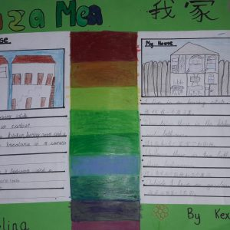 | 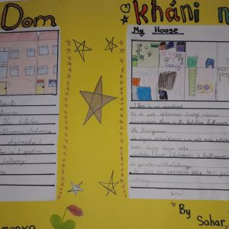
Children describe their homes in their home languages
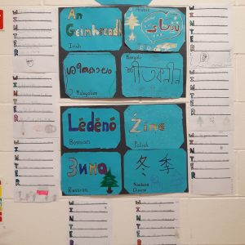 | 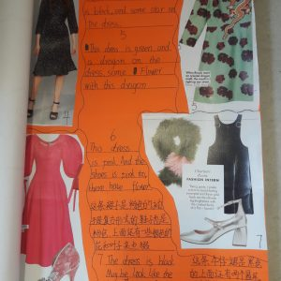
Examining the word ‘Winter’ in languages of the classroom and writing acrostic poems with the letters of Winter | Dual language fashion magazine
Source: Scoil Bhríde website http://scoilbhridec.ie/language-events/

Vignette 6: Scoil Phádraig Dobhar, Dhún na nGall – Fraincis

Is bónas é teanga eile a fhoghlaim. (Príomhoide scoile/múinteoir Fraincise).

Cúlra na scoile

Scoil lán-Ghaelach í Scoil Phádraig Dobhar i nGaeltacht Dhún na nGall. Scoil bheag í le 81 páiste, idir bhuachaillí agus chailíní, agus 5 mhúinteoir. Labhraíonn na páistí Gaeilge agus Béarla. Faoi láthair, níl aon riachtanais breise oideachais ag aon duine de na páistí.

Foghlaim nua-theangacha agus an múinteoir teanga

Bhí Scoil Phádraig Dobhar páirteach i dTionscnamh Nua-theangacha sna Bunscoileanna (TNTB) idir na blianta 2000-2002. Múineadh Fraincis do ranganna a 5 agus a 6 sa scoil. Ghlac an scoil páirt i dtionscnamh cara pinn as Fraincis agus ceanglaíodh iad le bunscoil i Vron, An Fhrainc. Bhí na páistí i dteagmháil lena chéile trí Skype agus tríd an bpost.
Ba í an príomhoide reatha an múinteoir Fraincise (agus múinteoir ranga sa scoil) le linn don scoil a bheith páirteach sa TNTB. Bhain sí cáilíocht i dteagasc nua-theangacha amach in Institiúid Teicneolaíochta Leitir Ceanainn. Bhí na hInstitiúidí Teicneolaíochta ar fud na tíre ag cur cúrsaí teastais agus dioplóma i dteagasc nua-theangacha ar fáil do mhúinteoirí cáilithe ar bhonn páirt-mhaoinithe ag an am sin.
Leanann an príomhoide ar aghaidh le múineadh na Fraincise do Rang 5/6 gach bliain ar feadh tréimhse 6 seachtaine. Bíonn na páistí i Rang 5/6 á múineadh le chéile. Mar sin, bíonn athdhéanamh agus breis foghlama ar siúl ag páistí Rang 6 agus bíonn Rang 5 ag foghlaim Fraincise den chéad uair.
Ranganna | Am in aghaidh na seachtaine
Rang 5 agus 6 (rang ilrangach) | 1-2 uair gach seachtain ar feadh 6 seachtaine
Tábla 8.6 Am a chaitear ar fhoghlaim na Fraincise le linn an tréimhse ama Fraincise 6 seachtaine
Úsáidtear na háiseanna a fuarthas leis an deontas TNTB sa scoil go fóill. Is éard ata iontu ná téacsleabhair, leabhair scéalta, dlúthdhioscaí agus cluichí foghlaim teanga.
Múintear an Fhraincis san iar-bhunscoil áitiúil, rud a chinntíonn go mbíonn leanúnachas ann maidir le foghlaim teanga. Deir na mic léinn a chuaigh go dtí an scoil seo gur chuidigh a gcuid eolais faoin bhFraincis leo aistriú go héasca go dtí foghlaim na Fraincise ag leibhéal iar-bhunscoile.
Múintear an Fhraincis mar ábhar faoi leith le linn na 6 seachtaine. Déantar comparáid áirithe idir Fraincis agus Gaeilge (mar shampla, ord na n-ainmfhocal agus na n-aidiachtaí sa Ghaeilge agus sa Fhraincis de ghnáth) le gur féidir leis na páistí úsáid a bhaint as a gcuid eolais faoi theangacha. Úsáidtear am roghnach curaclaim chun Fraincis a mhúineadh.
Baintear leas as an gcur chuige cumarsáideach chun Fraincis a mhúineadh, rud a dhéanann comhlánú ar an gcur chuige sa Ghaeilge agus sa Bhéarla. Déantar na bunfhrásaí agus bunfhoclóir a theagasc trí chluichí, trí amhráin agus trí scéalta. Mar sin, bíonn an bhéim ar thaitneamh a bhaint as an bhfoghlaim nuair atá siad ag sealbhú na teanga.
Ceapann an múinteoir Fraincise gur bónas é do na páistí teanga eile a fhoghlaim agus thug sí faoi deara go raibh tionchar dearfach ag an bhFraincis ar fhoghlaim na Gaeilge. Faoi mar a dúradh, deineadh comparáid idir foghlaim na Fraincise agus na Gaeilge le linn na gceachtanna Fraincise.

Vignette 6: Scoil Phádraig Dobhar, Dhún na nGall – French

Any extra language learning is a bonus. (School principal / French language teacher)

School background

Scoil Phádraig Dobhar is an Irish-medium school in the Donegal Gaeltacht. It is a small mixed gender multi-grade school housing 81 children and 5 teachers. Children speak Gaeilge and English. Currently, none of the children attending the school have special educational needs.

Modern language learning and the language teacher

Scoil Phádraig Dobhar participated in the MLPSI during the period 2000 to 2002. French was the language taught to 5th and 6th Class children in the school. During this period, the school partook in a French penpal project and were matched up with a primary school in Vron, France. Children communicated with one another via Skype and by post.
The current school principal was the French teacher (and a class teacher at the school) during the school’s participation in the MLPSI. She received a teaching qualification in modern languages (French) at the local Letterkenny Institute of Technology (IT). ITs across Ireland offered partially-funded certificate and diploma courses to qualified teachers in a modern language at this time.
The school principal continues to teach French each year to the 5th/6th Class over a 6 week period. Children in the 5th/6th Class are taught together. Therefore, the 6th Class cohort revise and add to their prior learning and the 5th Class cohort learn French for the first time.
Classes | Time allocation per week
5th and 6th class (multi-grade class) | 1-2 hours per week over 6 weeks
Table 8.6 Time allocated to French language learning during the 6 week French term
Resources sourced using the MLPSI resource grant are still in use in the school. They comprise textbooks, story books, CDs and language learning games.
French is taught in the local post-primary school, ensuring continuity of language learning. Students who carry on to this school have reported positively on their existing knowledge of French easing their transition into French language learning at post-primary level.
French is taught as a separate subject during its 6 week period. Some parallels are drawn between French and Gaeilge (e.g. noun/adjective word order is used in Irish and with most French adjectives) so that children can apply their prior knowledge of languages. Discretionary time is used to facilitate French.
French is taught using a communicative approach, which complements the approach used for Gaeilge and English. Basic phrases and vocabulary are taught and learnt through games, songs and stories. In this way, a focus is placed on having fun whilst learning the language. The French teacher feels that any extra language learning is a bonus to the children involved and noted the positive impact that French had on Gaeilge language learning. As noted above, parallels were drawn between French and Gaeilge during French lessons.

Modern languages in primary schools: School trends

The vignettes presented here provide a snapshot of modern language teaching in primary schools. They represent a tiny sample of schools in Ireland and are by no means generalisable. However, they do assist in highlighting some possible solutions for the challenges which present themselves around the discussion of modern languages in the primary curriculum. Just as some trends emerged from the small sample of jurisdictions examined in earlier sections, similar trends emerge from the Irish school settings.

Change can happen at local level

All six of the vignettes have highlighted how a new programme, such as modern language learning, can take root at the local level through the initiative of an individual or local programme. In the case of language learning, a language ambassador (principal and/or teacher) who believes in the benefits of a broad language learning experience and/or has a personal interest in promoting a broad language learning experience from their own positive interaction with languages, can positively influence many cohorts of children passing through their care. The support of the school principal is also a requirement in the success of any local change. Looking through the awards presented by language organisations such as Léargas (e.g. European Language Label) and eTwinning, it is evident that many of these language ambassadors exist across Irish primary schools.
Similarly, the Mandarin and 5th Year French language programmes described also provided a basis from which a local change could commence. In the case of the Mandarin programme, clusters of schools worked with the Confucious and Han Ban Institutes and the shared expertise of one language specialist benefitted many schools and children. The 5th Year French programme provided one example of how language expertise could be shared within a community. A similar example is evident from the New Zealand jurisdiction where the linguistic expertise of local Maori speakers is drawn upon in schools. In Ireland, a new model of post-primary language teachers being shared between schools has been proposed to help combat some of the challenges associated with the short supply of language teachers. The language teacher will be discussed further in Section 8 below.
Of note across the Irish vignettes, is that five of the six schools described had participated in the MLPSI. In some cases, resources sourced with MLPSI funding were still in use in classrooms.
Section 7 noted how any educational change at a system level requires a top-down, government-led policy, to drive the change. The Irish vignettes have highlighted how a bottom-up approach can also be effective at local level.
This push and pull between national and local programmes was also evident in the international jurisdictions. Many of the national policy changes were led by the successes of pilot projects in schools. Local preferences were then accounted for by creating a framework or core curriculum at national level from which the local school boards or systems could base their own tailored curriculum or model on. In this way, local schools could tailor the language choices to those which were most relevant to their school-going cohorts.

Time for modern language teaching

In each of the vignettes, time was sourced within the school day for modern language teaching and learning to take place. This time varied from 30 minutes to 120 minutes per week.
In the case of the first vignette from Lucan Community National School, language time for English and Gaeilge was shared with Mandarin. The second vignette from Gaelscoil de hÍde also described how this language time was shared with German. The third vignette from St. Comán’s Wood used a combination of language and discretionary time for French. Discretionary time was used in Scoil Bhríde alongside using an integrated approach to draw on French language learning through other language awareness activities. Scoil Phádraig Dobhar also used discretionary time to facilitate the 6-week course in French each year. In each case, English and Gaeilge teaching and learning were noted to have benefitted from the inclusion of a third language which could be used as a further basis for the transferrable language skills described in the new Primary Language Curriculum/Curaclam Teanga na Buncoile (2019). The modern language provided one basis for other languages referred to in the curriculum.
In each of the vignettes, making space for modern languages showed examples of how the modern language enhanced other areas of teaching and learning. For example, images included in the description of the vignette from Gaelscoil de hÍde highlighted how a language-based project on climate change extended learning from the language area to SESE. SESE, cultural learning and intercultural awareness were also fostered in the same school through eTwinning links and the week-long visit of an English teacher from Germany. Similarly, the Erasmus+ links with European schools established in the fourth vignette highlighted how a History-based project can form a common basis from which language can be shared and learnt. The fifth vignette showed an example of a plurilingual school embracing all of the languages of the school children. These languages were seen to be included in all teaching and learning across curriculum subjects.

Which language?

In all six vignettes, the choice of language was dependent on the availability of a teacher with language expertise (Mandarin, German or French).
Mandarin was accessed through the initiative described in the first vignette from Lucan Community National School. The language was chosen as the school principal continued her participation in a Mandarin programme in which she had previously participated in Galway. Her link with the Confucious Institute and Han Ban Institutes allowed the school to access a native Mandarin speaker.
The second vignette from Gaelscoil de hÍde described how the school teacher’s expertise in German language was accessed and shared across her school. Her language background and positivity towards language learning extended local language learning to include intercultural awareness and understanding through European links with other schools. The fourth vignette from Eglish NS also highlighted how two school teachers’ educational background in French and the willingness of two other school teachers to facilitate French, fostered an interest in progressing children’s linguistic and intercultural learning through two EU projects – Comenius and its successor, Erasmus+. Similarly, teachers’ expertise at Scoil Bhríde (Vignette 5) and Scoil Phádraig Dobhar (Vignette 6) allowed French language provision, originally with the support of the MLPSI, to be continued after the official cessation of the MLPSI.
The third vignette from St. Comán’s Wood Primary School highlighted how language expertise from the local post-primary school was accessed so that French language learning could be facilitated in the school.
The varied choice in each case shows how facilitating decision-making at local level can help to overcome challenges in accessing the required language expertise and in doing so, assist with the diversification of languages taught and learnt, one of the key goals in Ireland’s language strategy (DES, 2017).
In each case described, the language being learnt at primary level was also available at some or all of the local post-primary schools, facilitating some language continuity between school levels.

The language teacher

The discussion above (Section 8) around which language was taught in each setting highlighted the varying sources of language expertise accessed across the small sample of schools. The language teachers were a mixture of a native language speaker (with language teaching expertise), an in-house teacher (with a German or French language background) and language students still on their language learning path (local 5th Year students). One of the key logistical challenges with incorporating a modern language into a redeveloped primary curriculum is accessing suitable language expertise and/or providing professional development for primary school teachers.
The same challenge exists for any new addition to the primary curriculum. Millwood, Bresnihan, Walsh and Hooper (2018) described how Computational Thinking could be integrated into the curriculum by providing a phased approach to its embedding and the progression of teachers’ knowledge over time in the area.
At post-primary level, the goals of the national language strategy (DES, 2017) in diversifying and extending language learning are being achieved in spite of the dearth of language teachers. Peripatetic teachers have been employed to teach Japanese and Russian and concessionary teaching hours have been provided to support the greater uptake of Spanish and Italian. Saturday classes have also been offered to teachers in Japanese and Russian. Additional resources have been developed to support these four languages—Japanese, Russian, Italian and Spanish (DES, 2017). The language strategy noted that obtaining more widespread diversity in the languages being studied at post-primary level, and addressing the prevalence of French, would require attracting foreign language graduates into teacher education (DES, 2017). One further strategy refers to blended learning options (DES, 2007), which echoes the possible resourcing option (Section 7) drawn from the international jurisdictions around correspondence schools and the use of online tools to facilitate teaching and learning in New Zealand. Similar strategies could be considered at primary level.

Legacy of the MLPSI

Five of the six schools described within this section had had experience with modern language learning in the past through the MLPSI and the services it offered. The MLPSI legacy in these schools left a willingness and goodwill towards modern language learning from their prior positive experience. Teacher training and resources provided were still being accessed and used within Gaelscoil de hÍde, St. Comán’s Wood Primary School, Scoil Bhríde and Scoil Phádraig Dobhar, with provision to come back on stream at Eglish NS in September 2019.
The MLPSI also left a curriculum and resource legacy for modern language teaching at primary level in Ireland. A draft curriculum and associated teacher guidelines were developed by the NCCA for use within MLPSI schools. The MLPSI team also developed an accredited European Language Portfolio, My ELP, which was based on the draft modern language curriculum and aligned to the CEFR layout and requirements for a European Language Portfolio. Its running as a pilot project and initiative from 1998 to 2012 also provided a basis for much research on modern language teaching in Irish schools.
Figure 8.1 provides a brief summary of the MLPSI.

Modern Languages in Primary Schools Initiative (MLPSI): 1998-2012
(Annotations on the MLPSI chronology are provided in Appendix 5)
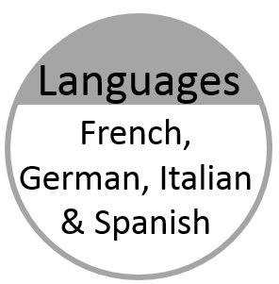 | 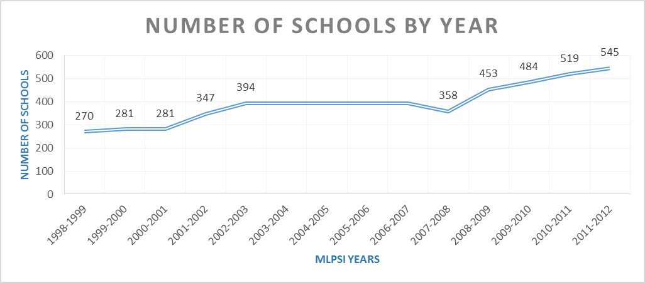
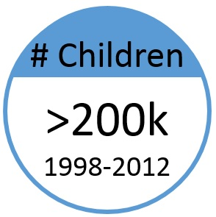
Figure 8.1 MLPSI Summary
(Compiled from Harris & Conway, 2002; Harris & O’Leary, 2006; NCCA, 2008; DES & Kildare Education Centre, 2012)

Conclusion

As mentioned at the outset of this section, the few samples of modern language teaching practice presented in Irish schools are far from representative. They do, however, provide glimpses into how modern languages are being integrated into the school day in different ways. Some of the conversation around logistical challenges associated with modern languages in the primary curriculum such as time, choice of language, continuity and teacher expertise commenced in this section. They have been more thoroughly considered at other junctures, such as the Feasibility and Futures Report in 2008 (NCCA). At this juncture, there have been a few developments since this topic was last examined in 2008, namely
- the phased development and implementation of the new Primary Language Curriculum/Curaclam Teanga na Bunscoile
- the new language curriculum’s focus on, and support for, other languages of new Irish children
- a cohesive national languages strategy which promotes diversity of languages being taught and learnt and a greater uptake of language learning.

The conversations around logistical challenges are as yet incomplete, but their consideration is timely. If modern languages are to form part of the curriculum story that this generation chooses to tell the next (O’Ruairc, 2013 citing Looney), then the discussion in Section 10 provides possible options for curriculum routes forward.
Before the discussion surrounding possible options progresses, the next section focuses on one of the concerns surrounding learning a third language (L3) in an educational context which already encompasses two languages (L1 and L2). Section 9 examines the impact of learning a third language within an existing L1/L2 language learning environment. Evidence from three sources is examined – (1) language learning research, (2) the Irish context of the MLPSI and (3) an Irish plurilingual classroom.

  - 9. Impact of learning a third language (L3) on existing language learning (L1 and L2)

Introduction

Ireland has a long tradition of language teaching and learning with English, Irish and other languages taught, learnt and considered in our classrooms. Evidence indicates that languages learnt in an integrated fashion have mutual benefit for all languages (e.g. Kirwan, 2015, 2018; O’Duibhir & Cummins, 2012; Groseva, 1998; Cummins, 2000). Indeed, O’Duibhir and Cummins (2012) collated the evidence of the positive impact of teaching languages in a cohesive and unified fashion through their background research on an integrated language curriculum. This positive impact was considered and adopted throughout the Primary Language Curriculum/Curaclam Teanga na Bunscoile (2019), where the diversity of English, Irish and other languages is celebrated and all languages are drawn upon as a rich resource in supporting language teaching and learning.
The Irish context of
- English and Irish teaching and learning
- heritage languages of new Irish children and their families, and
- a potential modern language
is a linguistically rich environment within which languages and their teaching and learning can positively impact one another.
The following subsections examine some of the evidence in more detail. While the discussion centres on integrated language learning more generally, and the impact of subsequent language learning on Irish more specifically, both are relevant to the discussion on the latter theme. A more thorough discussion on this topic is beyond the scope of this background paper.

Impact of learning a modern foreign language (L3) on L1 and L2: Evidence-based analysis

There is a large body of empirical research which suggests that learning how to read and write in any language contributes to the development of an underlying ‘common language proficiency’ in children, that languages are interdependent and that literacy skills and learning strategies acquired in one language can be transferred to other languages. (Harris & O’Leary, 2012: 48 citing O’Duibhir & Cummins, 2012)

Evidence from language learning research

O’Duibhir and Cummins (2012) described the main principles and research surrounding integrated language learning. They highlighted the gains which have been shown to be made when languages are taught in coordination with one another.
O’Duibhir and Cummins (2012) noted that learning efficiencies can be made when children draw on knowledge of their first or other language in learning subsequent language(s). Cross linguistic connections are already made by children as they learn subsequent languages. Through drawing their attention to these similarities and differences between languages, alongside structural differences, their implicit knowledge is activated to become explicit. Certain areas of knowledge in a first language can interfere in the acquisition of the second, such as pronunciation and syntax (O’Duibhir and Cummins, 2012: 29). However, the overall gains of skills transferred far exceed those which interfere.
Children’s cognitive and linguistic functioning (Cummins, 2001) and metalinguistic awareness (e.g. Bialystok, 1987; Cummins, 1978) improve when their competence in two or more languages is developed (O’Duibhir and Cummins, 2012: 30).
O’Duibhir and Cummins (2012: 32) identified four types of cross-linguistic transfer:
- Conceptual knowledge
- Specific linguistic elements (morphemes which carry across languages, e.g. tele in television)
- Phonological awareness (knowledge of and decoding of sounds of languages)
- Metacognitive and metalinguistic strategies (language learning skills).
These different types of transfer account for the gains which can be made when learning languages which are similar, as well as dissimilar.

Evidence from the Irish context – the MLPSI

Much research was carried out during the course of the pilot project on modern languages in primary schools and its latter title of Modern Languages in Primary Schools Initiative (MLPSI) from 1998 to 2012. The focus of the research was on gains made in language competence by participating children, feedback from participating children, views of their language teacher (whether peripatetic or school-based), views of the school principal and views of the classroom teachers in participating schools (who do not teach a modern language).
Some 99% of principals perceived advantages for pupils in learning a modern language (Harris and O’Leary, 2012: 42). Amongst the listed benefits, 36% cited improved learning, awareness and use of different languages amongst pupils as specific benefits (Harris & O’Leary, 2012: 42).
Data gathered from class teachers (who did not teach the modern language) was equally favourable, with a high majority of 89% of teachers being very positive/positive about the impact of modern language learning on children (Harris & O’Leary, 2012: 42). Teachers referred to the added advantages a modern language brought to children’s education:
- Increased language awareness (87%)
- Increased cultural awareness (84%)
- Preparation for second level language learning (84%)
- More positive attitudes towards language learning in general (66%)
- Increased awareness of language as a tool for communication (55%)
- Increased child self-esteem/confidence (51%)
- Enhanced learning in other subjects (26%).
(Harris & O’Leary, 2012: 42).

A closer examination of the positive and negative impact of modern language learning on other subjects in the curriculum highlighted that 75% of class teachers perceived positive effects on other subjects such as Geography, Music, Visual Arts and History, with the remaining 25% of teachers perceiving negative effects on Physical Education, Mathematics, Religious Education and Science. Of those teachers who reported a negative impact, only 8% perceived negative effects only, and 16% perceived both positive and negative effects (Harris & O’Leary, 2006: 76).
Irish was cited by 31% of teachers as being positively impacted by modern language learning and by 18.3% of teachers as being negatively impacted (Harris & O’Leary, 2012). The positive impact reported for Irish centred around improved language awareness (e.g. similarities and differences between languages, verb differences and cognates), improved attitude to learning Irish, increased pride in Irish, Irish newly viewed as a tool to communicate and the transfer of fun teaching methodologies from the modern language to Irish (Harris & O’Leary, 2006). Further details from the teachers revealed positive impact of a modern language on Irish:
- Improved attitude to learning Irish and increased pride in the language
- Indicates that no language is straightforward; all have irregular verbs, different expressions, etc.
- Emphasis on oral Spanish helping children to see in Irish the importance of language as a communication tool…
- Cuirtear na teangacha i gcomparáid agus pléitear na cosúlachtaí/difríochtaí.
(Harris & O’Leary, 2006: 78)

Reduced time for other subjects, increased disinterest in Irish compared to the modern language and language confusion among weaker students were reasons provided by teachers (some 24%) for the reported negative impact (Harris & O’Leary, 2012: 43). Further details on teacher feedback revealed perceived differences in the children’s perception of the usefulness of Irish and their motivation to learn Irish in comparison to modern languages:
- The modern language is viewed as a working language while Irish is not
- Objection to learning Irish because Irish is not a spoken language
- Has heightened the difficulty of teaching and learning of Irish – the majority of pupils are negative to Gaeilge
- Dislike Irish compared to French.
(Harris & O’Leary, 2006: 80)
These attitudes towards teaching and learning Irish are echoed in other sources (e.g. Council of Europe & DES, 2007; DES, 2007; Smyth, Dunne, McCoy & Darmody, 2006), and are not unique to the setting of modern language learning. Conversely, as part of the review of Curaclam na Gaeilge, NCCA later reported on improving student attitudes to and enjoyment of learning Irish through the increased emphasis on the communicative use of Irish through games, songs and rhymes (2008a).
English was perceived to be positively influenced by the modern language by 23% of teachers, and negatively by 14% of teachers (Harris & O’Leary, 2006). The positive impact reported for English related to additional opportunities to practise language skills (e.g. oral language and communication skills) and discussing areas of language awareness (the similarities between English and the modern language, more observant of word structure and order, tracing the origin of words) (Harris & O’Leary, 2006: 79). Reasons provided for modern languages having a negative impact on English included a reduction in teaching time for English, falling standards in English and the existing literacy needs of children in English (Harris & O’Leary, 2006).
When asked about any perceived change in children’s attitudes towards cultural and linguistic diversity, 54% of teachers noted a positive change in children’s attitudes, particularly towards improved interest in and awareness of other languages (Harris & O’Leary, 2012: 42). No change was perceived by 35% and 11% were uncertain (Harris & O’Leary, 2012: 42).
The positive impact of Irish language learning on modern language learning was noted by 49% of teachers. Of these teachers, 93% of those in Irish-medium settings reported benefits (Harris & O’Leary, 2012: 43). The benefits referred to by all positively responding teachers included language awareness and skills transfer (69%) and children being more open to learning new languages (12%) (Harris & O’Leary, 2012: 43).
Each of the six vignettes explored in Section 8 pointed to the positive influence of the modern foreign languages in the classroom and in some cases, on particular subjects like English and Irish. The next section examines findings from one school in more detail, through the school-based research of Kirwan (2015, 2018, 2019).

Evidence from a plurilingual setting

It is sad when schools do not permit pupils to learn other languages…”that’s like blocking a huge doorway…it’s taking away an advantage of exploring.” (Kirwan, 2019: 42, quoting a child whose home language is Kurdish)

Section 8 referred to the successes of including all languages of the classroom, curriculum and school into the day to day teaching of the Primary School Curriculum.
Evidence gathered by Kirwan (2015, 2018, 2019) has highlighted how indigenous Irish children, when hearing many other languages around them, took greater ownership of Irish as their language. As their peers used their home languages in school and pondered the contrastive linguistics of the languages within their environment, Irish became a more important facet for inclusion in these discussions. Kirwan (2019) discussed how facilitating children’s implicit language knowledge to become explicit, resulted in greater child autonomy in driving their exploration of language, honing their observational, reflective and analytical skills. These skills, once activated, become available for transfer to other areas of learning aswell (p. 41).
Kirwan (2018) noted children using their Irish more often for day to day interactions, to the extent that children were coming to the secretary in the morning to buy copies or pencils and they were asking for these items in Irish (p. 32). Children began to use Irish as a form of meaningful communication, inside and outside of the classroom setting. They realised it was more than a subject to be learned from a textbook (Kirwan, 2018: 31). Kirwan (2018) notes, that it is in using a language that we really learn that language (p. 32).
Children’s increased use of Irish as their second language around the school had a domino effect within the school and at home. Teachers were able to use a greater amount of Irish beyond daily interactions. The school secretary accessed an Irish language learning programme to revise her Irish language so that she could interact with the children more fluidly. A school SNA who was a non-native speaker of English also learnt Irish through communicating with the children. The parents asked the school to facilitate an Irish language class so that they could improve their Irish to assist their children with homework (Kirwan, 2019).

Conclusion

This section has examined some of the evidence surrounding the learning of a third language in an educational context which already accounts for two languages – English, Irish and other languages. Evidence suggests that additional language learning in any linguistic context is mutually beneficial to all languages in that context. This holds true of maintaining heritage languages and the impact of this linguistic knowledge on subsequent language learning, or the learning which is presented with new languages such as modern foreign languages, which present equal benefit to existing languages within that learning environment. Learning efficiencies, cross-linguistic connections, metalinguistic awareness and cognitive and linguistic functioning are just some of the gains made by learning languages in a cohesive fashion and with mutual gain.
Section 1 briefly focused on some of these cognitive and linguistic functions which language learning provides, such as enhanced logical thinking, creativity and interpersonal communication skills. These transferrable skills are relevant to other languages, as well as other curriculum areas.
The MLPSI provided a source of Irish-based evidence of the impact of modern foreign language learning on existing languages and subjects of the Primary School Curriculum. Evidence from two independent evaluations of the MLPSI reinforced some of the findings relating to the positive impact of language learning compiled by O’Duibhir and Cummins (2012). Improved language awareness, improved intercultural awareness and enhanced learning in other subjects were some of the positive impacts of modern foreign language learning reported. Classroom teachers reported on the positive impact that modern foreign languages had on other subjects like Geography, History and Irish, and the negative impact they had on Physical Education, Religious Education and Science. While the introduction of a modern foreign language to the school day had reduced time for other subjects, it was seen to have enhanced language learning as well as learning in some other subjects.
Kirwan’s research from a plurilingual school provided furte research-based evidence from an Irish source. Kirwan reported on the positive effect of embracing the many heritage languages of a school in the teaching and learning of all subjects in the primary curriculum. This increased integration of languages and focus on contrastive linguistics in the classroom, had a positive impact on existing languages of the school and languages of the curriculum. The status of Irish amongst Irish-born children improved. Irish was seen as a useful mode of communication, and not simply a school subject to be mastered. Consequently, the day to day use of Irish increased in the school, with more Irish being used for interactions between the children and school staff.
The new Primary Language Curriculum/Curaclam Teanga na Bunscoile celebrates the diversity of languages in primary classrooms and draws on this rich resource in supporting language teaching and learning. This, together with the integration of a modern foreign language, could have the potential to impact positively on all language learning at primary level and subsequent language learning at post-primary level.

The next section of this paper examines potential routes forward for modern language teaching and learning in a redeveloped primary curriculum. They are presented tentatively and for discussion.

  - 10. Potential routes forward for modern languages in a redeveloped primary curriculum

Introduction

This section provides potential routes forward for including modern foreign languages in the redevelopment of the primary curriculum. These are for consideration and discussion.

Stage 3: 3rd and 4th classes

Evidence from the jurisdictions examined in Sections 2-6 highlighted how other education systems embrace the transferrable language skills and enhanced linguistic ability presented through language learning. The skills listed, for example, within the Canadian second language curriculum, recognise that language learning presents improved cognitive development and creative thinking, the development of cultural awareness and understanding, a deepened understanding of personal identity, enhanced understanding of first languages and skills which transfer to other language learning. The Finnish curriculum refers to multilingual teaching situations which embrace all languages of the curriculum and children in the classroom. Finland capitalises on its linguistic diversity, and fosters it as a national asset. The Draft Curriculum for Wales 2022 recognises English, Welsh and other languages of the classroom and details achievement outcomes which draw on all linguistic resources.
The vignettes gathered from schools in Ireland, while not generalisable, show how many languages are present in Irish classrooms alongside the curriculum languages of Irish and English. Vignette 5 on Scoil Bhríde, for example, illustrated how plurilingual classrooms which take account of all linguistic resources in the school can lead to increased opportunities for teaching and learning languages of the curriculum. Encouraging children’s implicit knowledge of language to become explicit, resulted in greater child autonomy in exploring, observing and reflecting on known languages and new languages being learnt (Kirwan 2019). Plurilingual classrooms also reinforce the cultural identity of children who come from other cultural and linguistic backgrounds.
Section 9 highlighted how moving away from teaching languages in isolation from one another, can have mutual gain for all languages of the curriculum and classroom.
Given the existing challenges around modern language provision at primary level in Ireland (see Section 8) which remain as yet, unsolved, a Language Awareness approach is suggested at Stage 3 for 3rd and 4th Classes. This provision allows all schools to immediately draw on the languages of the curriculum and classroom, and maximise the linguistic and learning potential of Irish, English and other languages. A Language Awareness approach would also enhance the transferrable skills outlined in the Primary Language Curriculum/Curaclam Teanga na Bunscoile under the integrated process of language learning and across the elements of language learning. Language Awareness enables children to make cross-lingual connections, and develop an awareness of how language works and how it can be learnt.

Stage 4: 5th and 6th classes

Four of the five jurisdictions examined have a mandatory modern foreign language curriculum at primary level (Wales, Canada (BC), Finland and Belgium). Of these, each one commences its mandatory modern foreign language learning at upper primary level, between the ages of 10 and 11. Optional modern foreign language learning is available across all jurisdictions from an earlier stage, in some cases, commencing at the pre-school stage.
At a European level, 83.8% of primary school children learn a modern foreign language, with the provision commencing before the age of eight in the majority of cases (Eurydice, 2017).
The educational and economic imperative of modern foreign language learning for Ireland were outlined in Section 1.
A language competence model is suggested at Stage 4 for 5th and 6th Classes. The approach aims to complement the Primary Language Curriculum/Curaclam Teanga na Bunscoile and the Framework for Junior Cycle Modern Foreign Languages so that continuity of language learning across subjects, levels and sectors can be ensured. A language competence model presents specific modern language content to be taught and learnt.
The national languages strategy (DES, 2017) supports the languages of immigrant communities and their inclusion in the Irish education system. The strategy recognises that this should commence at primary level and that proficiency in the home language assists with accessing the language of instruction of the school, as well as fostering language awareness and positive attitudes to other cultures (DES, 2017). The strategy also recognises the need to diversify the range of languages taught in Irish schools and to increase their uptake. An earlier start in modern language learning could, over time, have a positive impact on post-primary and third level uptake of language learning.

Stage 3: 3rd and 4th Classes, Language Awareness model

What is Language Awareness?

Language Awareness involves engaging the child in reflecting on how languages are learnt, on similarities and differences between known and unknown languages (sentence structure, orthography, sounds) and the conventions of language. (NCCA, 2008: 28)

Language Awareness (LA), or knowledge about language, has been proposed as a bridging subject between a child’s native language and a new modern language (Hawkins, 1999). In bridging the divide between known and new languages, LA is a pedagogic approach which involves paying motivated attention to language in use, gaining insights into how languages work and learning the skills of language learning. LA assists in teaching languages in a more cohesive way, diverting from teaching them in isolation from one another (Candelier, 2004; Hawkins, 1999). The approach engages the child’s deductive skills, to recognise patterns and consistency or inconsistency across language(s) in his/her domain (Bolitho et al, 2003). This approach to teaching languages complements and reinforces the approach espoused in the new Primary Language Curriculum/Curaclam Teanga na Bunscoile (2019).
The cohesive nature of the Primary Language Curriculum/Curaclam Teanga na Bunscoile which provides a common structure for Gaeilge and English, by providing scope for other languages and showing areas of transfer between Gaeilge and English, is already inherently promoting LA. By its definition, LA is inferred in the curriculum’s description of language learning being an integrated process. The Primary Language Curriculum/Curaclam Teanga na Bunscoile recognises that an explicit focus on integration between languages enables children to make cross-lingual connections and develop an awareness of how language works (NCCA, 2019: 8). References to the transfer of certain skills and concepts between known and new languages as well as the differences which exist between languages all build upon the LA concept.
It is important to reinforce the point that LA is already an important component in the Primary Language Curriculum/Curaclam Teanga na Bunscoile and features through some of the initial support materials entitled “Language Awareness,” “Exploring Linguistic Diversity” and “The Place of Irish in a Multilingual Environment.”

A proposed Language Awareness model for Stage 3: 3rd and 4th Classes

Sometimes it’s, like, when we learn a language it’s easier to learn other ones; sometimes it’s not really about which language you’re learning it’s, like, how to learn a language. (Primary school child quoted in Kirwan, 2019: 45)

The Junior Cycle Modern Foreign Languages Framework (DES, 2015) employs Language Awareness as one of its three curriculum strands, alongside Communicative Competence, and Sociocultural Knowledge and Intercultural Awareness. Three elements comprise the Language Awareness strand:
- Reflecting on how the target language works
- Comparing the target language with other languages they know
- Reflecting on how they learn languages.

These three elements highlight the main areas of Language Awareness which could be embedded in the existing structure and content of the Primary Language Curriculum/Curaclam Teanga na Bunscoile. In doing so, the integrity of the curriculum would remain intact and additional learning and skills associated with Language Awareness could be embedded to enhance teaching and learning across languages. This is a similar approach to that taken in Canada where the language and cultural elements of First Peoples were integrated into all curriculum areas. Table 10.1 below provides descriptions and examples of each of the elements of Language Awareness in practice.
Junior Cycle Modern Foreign Languages: Language Awareness Strand Elements | Descriptions of Language Awareness (from DES, 2015; Keogh, 2015) | Examples
Reflecting on how the target language works | Direct linguistic comparison: Examine similarities and differences between new and known language(s)  (Lexical, grammatical, phonetic, phonological, morphological and syntactical) | Pronunciation, intonation, rhyme, vocabulary  grammar, word order, parts of speech, spelling, noun gender
Comparing the target language with other languages they know
Reflecting on how they learn languages | Learning to learn: Highlighting opportunities in areas of language learning to teach skills | Cognates, false friends,  language learning strategies, Assessment for Learning
Table 10.1 Tenets of Language Awareness (compiled from DES, 2015 and Keogh, 2015)
Many skills can be associated with focusing on Language Awareness, such as comparing, contrasting, recognising patterns, formulating rules and hypothesising, some of which are relevant to other subjects like mathematics and science. These are some of the transferrable language learning skills referred to briefly in Section 1. Table 10.2 describes some of the transferrable skills in Language Awareness relevant to science and mathematics.
 | Skills |  | LA Example(s)
Science | Analysing > Recognising patterns | - select appropriate observations that fit a pattern | Examine how plurals are formed in each language
 | Analysing > Interpreting | - interpret information and offer explanations  - draw conclusions from suitable aspects of the evidence collected | Examine false friends and cognates across languages
Mathematics | Applying and problem-solving | - analyse problems and plan an approach to solving them | Examine how word order differs across languages (English: SVO, Gaeilge: VSO)
 | Integrating and connecting | - recognise and apply mathematical ideas and processes in other areas of the curriculum | Compare and contrast the use of numbers across languages (e.g. counting, price, age, dates and seasons)
 | Reasoning | - make hypotheses and carry out experiments to test them  - make informal deductions involving a small number of steps  - explore and investigate mathematical patterns and relationships
Table 10.2 Examples of transferrable Language Awareness skills

Table 10.3 below takes one strand and element of the Primary Language Curriculum/Curaclam Teanga na Bunscoile and provides examples of the complementary language awareness learning outcomes which could sit alongside the existing ones. These additional learning outcomes do not add any additional content per se to those already outlined, rather they provide further avenues for their learning and reinforcement. In the first instance (sentence structure and grammar), an existing learning outcome also applies to language awareness.
STAGE 3: 3rd and 4th Classes
ORAL LANGUAGE
 | Learning Outcome |  | Language Awareness Examples
Understanding  the content and structure of language | 4. Sentence structure and grammar | Vary sentence length and structure, moving fluidly between a range of sentence types; simple, compound and complex, as appropriate to audience, purpose and language being spoken
 |  | Use grammar conventions appropriately and identify differences in sentence structure and grammar across languages and dialects [TF, C4]
 | 5. Vocabulary | Select and apply a variety of strategies to acquire a wide range of words and phrases from different sources such as literature, subject-specific texts and other languages [TF5, C3+4] | Compare vocabulary of new and known languages, making connections and distinctions as appropriate  Identify strategies for learning new vocabulary across languages, including gender, cognates and false friends, where appropriate
 | 6. Demonstration of understanding | Demonstrate understanding by listening actively to, understanding, analysing and responding appropriately to conversations and texts in a range of genres and across other languages where appropriate [TF6, C3+4] | Demonstrate an awareness of the sounds of languages, those which are unique and/or common across languages  Demonstrate understanding of frequently-used words and phrases related to areas of immediate relevance and experience, including the language of routine classroom interactions
Table 10.3 Sample learning outcomes for Language Awareness alongside existing content of the Primary Language Curriculum/Curaclam Teanga na Bunscoile (existing content is shaded in grey)

Stage 4: 5th and 6th classes, Language competence model aligning to the Primary Language Curriculum/Curaclam Teanga na Bunscoile

Stage 4 could see the Language Awareness approach of Stage 3 progressing into a language competence model of language learning. A similar framework approach to that taken at Junior Cycle would allow for local choice in language to be taught. Using the format of the Primary Language Curriculum/Curaclam Teanga na Bunscoile for the modern language would facilitate the easier integration and transfer of language knowledge and skills across all languages.
As the language learning would be commencing from an ab initio level, the level of learning in the modern language would not align to the level of learning for Gaeilge and English at Stage 4. However, all languages being learnt could be included within the Language Awareness strand which commences at Stage 3. The language functions would align to those outlined for Gaeilge and would provide opportunities for the revision and reinforcement of these functions in Gaeilge, English and other languages.
Aligning the content of the draft curriculum developed for the Pilot Project on Modern Languages in the Primary School to the Primary Language Curriculum/Curaclam Teanga na Bunscoile could be the starting point in devising a new modern language curriculum. Content should also align to the Junior Cycle Modern Foreign Languages Framework to ensure continuity of learning across levels. It would be envisaged that the level of competency reached by children at the end of Stage 4 would align to CEFR A1 Level (Breakthrough).

  - 11. Conclusion

The first section of this paper provided the rationale and background for the current work and its basis in Ireland’s language strategy (DES, 2017), the Primary Language Curriculum/Curaclam Teanga na Bunscoile providing scope for English, Irish and other languages, and previous NCCA work examining modern languages in the primary curriculum (NCCA, 2008). Ireland’s linguistic landscape has changed over the years as migration patterns to Ireland have changed. Some 11.6% of the population are non-Irish nationals living in Ireland. Their languages include Polish, Lithuanian, Romanian and Portuguese. Chinese and Arabic are also prevalent in Ireland with increases in the number of migrants from Asia and Africa.
Five international jurisdictions, Wales, Canada (BC), Finland, Belgium and New Zealand, were then described according to their language policy and context, the teaching and learning of languages in their education systems and special educational needs. Trends which emerged showed that most of the jurisdictions have long established primary language programmes in place. New Zealand retains modern language learning at primary level as an optional component. At a European level, 83.8% of all children learn a modern language at primary level. The language teacher ranges from generalist teachers in Finland, Belgium and New Zealand to generalist or specialist teachers in Canada and specialist teachers in Wales. Curriculum time for modern languages ranges from 2 hours per week to 9 hours at more advanced levels of language learning. Each of the jurisdictions offered ‘big ideas’ which were of note to the Irish context.
In Wales, the Global Futures national policy provides a plan to improve and promote modern foreign languages in Wales in 2015-2020. Its aim is to increase the number of students studying modern foreign languages, building towards a bilingual plus 1 language environment in Wales. This policy sits alongside the Welsh Government’s strategy to double the number of Welsh speakers to 1 million by 2050.
Canada provides scope for aboriginal languages, migrant languages and the national languages French and English within its education system. The new core curriculum fully integrates Aboriginal language and culture across all curriculum areas. The modern language to be taught at primary level is decided at local level. If a curriculum does not already exist for a language, a curriculum framework can be used to establish a curriculum at local level. This is then approved at national level and made available online for other local boards of education to access.
Finland views its citizens’ language skills as a national language reserve or asset. Its basic core curriculum provides for 12xL1 curriculums, 7xL2 foreign language curriculums and 6xL2 national language curriculums. Key projects in Finland focus on diversifying languages being taught and learnt, providing an earlier start in language learning through language showers at pre-school level and an earlier start at primary level, and creating positive attitudes towards language learning. Where successful, key projects progress to changes at national level for all schools.
Belgium comprises three language communities – Flemish, French and German. Each of the communities provides for pre-primary language programmes which include language awareness, sensitisation or CLIL formats. Belgium’s official policy stated that the language of instruction of schools must be the national language of that community. Local legislation in each of the communities gradually bypassed this requirement to allow for CLIL approaches in their local schools.
Modern language learning at primary level remains optional in New Zealand. The new strategy for languages in New Zealand (2019-2033) aims to strengthen language learning across local communities. Its first phase of work aims to extend Maori language learning to all Year 1-4 students by 2020 accompanied by phased improvements to teacher training (e.g. one year immersion programmes). A new bill sits alongside this strategy and aims to improve resourcing for language learning through teacher professional development, language specialists and the development of online resources. Online resources have been used for some time already in correspondence schools which provide online education to those who cannot attend a physical school building or who wish to access curriculum subjects which are not available at their local school. In New Zealand, local language experts are sometimes used to facilitate language learning in local schools.
Section 8 described how six Irish schools currently integrate modern foreign language learning into their school day at primary level. These were included to provide a sample of how a few schools have worked around some of the logistical challenges associated with including a modern foreign language in the primary curriculum. This small and non-representative sample of schools illustrated how local choice in accessing the availability of language expertise helped to facilitate different models of language learning during the school day.
Section 9 provided evidence of the positive impact of learning a third language (L3) on existing languages in the education system (L1 and L2). This benefit was considered and incorporated into the work on the development of the new Primary Language Curriculum/Curaclam Teanga na Bunscoile. The evidence shows that additional language learning in any linguistic context is mutually beneficial to all languages within that educational sphere.
Section 10 provided a draft outline of potential routes forward for modern foreign languages if they are to be included as part of the redevelopment of the primary curriculum. Language awareness was proposed as one option at Stage 3: 3rd and 4th Class to provide a greater focus on language learning skills. A language competence model was proposed as a further option at Stage 4: 5th and 6th Class. These routes forward are tentative and offered only as a starting point for discussions.

  - 12. References
Auckland Languages Strategy Working Group (2018). Strategy for Languages in Education in Aotearoa New Zealand 2019-2033. Retrieved from https://ilep.ac.nz/ [Accessed: 17/2/19].
Bolitho, R., Carter, R., Hughes, R., Ivanic, R., Masuhara, H. & Tomlinson, B. (2003). Ten questions about language awareness. ELT Journal 57(3), pp. 251-259. UK: Oxford University Press.
British Columbia Ministry of Education (2004). Language Education Policy Retrieved from: https://www2.gov.bc.ca/gov/content/education-training/k-12/administration/legislation-policy/public-schools/language-education-policy?keyword=language&keyword=education&keyword=policy [Accessed: 01/02/19].
British Columbia Ministry of Education (2009). BC Performance Standards: Reading. Retrieved from: https://www2.gov.bc.ca/assets/gov/education/administration/kindergarten-to-grade-12/performance-standards/reading/reading_intro.pdf [Accessed: 01/02/19].
British Columbia Ministry of Education (2015). Introduction to British Columbia’s Redesigned Curriculum. Retrieved from: https://curriculum.gov.bc.ca/sites/curriculum.gov.bc.ca/files/pdf/curriculum_intro.pdf [Accessed: 02/01/19].
British Columbia Ministry of Education (2016). Required areas of Study in an Educational Program Order. Retrieved from: http://www.bced.gov.bc.ca/legislation/schoollaw/e/m295-95.pdf [Accessed: 01/02/19].
British Columbia Ministry of Education, (2016a). Special Education Services: A Manual of Policies, Procedures and Guidelines. Retrieved from: https://www2.gov.bc.ca/assets/gov/education/administration/kindergarten-to-grade-12/inclusive/special_ed_policy_manual.pdf [Accessed: 09/07/19].
British Columbia Ministry of Education (2018). Second Language: German Curriculum. Retrieved from: https://curriculum.gov.bc.ca/curriculum/second-languages/5/german [Accessed: 01/02/19].
British Columbia Ministry of Education (2019). Languages Template. Ministry of Education Website Retrieved from https://www2.gov.bc.ca/gov/content/education-training/k-12/teach/curriculum/languages-template [Accessed: 01/02/19].
British Columbia Ministry of Education (2019a). German Curriculum: Rationale and Goals. Ministry of Education Website Retrieved from https://curriculum.gov.bc.ca/curriculum/second-languages/german/goals-and-rationale [Accessed: 01/02/19].
British Columbia Ministry of Education (2019b). A Framework for Classroom Assessment. Retrieved from: https://curriculum.gov.bc.ca/sites/curriculum.gov.bc.ca/files/pdf/assessment/a-framework-for-classroom-assessment.pdf [Accessed: 01/02/19]
British Columbia Ministry of Education (2019c). B.C.’s K-12 Assessment System. Ministry of Education Website. Retrieved from https://curriculum.gov.bc.ca/assessment [Accessed: 05/02/19].
Buyl, A. and Housen, A. (2014). Factors, Processes and Outcomes of Early Immersion Education in the Francophone Community in Belgium. In International Journal of Bilingual Education and Bilingualism, 17(2), pp. 178-196.
Bialystok, E. (1987). Influences of bilingualism on metalinguistic development. Second Language Research, 3, pp. 112-125.
Bialystok, E. and Cummins, J. (1991). Language, cognition, and education of bilingual children. In E. Bialystok (Ed.). Language processing in bilingual children, (pp.222-232). Cambridge: Cambridge University Press.
Candelier, M. (Ed.) (2004). Janua Linguarum. The gateway to languages. The introduction of language awareness into the curriculum: awakening to languages. Strasbourg Cedex: European Centre for Modern Languages, Council of Europe Publishing.
Carr, W. (2007). Teaching Core French in British Columbia: Teachers’ Perspectives. BCATML/BCTF Research Report.
Chopey-Paquet, M. (2007). Belgium (French-Speaking). In Diverse Contexts – Converging Goals: CLIL in Europe. D. Marsh and D. Wolff (Eds.), pp. 25-32. Peter Lang: Frankfurt.
Council of Europe (2002). Common European Framework of Reference for Languages: Learning, teaching, assessment. Guide for users. Strasbourg: Council of Europe. Retrieved from: http://culture2.coe.int/portfolio/inc.asp?L=E&M=$t/208-1-0-1/main_pages/../&L=E&M=$t/208-1-0-1/main_pages/documents.html [Accessed: 02/03/19].
Council of Europe and DES (2007). Language Education Policy Profile: Country Report: Ireland Retrieved from: http://www.coe.int/t/dg4/linguistic/Source/IrelandCountry_report_EN.pdf [Accessed: 03/03/19].
CSO (2017). Census of Population 2016 – Profile 7 Migration and Diversity. Retrieved from: https://www.cso.ie/en/releasesandpublications/ep/p-cp7md/p7md/p7se/ [Accessed: 20/02/19].
Cummins, J. (1978). Bilingualism and the development of metalinguistic awareness. Journal of Cross-Cultural Psychology, 9, pp. 131-149.
Cummins, J. (2000). Language, power and pedagogy: Bilingual children in the crossfire. Clevedon: Multilingual Matters.
De Vries, R. (2010). Structures of Education and Training Systems in Europe. Belgium – Flemish Community 2009/10.
DES, (2007). Irish in the Primary School, Inspectorate Evaluation Studies. Dublin: DES.
DES, (2011). Literacy and Numeracy for Learning and Life: The National Strategy to Improve Literacy and Numeracy among Children and Young People 2011-2020. Dublin: DES.
DES, (2015). Junior Cycle Modern Foreign Languages. Retrieved from: https://www.curriculumonline.ie/getmedia/bbb30195-a78a-4d66.../JCMFLspec.pdf [Accessed: 26/03/19].
DES (2016). Action Plan for Education 2016-2019. DES: Dublin. Retrieved from: https://www.education.ie/en/The-Department/Action-Plan-for-Education-2016-2019/ [Accessed: 20/02/19].
DES (2017). Languages Connect. Ireland’s Strategy for Foreign Languages in Education 2017-2026. Retrieved from: https://www.education.ie/en/Publications/Corporate-Reports/Strategy-Statement/Department-of-Education-and-Skills-Strategy-Statement-2016-2019.pdf [Accessed: 20/02/19].
DES, (2017a). DES Press Release, 19 April, 2017 - Minister Bruton to Prioritise Teaching of Foreign Languages. Retrieved from: https://beta.gov.wales/new-school-curriculum [Accessed: 10/02/19]
DES and Kildare Education Centre (2012). Final Report on the Modern Languages in Primary Schools Initiative, 1998-2012. Retrieved from: http://www.mlpsi.ie/images/MLPSI_Final_Report_July_2012.pdf [Accessed: 05/04/19].
Dillon, A. (2011) Teachers and Language Learning in Primary Schools: the Acquisition of Additional Languages in the Early Years. Unpublished PhD Thesis. Dublin Institute of Technology.
Department for Children, Education, Lifelong Learning and Skills, Welsh Assembly Government (2008), Modern foreign languages in the National Curriculum for Wales: Key Stages 2-3. Retrieved from: http://learning.gov.wales/resources/collections/key-stages-2-4?lang=en [Accessed: 25/01/19].
Eurydice, (2012). Key Data on Teaching Languages at School in Europe 2012.
Eurydice (2017). Eurydice Brief. Key Data on Teaching Languages at School in Europe. European Commission: Brussels. Retrieved from: https://eacea.ec.europa.eu/national-policies/eurydice/content/eurydice-briefkey-data-teaching-languages-school-europe_en [Accessed: 02/02/19].
Eurydice (2019). National Education Systems. Belgium - Flemish Community Overview. Retrieved from: https://eacea.ec.europa.eu/national-policies/eurydice/content/belgium-flemish-community_en [Accessed: 12/02/19].
Eurydice (2019a). National Education Systems. Belgium - French Community Overview. Retrieved from: https://eacea.ec.europa.eu/national-policies/eurydice/content/belgium-french-community_en [Accessed: 12/02/19]
Eurydice (2019b). National Education Systems. Belgium – German Speaking Community Overview. Retrieved from: https://eacea.ec.europa.eu/national-policies/eurydice/content/belgium-german-speaking-community_en [Accessed: 12/02/19]
Eurydice (2019c). Finland: Single Structure Education (Integrated Primary and Lower Secondary Education) Retrieved from https://eacea.ec.europa.eu/national-policies/eurydice/finland/single-structure-education-integrated-primary-and-lower-secondary-education_en [Accessed: 09/02/19].
Finnish National Agency for Education (2017). Finnish Education in a Nutshell. Retrieved from: https://www.oph.fi/download/171176_finnish_education_in_a_nutshell.pdf [Accessed: 08/02/19].
Finnish National Agency for Education (2019). New National Core Curriculum for Basic Education. Retrieved from Finnish National Agency for Education website https://www.oph.fi/english/curricula_and_qualifications/basic_education/curricula_2014 [Accessed: 08/02/19].
Finnish National Agency for Education (2012). Distribution of lesson hours in basic education. Retrieved from https://www.oph.fi/download/179422_distribution_of_lesson_hours_in_basic_education_2012.pdf [Accessed: 08/02/19].
Finnish National Board of Education (2016). National Core Curriculum for Basic Education 2014. Next Print Oy, Helsinki.
Flemish Ministry of Education and Training (2010). Flemish Eurydice report 2010. Organisation of the Education System in the Flemish Community of Belgium. Flemish Ministry of Education & Training: Brussels. Retrieved from:
Folktinget (The Swedish Assembly of Finland) (2019). Swedish in Finland. Folktinget website. Retrieved from: https://www.folktinget.fi/eng/about/ [Accessed: 08/02/19].
Furlong, J. (2015). Teaching Tomorrow’s Teachers. Retrieved from at: https://beta.gov.wales/review-initial-teacher-training-2015-teaching-tomorrows-teachers [Accessed: 24/01/19].
Government of Canada website, (2019). Official Languages Act. Retrieved from: https://laws-lois.justice.gc.ca/eng/acts/O%2D3.01/ [Accessed: 01/02/19].
Groseva, M. (1998). Dient das L2-System als ein Fremdsprachenlernmodell? In B. Hufeisen & B. Lindemann (eds). Tertiärsprachen: Theorien, Modelle, Methoden. Tübingen: Stauffenburg.
Halinen, I., Harmanen, M. and Mattila, P. (2015). Making Sense of Complexity of the World Today: why Finland is Introducing Multiliteracy in Teaching and Learning. In V. Bozsik (Ed.) Improving Literacy Skills across Learning. CIDREE Yearbook 2015 (pp. 136-153). Budapest: HIERD.
Harris, J. and Conway, M. (2002). Modern Languages in Primary Schools: An Evaluation of the National Pilot Project. Dublin: Institiúid Teangeolaíochta Éireann.
Harris, J. and O’Leary, D. (2006). Modern Languages in Irish Primary Schools: Views and Practices of Principals and Class Teachers. Unpublished report on Phase 2 of an independent evaluation of the Modern Languages in Primary Schools Initiative submitted to the Department of Education and Science August 18th 2006.
Harris, J. and O’Leary, D. (2012). A Third Language at Primary Level in Ireland: An Independent evaluation of the Modern Languages in Primary Schools Initiative. In Final Report on the Modern Languages in Primary Schools Initiative, 1998-2012. Dublin: DES and Kildare Education Centre, pp. 39-49.
Hawkins, E. W. (1999). Foreign Language Study and Language Awareness. Language Awareness, 8(3-4), pp. 124-142..
Hiligsmann, P. and Van Mensel, L. (2016). Assessing Dutch and English Immersion Education in French-Speaking Belgium: Linguistic, Cognitive and Educational Perspectives. American Association for Applied Linguistics. Retrieved from: http://hdl.handle.net/2078.1/173500 [Accessed: 17/02/19].
IBEC (2017). Ibec welcomes strategy for foreign languages in education. Retrieved from: https://www.ibec.ie/IBEC/Press/PressPublicationsdoclib3.nsf/vPages/Newsroom~ibec-welcomes-strategy-for-foreign-languages-in-education-04-12-2017?OpenDocument [Accessed: 20/02/19].
Irish National Teachers’ Organisation (1991). Foreign Language Teaching in Primary Schools: Issues and Research. Dublin: Author.
Keogh, K. A. (2015). Towards the development of localised and reusable teaching and learning content and resources for languages: From one content database to many teaching and learning resource outputs. PhD Thesis, Dublin City University. Retrieved from: http://doras.dcu.ie/20724/ [Accessed: 01/04/19].
Kirwan, D. (2015) Cultivating Plurilingual Environments: Opportunities in Pre-school, Primary School and Beyond. ETBI Spring 2015 edition (pp. 60-62). Retrieved from at http://www.etbi.ie/wp-content/uploads/2015/02/ETBI_Spring15_final_low-res.pdf [Accessed: 09/04/19].
Kirwan, D. (2018) Creating a plurilingual whole-school environment to support pupils’ learning. In (eds.) B. Skinner and B. O’Toole Minority Language Pupils and the Curriculum: Closing the Achievement Gap (pp. 28-33).
Kirwan, D. (2019) Multilingual environments: benefits for early language Learning. Teanga Special Issue 10, pp. 38-57.
Millwood, R., Bresnihan, N., Walsh, D. and Hooper, J. (2018). Review of Literature on Computational Thinking. Report commissioned by NCCA as part of the redevelopment of the Primary Curriculum. NCCA: Millwood et al. Retrieved from at: https://www.ncca.ie/en/resources/primary-coding_review-of-literature-on-computational-thinking [Accessed: 01/04/19].
Ministerium der Deutschsprachigen Gemeinschaft Belgiens (2008). Unterricht und Ausbildung in der Deutschsprachigen Gemeinschaft Belgiens. Ministerium der Deutschsprachigen Gemeinschaft: Eupen. Retrieved from: http://www.ostbelgienbildung.be/desktopdefault.aspx/tabid-2209/5222_page-2/ [Accessed: 17/02/19].
Ministerium der Deutschsprachigen Gemeinschaft Belgiens (2008a). ANHANG II. Rahmenplan Fach Französisch 1. Fremdsprache. Retrieved from: http://www.ostbelgienbildung.be/desktopdefault.aspx/tabid-2209/5222_page-2/ [Accessed: 17/02/19].
Ministry of Education (2007). The New Zealand Curriculum for English-medium teaching and learning in years 1–13. Retrieved from http://nzcurriculum.tki.org.nz/ [Accessed: 17/02/19].
Ministry of Education (2008). Te Arautanga o Aotearoa. Wellington: Learning Media Limited.
Ministry of Education (2011) Collaboration for Success: Individual Education Plans. Wellington: Learning Media Limited. Retrieved from: http://seonline.tki.org.nz/content/download/303/1782/file/CfS-IEP-web-low-res-F.pdf [Accessed: 13/05/19].
Ministry of Education (2019). New Zealand Education System: Overview. Retrieved from https://www.education.govt.nz/assets/Uploads/NZ-Education-System-Overview-publication-web-format.pdf [Accessed: 17/02/19].
Ministry of Education and Culture (2017). Multilingualism as a Strength: Procedural recommendations for developing Finland’s national language reserve. Retrieved from: https://ei-ie.org/en/detail/15618/finland-enhancing-national-language-skills. [Accessed: 04/02/19].
Ministry of Education and Culture (2017a). Development of Finland’s language reserve – making multilingualism Finland’s strength. Retrieved from: www.minedu.fi/en/multilingualism [Accessed: 10/02/19].
Ministry of Education and Culture & Finnish National Agency for Education (2018). Finland invests in early language learning. Retrieved from https://www.oph.fi/.../187642_Finland_invests_in_early_language_learning.pdf [Accessed: 10/02/19].
Ministry of Education and New Zealand Government (2019) Maori Education. Retrieved from Education Counts website: https://www.educationcounts.govt.nz/statistics/schooling/student-numbers/6040 [Accessed: 17/02/19].
Ministry of Education and New Zealand Government (2019a). Pacific Language in Education. Retrieved from https://www.educationcounts.govt.nz/statistics/schooling/student-numbers/6044 [Accessed: 17/02/19].
Ministry of Justice (2003). Language Act. Finlex Data Bank Website. Retrieved from

https://www.finlex.fi/en/laki/kaannokset/2003/en20030423.pdf [Accessed: 10/02/19].
Ministry of Justice (1998). Basic Education Act. Finlex Data Bank Website. Retrieved from https://www.finlex.fi/en/laki/kaannokset/1998/en19980628.pdf [Accessed: 04/02/19].
Ministry of the Flemish Community Department of Education (2001). The Development of Education. Micheline Scheys: Brussels. Retrieved from: https://www.vlaanderen.be/en/publications/detail/the-development-of-education [Accessed: 12/02/19].
National Council for Curriculum and Assessment, (2005). Primary Curriculum Review Phase One: Summary of Findings and Recommendations. NCCA: Dublin.
NCCA (2008). Modern Languages in the Primary School Curriculum: Feasibility and Futures. NCCA: Dublin.
National Council for Curriculum and Assessment, (2008a). Primary Curriculum Review Phase Two. NCCA: Dublin.
NCCA (2008b). Leading and Supporting Change in Schools. A Discussion Paper. NCCA: Dublin. Retrieved from: https://www.ncca.ie/en/resources/leading_and_supporting_change_in_schools_a_discussion_paper [Accessed: 02/02/19].
New Zealand Parliament (2019). Education (Strengthening Second Language Learning in Primary and Intermediate Schools) Amendment Bill. Member’s Bill. Retrieved from https://www.parliament.nz/en/pb/bills-and-laws/bills-proposed-laws/document/BILL_80226/education-strengthening-second-language-learning-in-primary [Accessed: 17/02/19].
O’Connor, A. and Ciribuco, A. (2017). Language and Migration in Ireland. Immigrant Council of Ireland: Dublin. Retrieved from: https://www.immigrantcouncil.ie/sites/default/files/files/Language%20and%20Migration%20in%20Ireland.pdf [Accessed: 20/02/19].
O’Duibhir, P. and Cummins, J. (2012). Towards an integrated language curriculum in early childhood and primary education (3–12 years). Research Report No. 16. Dublin: NCCA. Retrieved from: https://www.ncca.ie/en/resources/towards_an_integrated_language_curriculum_in_early_childhood_and_primary_education {Accessed: 03/03/19].
OECD (2015). Education at a Glance 2015: OECD Indicators, OECD Publishing, Paris, http://dx.doi.org/10.1787/eag-2015-en, Indicator D1.[Accessed: 21/01/19].
O’Ruairc, T. (2013, February). Current directions in teacher education and curriculum reform in Ireland. Paper presented at Symposium on Current directions in teacher education and curriculum reform in Ireland, UCC, 22 February 2013. Retrieved from at: https://www.teachingcouncil.ie/.../teacher-education/presentations/teacher-education-and-curriculum-reform-in-ireland-ucc-22feb2013.pdf [Accessed: 01/04/19].
Parliament of Canada, (2019). BILL C-91. An Act respecting Indigenous languages. Retrieved from: http://www.parl.ca/DocumentViewer/en/42-1/bill/C-91/first-reading [Accessed: 08/02/19].
PISA (2015). Finland Student performance. Retrieved from: Education GPS, OECD http://gpseducation.oecd.org [Accessed: 20/02/19].
Prime Minister’s Office Finland (2015). Finland, a land of solutions. Strategic Programme of Prime Minister Juha Sipilä’s Government. 29 May 2015. Retrieved from: https://valtioneuvosto.fi/documents/10184/1427398/Ratkaisujen+Suomi_EN_YHDISTETTY_netti.pdf/8d2e1a66-e24a-4073-8303-ee3127fbfcac/Ratkaisujen+Suomi_EN_YHDISTETTY_netti.pdf.pdf [Accessed: 09/02/19].
Pynnönen, J. (2013). Finnish preschool children’s experiences of an English language shower. Unpublished Master’s Thesis. University of Jyväskylä Department of Languages: Finland.
Smyth, E., Dunne, A., McCoy, S., and Darmody, M. (2006). Pathways through the Junior Cycle: The Experience of Second Year Students. ESRI: NCCA and the Gender Equality Unit funded research report. Dublin: The Liffey Press in association with the Economic and Social Research Institute.
Smyth, E., Darmody, M., McGinnity, F. and Byrne, D. (2009). Adapting to Diversity: Irish Schools and Newcomer Students. Research Series Number 8 June 2009. ESRI: Dublin.
Statistics Canada (2012). Visual Census – Language, British Columbia. Retrieved from: https://www12.statcan.gc.ca/census-recensement/2011/dp-pd/vc-rv/index.cfm?LANG=ENG&VIEW=D&TOPIC_ID=4&GEOCODE=59&CFORMAT=html [Accessed: 01/02/19].
Statistics Canada (2018). Immigrant languages in Canada. Retrieved from: https://www12.statcan.gc.ca/census-recensement/2011/as-sa/98-314-x/98-314-x2011003_2-eng.cfm [Accessed: 01/02/19].
Statistics Canada (2019). The Aboriginal languages of First Nations people, Métis and Inuit. Retrieved from: https://www12.statcan.gc.ca/census-recensement/2016/as-sa/98-200-x/2016022/98-200-x2016022-eng.cfm [Accessed: 01/02/19].
Statistics Finland (2017). Participation in adult education: Language skills 2017. Retrieved from: http://www.stat.fi/til/aku/2017/04/aku_2017_04_2018-12-12_tau_001_en.html [Accessed: 05/02/19].
Statistics Finland (2018). Population Structure. Retrieved from: https://www.tilastokeskus.fi/tup/suoluk/suoluk_vaesto_en.html [Accessed: 08/02/19].
StatsNZ (2014). 2013 Census QuickStats about culture and identity: Languages Spoken. Retrieved from http://archive.stats.govt.nz/Census/2013-census/profile-and-summary-reports/quickstats-culture-identity/languages.aspx [Accessed: 17/02/19].
Suomi, U. (2018, 13 April). Finland’s first-graders to start learning foreign language in spring 2020. Helsinki Times 13 April 2018. Retrieved from http://www.helsinkitimes.fi/finland/finland-news/domestic/15462-finland-s-first-graders-to-start-learning-foreign-language-in-spring-2020.html [Accessed: 10/02/19].
Tabberer, R. (2013). A Review of Initial Teacher Training in Wales. Retrieved from at: https://beta.gov.wales/review-initial-teacher-training-itt-2013-professor-ralph-tabberer [Accessed: 24/01/19].
The Office of Ethnic Communities (2014). Language Learning. Retrieved from https://ethniccommunities.govt.nz/story/language-learning [Accessed: 17/02/19].
The Teaching Council (2017). Striking the balance: Teacher Supply in Ireland: Technical Working Group Report. Retrieved from http://www.teachingcouncil.ie/en/Publications/Teacher-Education/Teacher-Supply-in-Ireland.pdf [Accessed: 20/02/19].
Tinsley, T. (2018). Language Trends Wales 2018. The state of language learning in secondary schools in Wales. Retrieved from: https://wales.britishcouncil.org/en/language-trends-wales [Accessed: 24/01/19].
Tinsley, T. and Board, K. (2016). Language Trends Wales 2015/16: The state of language learning in primary and secondary schools in Wales. Retrieved from: https://wales.britishcouncil.org/en/language-trends-wales [Accessed: 24/01/19].
Van Driel, B. (2008). Intercultural Education- Preparing Europe’s young of today for the challenges of tomorrow, Equal Voices, 23 (May), 2008, pp. 15-17.
Vitikka, E., Krokfors, L. and Hurmerinta, E. (2012). The Finnish National Core Curriculum. In H. Niemi, A. Toom and A. Kallioniemi (Eds.), The Miracle of Education. The Principles and Practices of Teaching and Learning in Finnish Schools (pp. 83-94). Sense Publishers: Rotterdam, Boston, Taipei.
Welsh Assembly Government, (2004). Special Educational Needs Code of Practice for Wales. Retrieved from : https://gov.wales/special-educational-needs-code-practice [Accessed: 09/05/19].
Welsh Assembly Government, (2008). Modern foreign languages in the National Curriculum for Wales: Key Stages 2-3. Retrieved from: http://learning.gov.wales/resources/browse-all/foreign-languages-in-the-curriculum/?lang=en [Accessed: 28/01/19].
Welsh Government (2015) Global Futures. A plan to improve and promote modern foreign languages in Wales, 2015–2020
Welsh Government, (2017). Cymraeg 2050. Retrieved from: https://gov.wales/about/open-government/freedom-of-information/responses/20171/Sep17/atisn11499/?lang=en [Accessed: 25/01/19].
Welsh Government, (2017a). A new curriculum for Wales: The story so far…. Retrieved from: https://beta.gov.wales/areas-learning-and-experience-aole-update [Accessed: 25/01/19].
Welsh Government, (2017b). Languages, Literacy and Communication AoLE. Submission to Curriculum and Assessment Group: December 2017. Retrieved from: https://beta.gov.wales/areas-learning-and-experience-aole-update [Accessed: 25/01/19].
Welsh Government, (2018). Curriculum Update: Developments to May 2018. Retrieved from: https://beta.gov.wales/new-curriculum-update-may-2018 [Accessed: 28/01/19].
Welsh Government, (2019). Draft Curriculum for Wales 2022: A guide to Curriculum for Wales 2022. Retrieved from: https://hwb.gov.wales/draft-curriculum-for-wales-2022/a-guide-to-curriculum-for-wales-2022/ [Accessed: 13/08/19].
Welsh Government, (2019a). Draft Curriculum for Wales 2022: Languages, Literacy and Communication. Retrieved from: https://hwb.gov.wales/draft-curriculum-for-wales-2022/languages-literacy-and-communication/ Accessed: 13/08/19].
Welsh Government, (2019b). Draft Curriculum for Wales 2022: Assessment proposals to inform the development of statutory guidance. https://hwb.gov.wales/draft-curriculum-for-wales-2022/a-guide-to-curriculum-for-wales-2022/ Retrieved from: Accessed: 13/08/19].
  - Appendix 1: Lines of Inquiry for the Jurisdictions Audit
1.1 POLICY AND CONTEXT
- Some general information on the language context of the jurisdiction.
- Which foreign languages do they teach in their primary school curriculum (up to 12/13 years of age)? In the case of each language, indicate which is L1, L2 and L3 (languages of the school). Are all the languages compulsory? Is there choice? If so, are guiding parameters given?
- Why has the jurisdiction chosen to include a third language (rationale, policy drivers)? In what year did this development happen?
1.2. TEACHING AND LEARNING
- What are the curriculum aims for the third language?
- How is the curriculum presented for this third language—levels of specificity; structure—strands; learning outcomes/objectives? How is it integrated in the primary curriculum? (e.g., taught as a separate timetabled subject; as part of a broad languages area; CLIL, extra-curricular; combination of these)?
- How many hours does it get per week? And how are these hours fitted into the school timetable (what is sacrificed as a result)?
- Who teaches the foreign language L3? How is their capacity to teach it supported and encouraged? (i.e. are there trained teachers within the school or does the school bring in external teachers)?
- What kind of training is given? Is it done in Initial Teacher Education or through CPD, or both?
- How are bridges, if any, made between languages taught in primary and in second level (e.g., what if the local post-primary school doesn’t teach that language?)
- What is assessed in the L3 foreign language curriculum and how?
  - Appendix 2: AoLE Design Model (Welsh Government, 2017a)

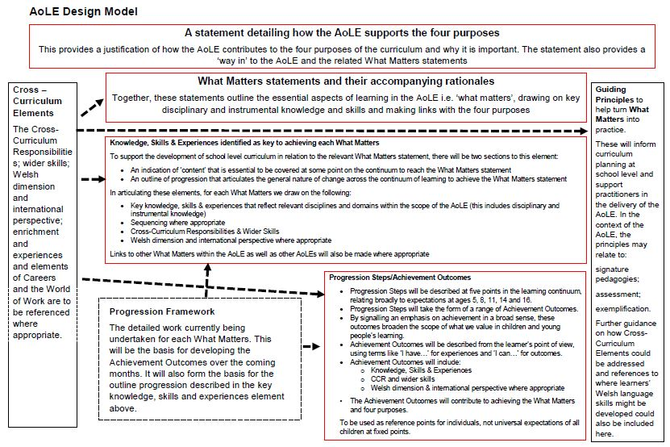

  - Appendix 3: Vignette Template: Template used to gather details of modern language teaching and learning in Irish schools

  - Vignette Template

Purpose
The purpose of gathering these vignettes is to show examples of how modern languages have been integrated into the Irish primary school day.

School and language learning description
- Please describe your school
English medium/Irish-medium; urban/rural; multi-grade/single-grade; school size

- Do children in your school speak languages other than English or Irish at home? Yes □ No □
If yes, please note down the home language(s) below.

- Which modern language(s) is taught during the school day at your school?

- How was the language(s) chosen?

- Why did your school choose to introduce a modern language into the curriculum?

- Which classes learn the modern language?
(Junior infants, senior infants, 1st, 2nd, 3rd, 4th, 5th, 6th)

- Do all children in the classes you noted in Q.6 learn the modern language?

- Who teaches the modern language?
(e.g. Classroom teacher/school teacher with language competence/external language teacher/external language specialist/other)

- Why was this particular person chosen to teach the modern language?
(e.g. competence in the specific language(s), general language expertise, interest in teaching the language, has a particular qualification, other)

- What types of resources are used to support the language teaching and learning?

- Is the same language taught at the local post-primary school(s)?

- Are any partnerships in place which support or facilitate the language learning? If so, please describe them.
(e.g. partnerships with local language institutes, universities, post-primary schools or language specialists)

- How much time is invested in modern language teaching and learning each week?

- Is the modern language taught as a separate subject?

- What do the children learn during their modern language classes?
(e.g. develop language awareness/link with English, Irish or other languages of the classroom/intercultural awareness/linguistic competence in the modern language/all of these/other [please specify])

- Any additional comments/information?

  - Appendix 4: Amended Vignette Template: Template used to gather details of modern language teaching and learning in Irish schools, with additional focus on special educational needs and the impact of a third language on English and Irish
  - Vignette Template

Purpose
The purpose of gathering these vignettes is to show examples of how modern languages have been integrated into the Irish primary school day.

School and language learning description
- Please describe your school
English medium/Irish-medium; urban/rural; multi-grade/single-grade; school size

- Do children in your school speak languages other than English or Irish at home? Yes □ No □
If yes, please note down the home language(s) below.

- Which modern language(s) is taught during the school day at your school?

- How was the language(s) chosen?

- Why did your school choose to introduce a modern language into the curriculum?

- Which classes learn the modern language?
(Junior infants, senior infants, 1st, 2nd, 3rd, 4th, 5th, 6th)

- Do all children in the classes you noted in Q.6 learn the modern language?

- Are there any children with special educational needs (SEN) learning a modern language?

  - If yes, what are their ranges of ability?
(e.g. access to an SNA, would any have exemptions from Irish?)

  - How does the modern language teacher differentiate for any children with SEN in their classes?

  - How do these children find their modern language classes?

- Who teaches the modern language?
(e.g. Classroom teacher/school teacher with language competence/external language teacher/external language specialist/other)

- Why was this particular person chosen to teach the modern language?
(e.g. competence in the specific language(s), general language expertise, interest in teaching the language, has a particular qualification, other)

- What types of resources are used to support the language teaching and learning?

- Is the same language taught at the local post-primary school(s)?

- Are any partnerships in place which support or facilitate the language learning? If so, please describe them.
(e.g. partnerships with local language institutes, universities, post-primary schools or language specialists)

- How much time is invested in modern language teaching and learning each week?

- Where does the modern language time come from within the school week?
(e.g. Discretionary time, language time, etc. )

- Is the modern language taught as a separate subject?

- What do the children learn during their modern language classes?
(e.g. develop language awareness/link with English, Irish or other languages of the classroom/intercultural awareness/linguistic competence in the modern language/all of these/other [please specify])

- What is the impact of the modern language on Irish?
Positive impact □ No impact □ Negative impact □
Please explain your answer

- Any additional comments/information?

  - Teimpléad le haghaidh Fínéid

Cuspóir
Is é is cuspóir do na fínéid seo a bhailiú ná samplaí a thaispeáint den chaoi ar comhtháthaíodh nuatheangacha sa lá scoile i mbunscoileanna na hÉireann.

Cur síos ar an scoil agus ar an bhfoghlaim teanga
- Déan cur síos ar do scoil le do thoil
Scoil Ghaeltacha/scoil lán-Ghaeilge/scoil Bhéarla; scoil uirbeach/tuaithe; scoil ilghrád/aon ghráid; méid na scoile

- An labhraíonn páistí i do scoil teangacha nach iad an Béarla ná an Ghaeilge iad sa bhaile? Labhraíonn □ Ní labhraíonn □
Má labhraíonn, breac síos teanga(cha) an bhaile thíos.

- Cén nuatheanga (nó cé na nuatheangacha) a mhúintear i gcaitheamh an lae scoile i do scoil?

- Cén chaoi ar roghnaíodh an teanga/na teangacha?

- Cén fáth ar roghnaigh do scoil nuatheanga a chur isteach sa churaclam?

- Cé na ranganna a fhoghlaimíonn an nuatheanga?
(Naíonáin bheaga, naíonáin mhóra, rang 1, 2, 3, 4, 5, 6)

- Maidir leis na ranganna a luaigh tú i gceist 6, an bhfoghlaimíonn gach páiste sna ranganna sin an nuatheanga?

- An bhfuil aon pháistí a bhfuil riachtanais speisialta oideachais (RSO) acu ag foghlaim nuatheanga?

  - Má tá, cén raon cumais atá acu?
(e.g. fáil a bheith acu ar chúntóir riachtanas speisialta, an mbeadh díolúine ón nGaeilge ag aon duine acu?)

  - Cén chaoi a ndéanann an múinteoir nuatheanga idirdhealú idir aon pháistí sa rang a bhfuil RSO acu agus na páistí eile?

  - Cén chaoi a n-éiríonn leis na páistí a bhfuil RSO acu sna ranganna nuatheanga?

- Cé a mhúineann an nuatheanga?
(e.g. an múinteoir ranga/múinteoir sa scoil a bhfuil inniúlacht teanga aige nó aici/múinteoir teanga ón taobh amuigh/speisialtóir teanga ón taobh amuigh/eile)

- Cén fáth ar roghnaíodh an duine áirithe seo chun an nuatheanga a mhúineadh?
(e.g. inniúlacht sa teanga nó sna teangacha ar leith sin, saineolas teanga i gcoitinne, suim i múineadh na teanga, cáilíocht ar leith a bheith aige nó aici, eile)

- Cén cineál acmhainní a úsáidtear chun tacú le teagasc agus múineadh na teanga?

- An múintear an teanga chéanna san iar-bhunscoil áitiúil/sna hiar-bhunscoileanna áitiúla?

- An bhfuil aon chomhpháirtíochtaí ar bun a thacaíonn le foghlaim na teanga nó a éascaíonn í? Má tá, déan cur síos orthu le do thoil.
(e.g. comhpháirtíochtaí le hinstitiúidí teanga, ollscoileanna, iar-bhunscoileanna nó speisialtóirí teanga áitiúla)

- Cé mhéad ama a chaitear ar theagasc agus ar fhoghlaim na nuatheanga gach seachtain?

- Cé as a dtagann an t-am a chaitear ar an nuatheanga?
(e.g. am lánroghnach, am teanga, etc.)

- An múintear an nuatheanga mar ábhar ar leith?

- Céard a fhoghlaimíonn na páistí sna ranganna nuatheanga?
(e.g. feasacht teanga a fhorbairt/nasc le Gaeilge, Béarla nó teangacha eile an tseomra ranga/feasacht idirchultúrtha, inniúlacht sa nuatheanga/gach ceann díobh sin/eile [sonraigh le do thoil])

- Cén tionchar atá ag an nuatheanga ar an nGaeilge?
Tionchar dearfach □ Gan aon tionchar □ Tionchar diúltach □
Mínigh an freagra a thug tú le do thoil

- Aon rud eile le rá nó aon eolas eile le tabhairt?

  - Appendix 5: Annotation details for MLPSI Chronology, Figure 8.1

MLPSI Chronology Annotation

1991: 24% of schools in Ireland were reported to be teaching a modern language (INTO, 1991). Modern languages were usually provided as an after-school activity on a fee-paying basis. French was the predominant language taught (reported in 75% of schools) and Italian was not reported to be taught in any school (INTO, 1991). Modern language teaching was more likely to be provided in scoileanna lán Ghaeilge, multi-denominational schools and larger schools (INTO, 1991). Teachers were reported to comprise 46% staff teachers and 54% visiting teachers.
1997: The pilot project on modern languages in primary schools was announced. 5th and 6th class children were to be afforded the opportunity to learn a modern language in participating schools for 90 minutes per week. 1,300 schools applied to participate and 270 were chosen from this cohort. Schools comprised a mixture of school types, including special needs, thus ensuring a representative sample of schools for the pilot.
Seven language-specific project leaders were appointed to support project schools and provide professional development for teachers. Schools were provided with an annual resource grant ranging from €254-€635, depending on student numbers. Additional funding was provided for peripatetic teachers, where required.
Schools were provided with an introductory pack of materials and resources. Project leaders supported schools in person, by email and by phone in setting up their modern language provision. Two in-service days were provided per year for modern language teachers, with an additional one at the start of the year for new teachers or schools. Teachers were also encouraged to access training available through the relevant language and cultural institutes. The majority of modern language teachers at this stage were peripatetic teachers.
1998-2001: Participating school numbers gradually increased during this period. In 2001, the pilot project was promoted to an Initiative and a national coordinator was appointed. At this point, certificate and diploma courses commenced in Institutes of Technology to provide professional development for primary school teachers in a modern language. These courses were partially funded by the DES. Certificates were awarded after one year for ab initio Spanish and Italian. Diplomas were awarded after two years in French and German (commencing from Leaving Certificate level).
2002-2007: During this period, a cap was placed on numbers of schools participating in the Initiative. New schools could only partake when they were replacing schools leaving the Initiative. Newer schools needed to provide Spanish or Italian, the lesser taught languages on the Initiative, in order to participate. In 2002, the first independent evaluation report on the Initiative was published (Harris and Conway, 2002). Modern language time could now range from 60-90 minutes per week.
In 2005 the Initiative team developed a European Language Portfolio, My ELP, which received European accreditation. In 2006, a standalone MLPSI website was launched (heretofore the MLPSI provided information through the Kildare Education Centre website).
In 2006, the second evaluation report on the Initiative was submitted to the DES (Harris and O’Leary, 2006).
In 2007, a partial lift on the cap was allowed to facilitate new schools to join the initiative if the school had capacity within its own staff to facilitate a modern language. The language teacher profile was rebalanced to 56% staff teachers and 44% peripatetic teachers at this stage. Support was moved from a language-specific model to a regional model of generic support with language-specific resources and professional development.
2008-2011: Numbers of schools gradually increased during this time. By the end of the 2011/2012 school year, 545 schools were participating in the MLPSI.
2012: The MLPSI ceased in 2012 due to budgetary cutbacks during the economic downturn.

People who answered ‘Chinese’ without adding any specification. Data was also gathered on Mandarin and Cantonese separately to the category ‘Chinese’.
The autonomy of the Åland region means that the linguistic legislation of the Language Act is not applied.
The Common European Framework of Reference for Languages (CEFR) provides a benchmark for levels of language competence achieved. There are six levels as follows: Basic User levels A1 (Breakthrough) and A2 (Waystage); Independent User levels B1 (Threshold) and B2 (Vantage); and Proficient User levels C1 (Effective Operational Proficiency) and C2 (Mastery).
http://nzcurriculum.tki.org.nz/The-New-Zealand-Curriculum/Learning-languages/Learning-area-structure
http://assessment.tki.org.nz/Assessment-tools-resources
Storyline teaching is an active learning method where students draw on what they already know to construct new knowledge of what is being learnt by answering and hypothesising around a series of teacher-directed key questions. The key questions generate a framework of a story. Storyline creates a partnership between the teacher and the learners in which the teacher designs the ‘line’ – the chapters of the story, and the learners create and develop the story. The line or plan aims at curricular content (knowledge) and skills practice while the story provides the context within which the pupils feel motivation through ownership. They create the characters that will bring the story to life. The ‘line’ is designed in a series of key questions (Source: http://www.storyline-scotland.com/what-is-storyline-2/).
One of the three communities in Belgium, the German-speaking Community, commences mandatory modern foreign language provision in Grade 1 at age 6.
S: Subject; V: Verb; O: Object.
This resource grant was later reduced from an annual grant to the first two years of a school’s participation in the Initiative.

