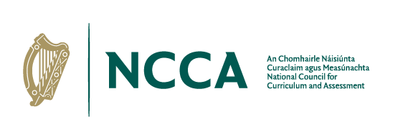

Junior Cycle Coding Short Course: Early Insights Review

NCCA is undertaking an early insights review of the junior cycle short course specification for Coding. The purpose of this review is to gather feedback from school management, teacher/educators, students and interested parties in relation to the experience of the Coding short course.
Feedback for the review will be gathered through school visits, written submissions and online surveys. All of the feedback will be analysed, and a report will be published. NCCA will use this feedback to continue to support post-primary schools in implementing Coding in their schools.
If you wish to provide written feedback on Junior Cycle Visual Art, please use the prompts below and return your written feedback by email to consultations@ncca.ie marked ‘Junior Cycle Coding’ in the subject line, by Monday 29th May.
You will find it helpful to access a copy of the Coding specification before completing the survey. This can be accessed here https://www.curriculumonline.ie/Junior-Cycle/Short-Courses/Coding/ in addition to the Assessment Guidelines for the short course.

- The aim of the Coding specification is to develop the student’s ability to formulate problems logically; to design, write and test code through the development of programs, apps, games, animations or websites; and, through their chosen learning activities, to learn about computer science.
Does the Coding specification achieve this aim?
Does it capture and facilitate learning about what’s really important for coding?
In other words, through engaging in this course, do students come to understand, value and take appropriate action on topics that are relevant and important in learning coding/computer science?
Your response:

- Are there any omissions or topics that need to be given more emphasis within the specification?
Your response:

- What opportunities and challenges have you experienced in using the learning outcomes within the specification to plan for teaching, learning and assessment?
Your response:

- Are there any particular learning outcomes that have really worked well in terms of teaching, learning and assessment?
Your response:

- Are there any particular learning outcomes that are unclear or problematic?
Your response:

- What feedback would you like to give us on doing the Classroom­Based Assessment (CBAs)?
Your response:

- Are the Assessment Guidelines helpful or is anything missing?
Your response:

- Overall, what have been the main successes and challenges so far in teaching the Coding short course?
Your response:

- Any additional feedback not covered in the questions above?
Your response:

